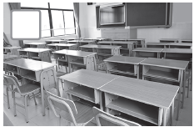
Unit 4 TEST A
My name is: ___________________________________________________________________________



Listen and tick () the box. There is one example.

Example:
How old is Mike?

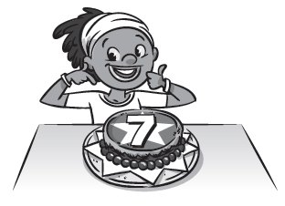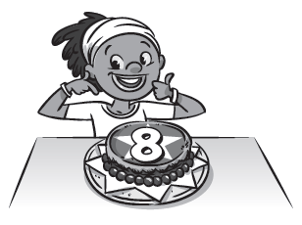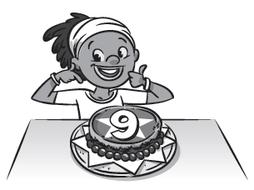
A □ B ☑ C □

1. What is Chloe doing?

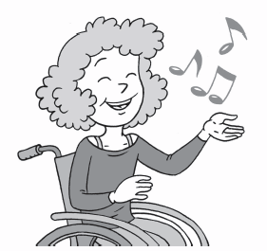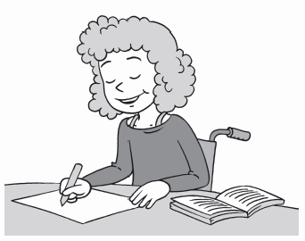
A □ B □ C □

2. Who’s in the bedroom?

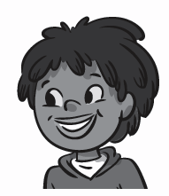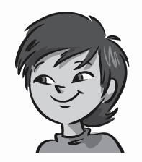
A □ B □ C □

3. What’s Lee’s favourite room?
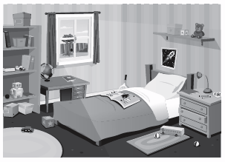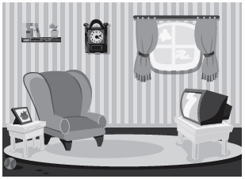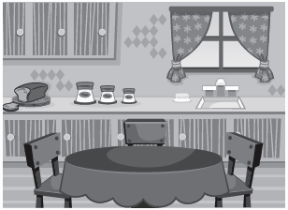
A □ B □ C □

4. Who’s at the door?

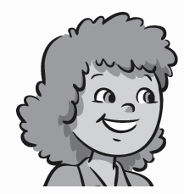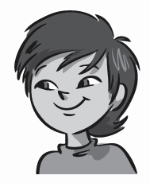
A □ B □ C □

5. Where is the TV?

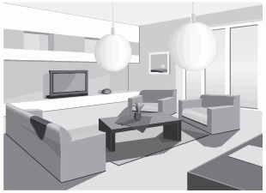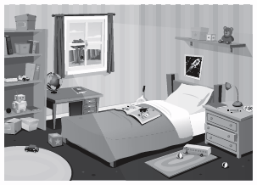
A □ B □ C □

Unit 4 TEST A
My name is: ___________________________________________________________________________



Look and read. Put a tick () or a cross () in the box. There are two examples.

Examples:
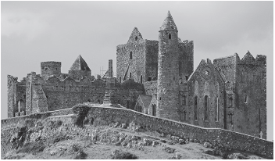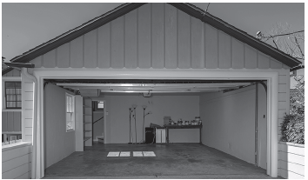
This is a castle. ☑ This is a bedroom. 

Part 1
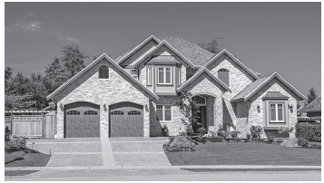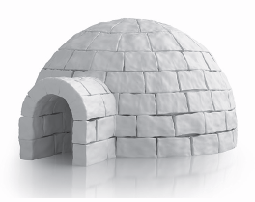
1. This is a flat. □ 2. This is an igloo. □

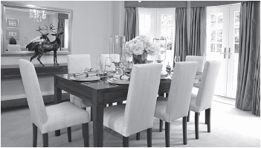 3. This is a kitchen. □

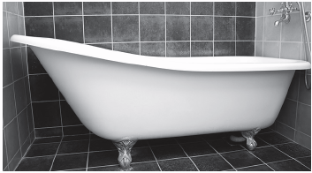
4. This a mirror. □ 5. This is a bedroom. □
Look at the pictures. Look at the letters. Write the words. There is one example.

Example:

Part 2
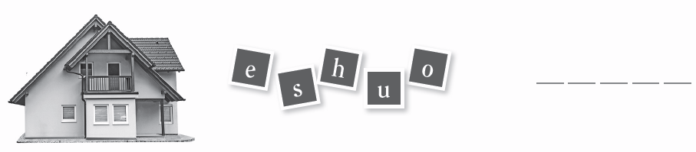
1.

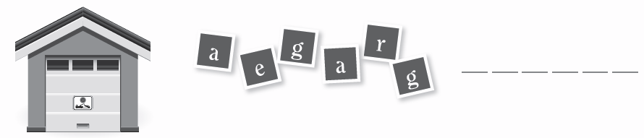
2.

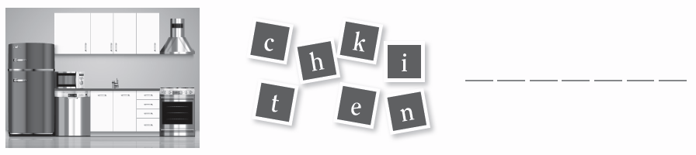

3.

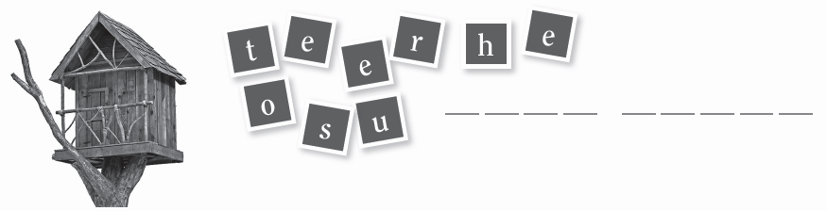

4.

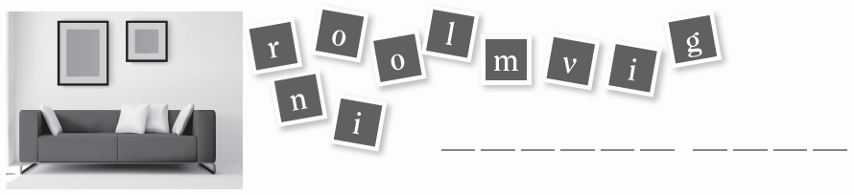

5.
Look at the picture and read the questions. Write one-word answers.
There is one example.
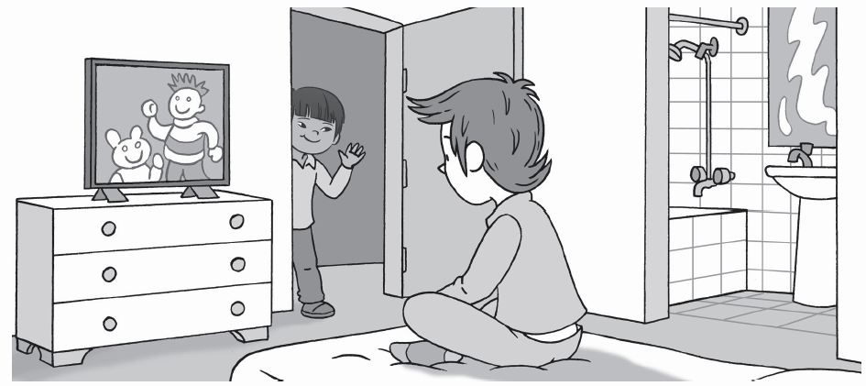

Example:
Where is Charlie? He’s in his bedroom .

Part 3
1. What is Charlie doing? Watching a film on his__________________.
2. Where is the mirror? In the__________________.
3. Who’s at the door? It’s__________________.
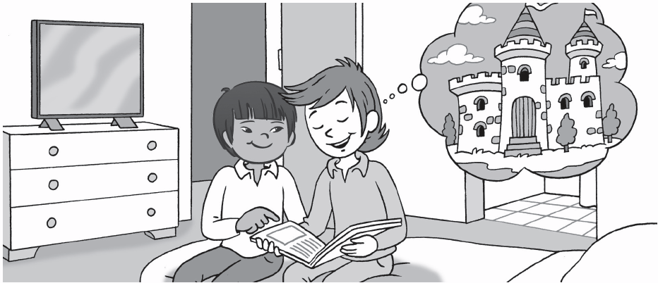
4. What are Charlie and Lee doing? They are__________________.
5. What are they thinking about? They are thinking about a__________________.

