
Unit 5 TEST A
My name is: ___________________________________________________________________________



Listen and tick () the box. There is one example.

Example:
How old is Mike?

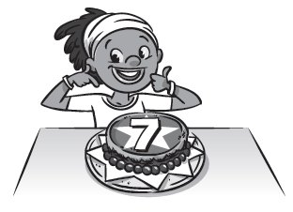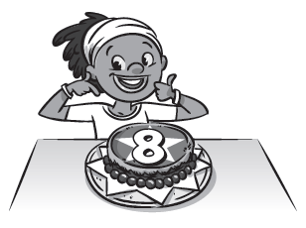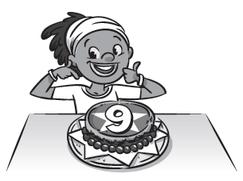
A □ B ☑ C □

1. Where are the Stars?

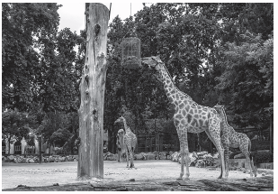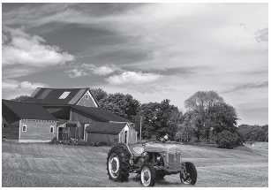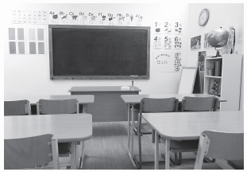
A □ B □ C □

2. What’s Mrs Harris holding?

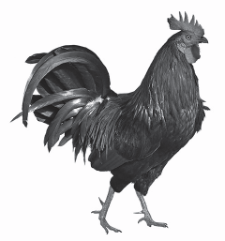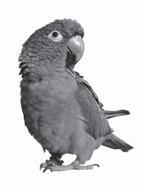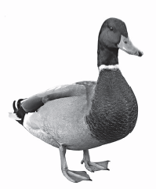
A □ B □ C □

3. What’s next to the sheep?
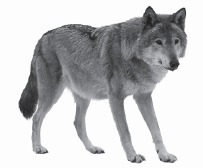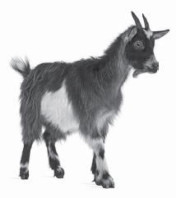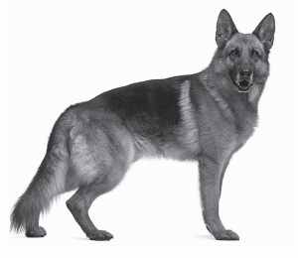
A □ B □ C □

4. How many cows does Mrs Harris have?


A □ B □ C □

5. What’s her favourite farm animal?
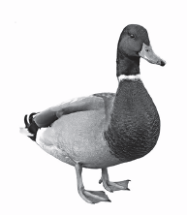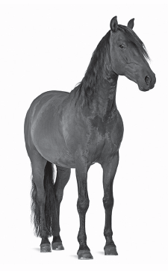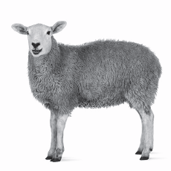
A □ B □ C □

Unit 5 TEST A
My name is: ___________________________________________________________________________



Look and read. Put a tick () or a cross () in the box. There are two examples.

Examples:
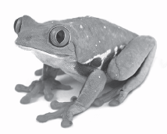
This is a horse. ☑ This is a lizard. 

Part 1
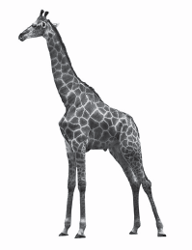
1. This is a hippo. □ 2. This is a wolf. □
 3. These are wings. □
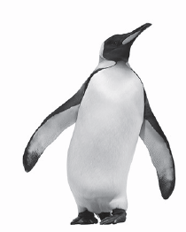
4. This is a penguin. □ 5. This is a lion. □
Look at the pictures. Look at the letters. Write the words. There is one example.

Example:

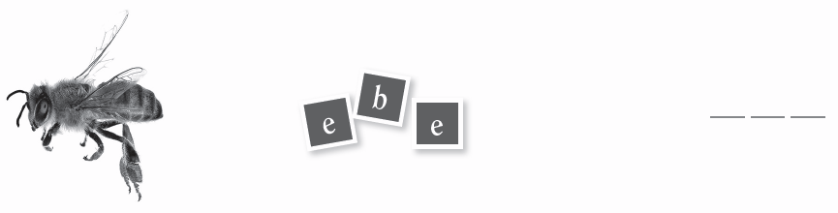
Part 2

1.

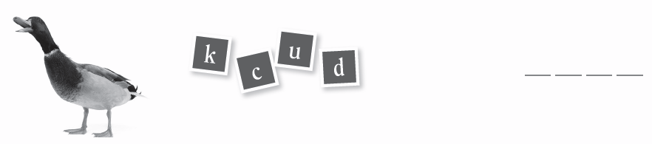

2.

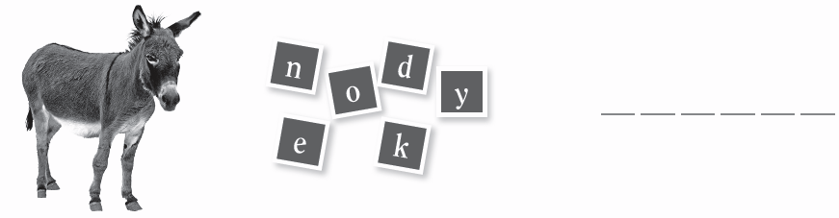

3.



4.

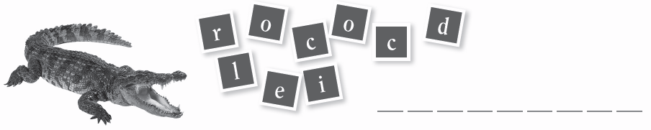

5.
Look at the picture and read the questions. Write one-word answers.
There is one example.

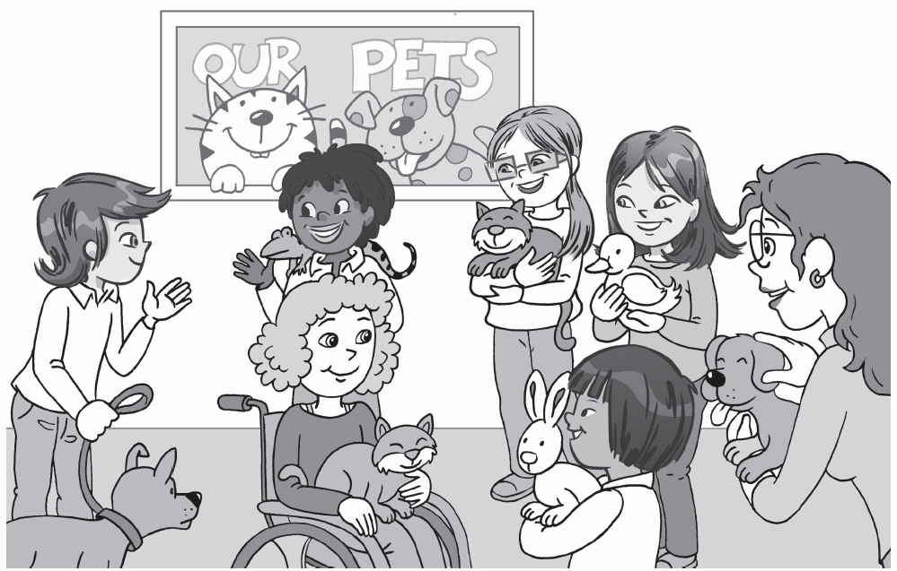

Example:
Where are the Stars? They are at school .

Part 3
1. What is Jessie’s pet? A ______________________________.
2. How many cats have they got? _____________________________ cats.
3. What is Mike’s pet? A _____________________________.
4. What pets have Charlie and _______________________________.
Miss Parker got?
5. Who has got a bunny? _______________________________.

