Unit 6 TEST A
My name is: ___________________________________________________________________________



Listen and tick () the box. There is one example.

Example:
How old is Mike?

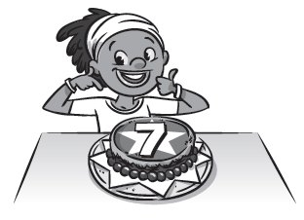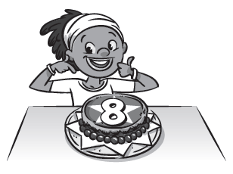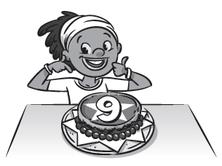
A □ B ☑ C □

1. Where are the Stars going?

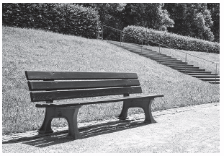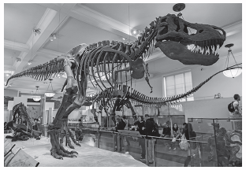
A □ B □ C □

2. What do the Stars hear?

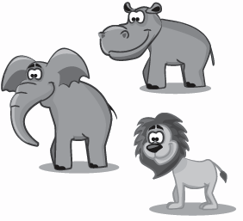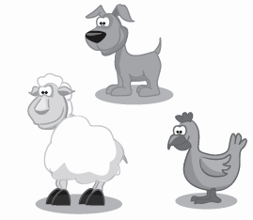
A □ B □ C □

3. What do the Stars eat?
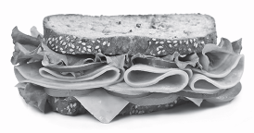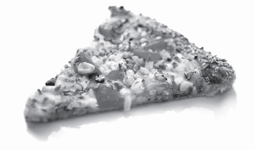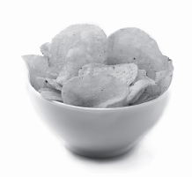
A □ B □ C □

4. What does Mike touch?

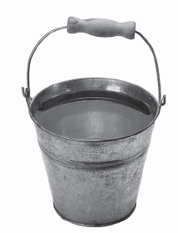
A □ B □ C □

5. What does Jessie smell?
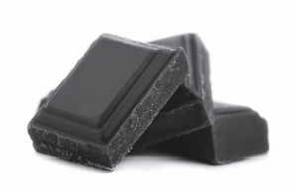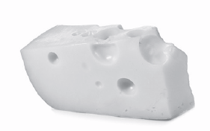
A □ B □ C □

Unit 6 TEST A
My name is: ___________________________________________________________________________



Look and read. Put a tick () or a cross () in the box. There are two examples.

Examples:
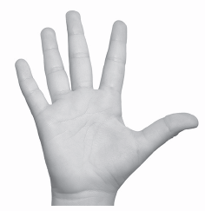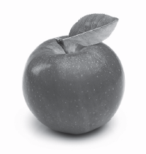
This is a hand. ☑ This is an ice cream. 

Part 1
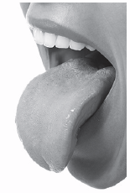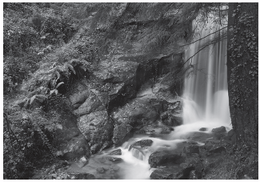
1. These are ears. □ 2. This is rain. □

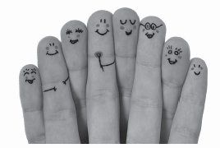 3. These are fingers. □


4. These are machines. □ 5. This is smoke. □
Look at the pictures. Look at the letters. Write the words. There is one example.

Example:

Part 2
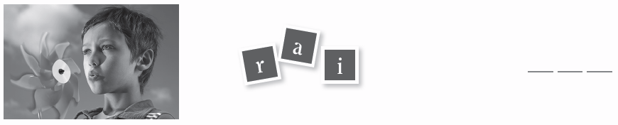
1.

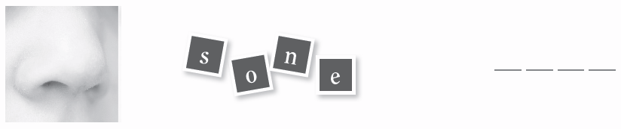

2.

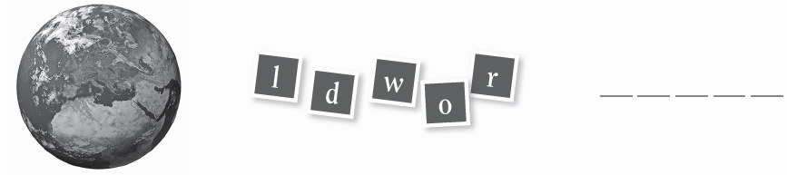

3.

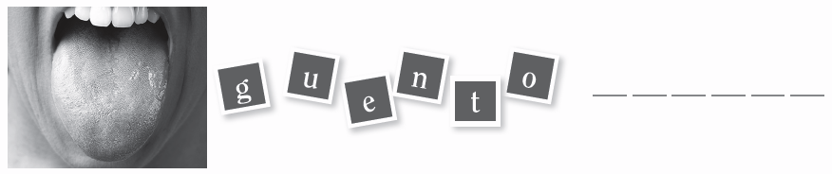

4.

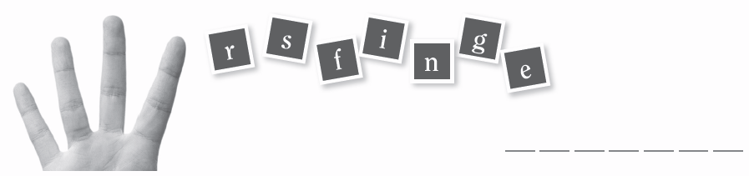

5.

Look at the picture and read the questions. Write one-word answers.
There is one example.

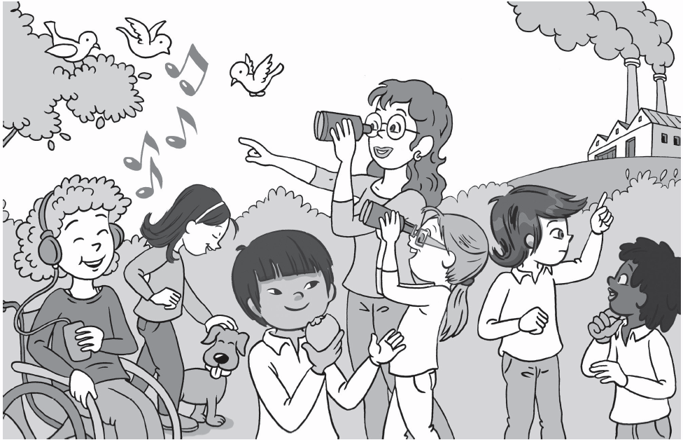

Example:
Where are the Stars? They are in the park .

Part 3
1. What is Lee eating? An ______________________________.
2. What is Chloe listening to? ______________________________.
3. What is Charlie smelling? ______________________________.
4. What is Jessie touching? A ______________________________.
5. What are Ana and Miss Parker looking at? ______________________________.
