Unit 7 TEST A
My name is: ___________________________________________________________________________



Listen and tick () the box. There is one example.

Example:
How old is Mike?

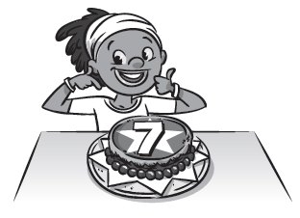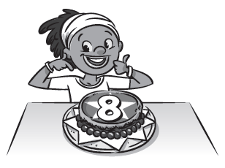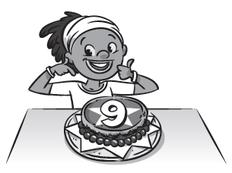
A □ B ☑ C □

1. Where are the Stars going?

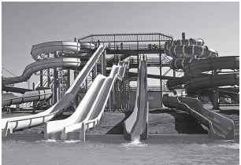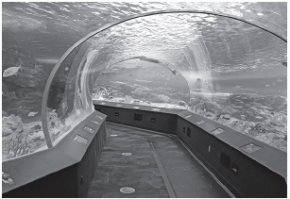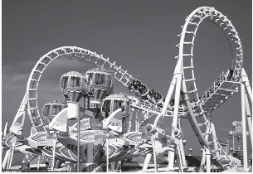
A □ B □ C □

2. What do the Stars ride?

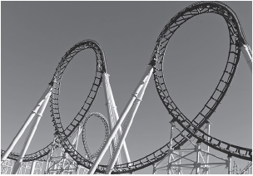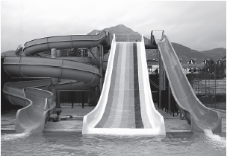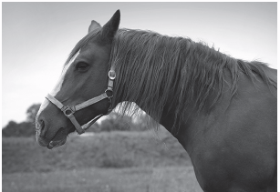
A □ B □ C □

3. What time do the Stars eat lunch?

A □ B □ C □

4. Who is next to the water slide?

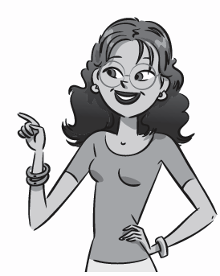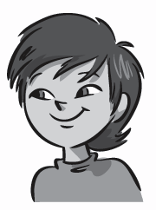
A □ B □ C □

5. What time do the Stars go back to school?


A □ B □ C □

Unit 7 TEST A
My name is: ___________________________________________________________________________



Look and read. Put a tick () or a cross () in the box. There are two examples.

Examples:
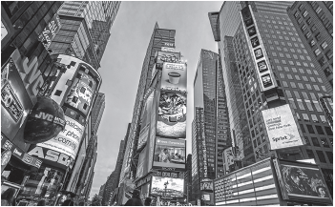
This is a lifeguard. ☑ This is the countryside. 

Part 1
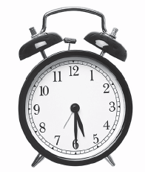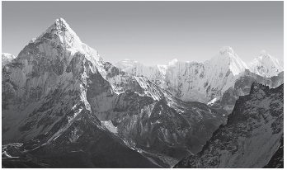
1. This is a clock. □ 2. This is a mountain. □

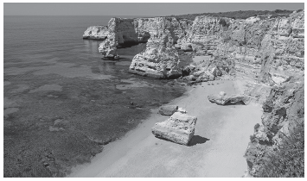 3. This is a water park. □

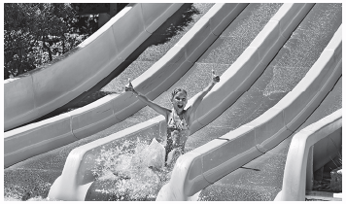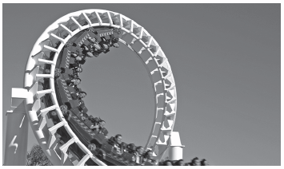
4. This is an aquarium. □ 5. These are fireworks. □
Look at the pictures. Look at the letters. Write the words. There is one example.

Example:

Part 2

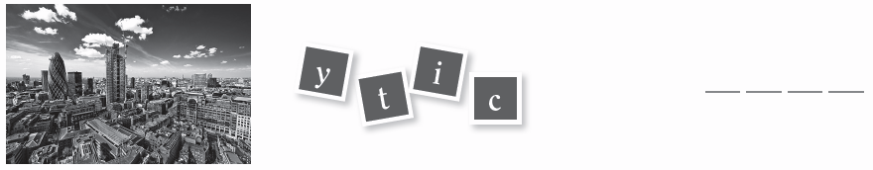
1.

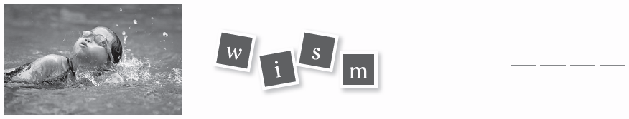

2.

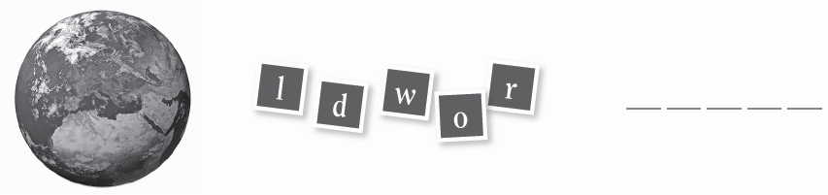

3.

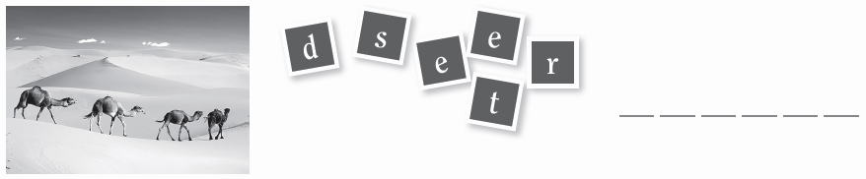

4.



5.
Look at the picture and read the questions. Write one-word answers.
There is one example.

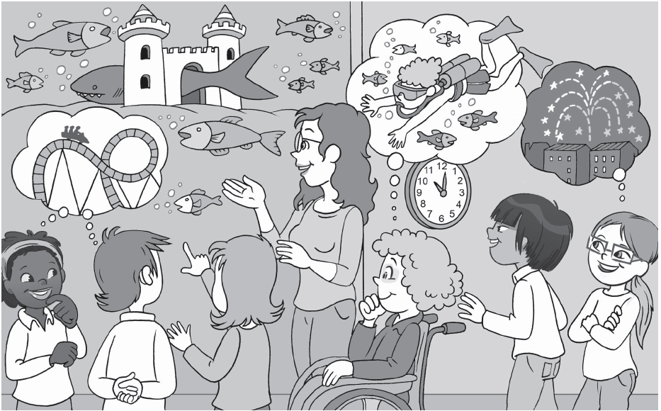

Example:
Where are the Stars? At the aquarium .

Part 3
1. What are the Stars looking at? ______________________________.
2. Where is the shark hiding? In a __________________________.
3. What are Charlie and Lee thinking about? ______________________________.
4. What time is it? ______________________________.
5. What is Ana thinking about? ______________________________.

