Unit 1 – Back to school | Arts & Crafts

My name is: ___________________________________________________________________________

Recycled soda bottle craft

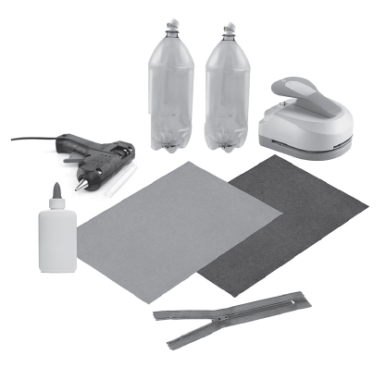
Materials
• 2 plastic soft-drink bottles of the same size
• Low-temperature glue gun and glue sticks
• Zipper to fit perimeter of bottle
• Brown card for stem
• Green card for leaves
• Material for a tag punch (optional)
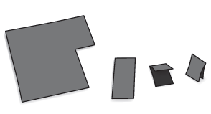
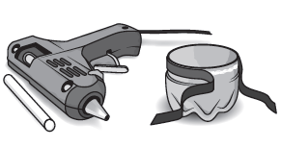
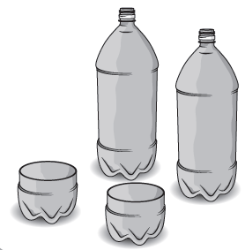
3. Cut the stem.
2. Hot glue zipper to bottle rims.

1. Clean and cut bottles.

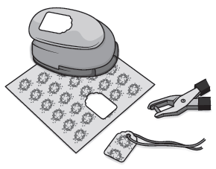
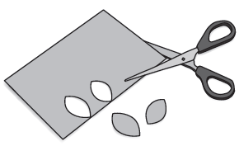
6. You can use the apple containers as a gift.
4. Cut leaves.

5. If you wish, make a tag.

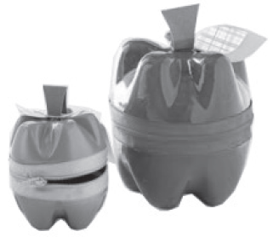

http://www.lovethecountry.com/project/recycled-soda-bottle-craft/ (abridged and adapted)

