Unit 4 – Where we live | Cross Curricular

My name is: ___________________________________________________________________________

Chore chart

1. Complete with your chores.

Mon
Tue
Wed
Thurs
Fri
Sat
Sun
Chores |   Clean up |   Feed pet |   Take out trash |   Sweep | 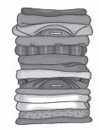  Put away laundry

http://kids.lovetoknow.com/wiki/Printable_Chore_Charts_for_Kids (adapted)

