Unit 7 – The sun is shining | Cross Curricular

My name is: ___________________________________________________________________________

Water safety

1. Circle what is safe when you are at the pool or at the beach.
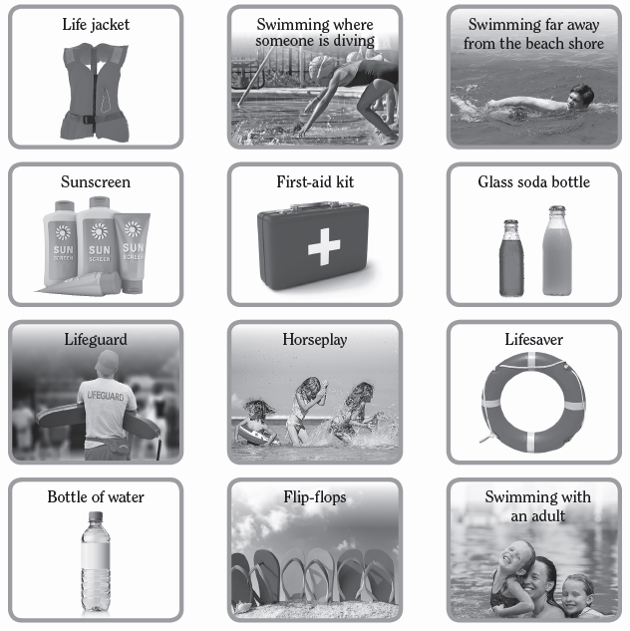

2. Do you prefer going to the beach or the swimming pool?

