Unit 2 – Our body | Star Fun

My name is: ___________________________________________________________________________

My body

1. Write the words.
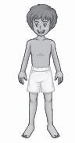
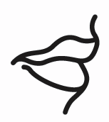
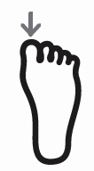
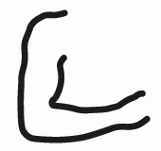
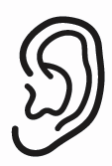

1. ___________ 2. ____________ 3. ___________ 4. ____________ 5. ___________
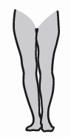
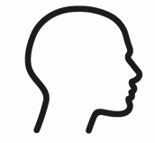
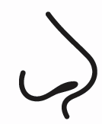
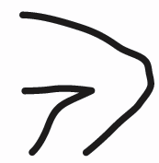


6. ___________ 7. ____________ 8. ___________ 9. ____________ 10. ___________

2. Complete the puzzle.
1 |  | 2
 |  | 3 |  | 4
 |  |  |  |  |  |  | 5
 |  |  |  | 6 | 7
 |  | 8 | 9

