Unit 5 – Let’s visit the animals | Star Fun

My name is: ___________________________________________________________________________

Farm animals

1. Complete the crossword below and colour the animals.

 |  |  |  |  |  |  | 1 | 2
 |  |  |  |  |  |  |  |  |  | 3
 |  |  |  |  |  |  |  | 4
 |  |  |  |  | 5
 |  |  |  | 6
7
8 |  |  | 9

Across
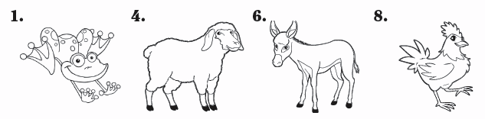

Down
