Unit 2 – Our body | Arts & Crafts

My name is: ___________________________________________________________________________

Paper snowflakes

Materials
• Paper (plain white A4, coloured or patterned – it’s up to you)
• Scissors

Steps
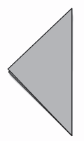
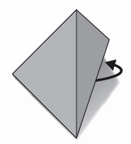
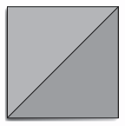
3. Fold again and put the paper like this.
2. Rotate the square like this.
1. Fold a square piece of paper.
5. Carefully unfold the paper to reveal your 4-sided snowflake.
4. Cut away shapes along the edges.

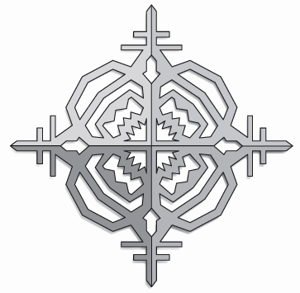
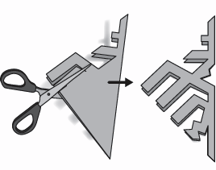

http://www.firstpalette.com/Craft_themes/Colors/papersnowflake/papersnowflake-4side8side.html (adapted)

