Unit 6 – The five senses | Star Fun

My name is: ___________________________________________________________________________

My tongue

1. Look and match. Write the words.
lemon • cake • pizza • cheese • chocolate • broccoli

2. _____________ .
It’s _____________ .

3. _____________ .
It’s _____________ .
1. broccoli.
It’s sour.


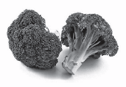


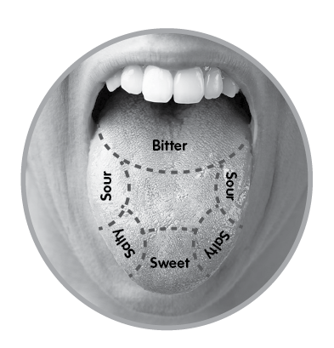

6. _____________ .
It’s _____________ .
4. _____________ .
It’s _____________ .


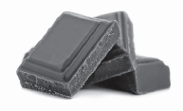
5. _____________ .
It’s _____________ .

