Unit 3 – Food is great | Arts & Crafts

My name is: ___________________________________________________________________________

My lunchbox
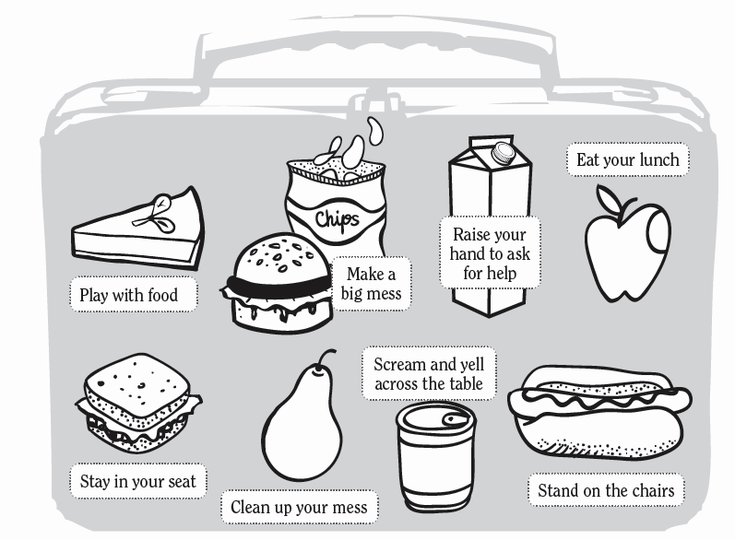

Cafeteria and canteen behaviour
☺ Good | ☹ Bad
_________________________  _________________________  _________________________  _________________________ | _________________________  _________________________  _________________________  _________________________

http://www.kindergartenkindergarten.com/2011/08/teaching-school-routines-is-essential-the-first-few-
days-weeks-of-school-i-go-over-every-single-routine-i-can-think-of-and.html (adapted)

