Unit 4 – Where we live | Arts & Crafts

My name is: ___________________________________________________________________________

An origami house

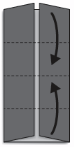
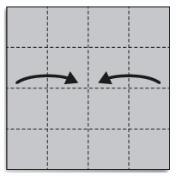
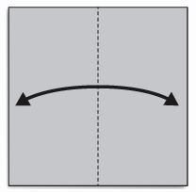
2. Fold to meet the center line along the crease.
1. Fold in half to make a crease.

3. Fold in the dotted line.

2. Fold to meet the center line along the crease.

1. Fold in half to make a crease.

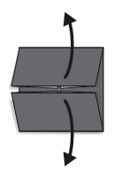
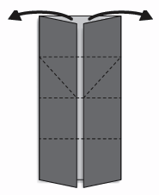
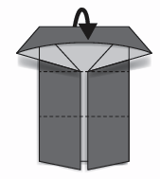
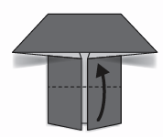

4. Fold back.
5. Open.
6. Flatten.
7. Fold in the dotted line.

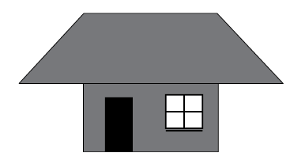

8. Draw a door and windows and… here is a house.

http://www.lovethecountry.com/project/recycled-soda-bottle-craft/ (abridged and adapted)

