Unit 5 – Let’s visit the animals | Arts & Crafts

My name is: ___________________________________________________________________________
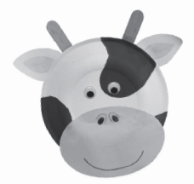

Paper plate animals

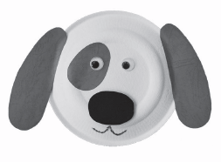

Materials
• Paper plate
• Water-based paint
• White glue
• Scissors
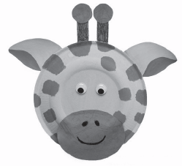
• Paint brush
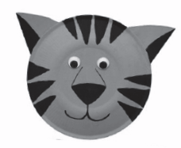
• Wiggle eyes
• Construction paper
• Crayons or markers
• Craft stick, pompoms, other
decorative materials

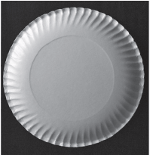
1. Think about what animal you want to make

– Imagine a paper plate to be the animal’s head.
– What do you need to decorate the paper plate?

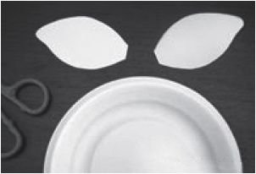
2. Make the ears and other special parts

– Cut out head parts, e.g. a pair of ears out of construction paper or cardboard.

3. Attach the ears

– With the paper plate’s right side up, glue the pair of ears on either side of the plate.
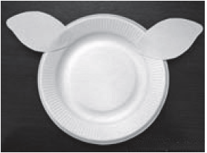

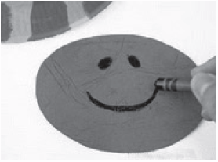
4. Paint the animal

– Put the paper plate bottom side up with the ears glued at the back.
– Paint the animal with any water-based paint.
– Paint on some spots or stripes if your animal has these patterns.
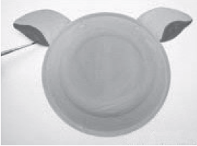

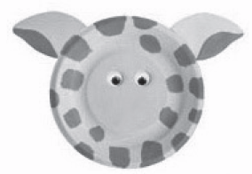
5. Add eyes

– Glue on wiggle eyes, buttons or paper cut-outs.

6. Make the nose and mouth

– Draw or paint a nose and mouth.
– You can use crayons or markers for drawing.
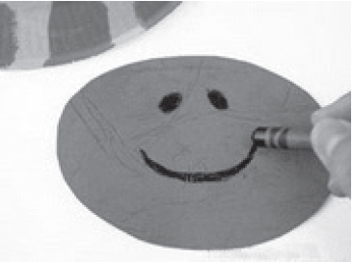

http://www.firstpalette.com/Craft_themes/Animals/paperplateanimals/paperplateanimals.html
(abridged and adapted)

