Unit 6 – The five senses | Arts & Crafts

My name is: ___________________________________________________________________________

The way I look

1. Draw faces.
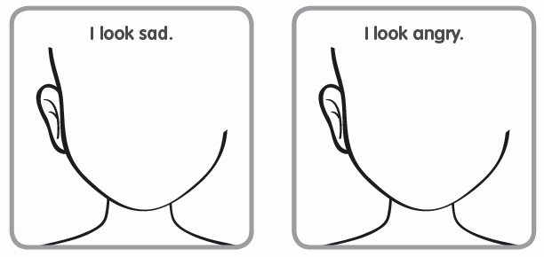

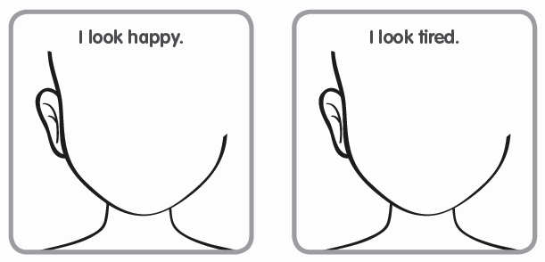

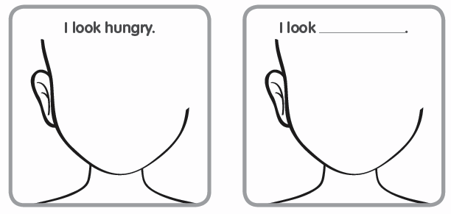

http://www.simplysprouteducate.com/2012/08/the-way-i-feel-helping-your-little-one.html

