Unit 7 – The sun is shining | Arts & Crafts

My name is: ___________________________________________________________________________

Homemade flubber

Materials

• 3/4 cup of cold water
• 1 cup of glue
• liquid food colouring
• 1/2 cup of hot water
• 1 teaspoon borax (you can find this in a box in the laundry aisle)

Steps

• 1: in bowl 1 – mix together the cold water,
glue, and food colouring. Set aside.
• 2: in bowl 2 – mix together the hot water and borax, until the borax is completely dissolved.
• 3: slowly add glue mixture to borax mixture.
Mix well. Pour off excess water.

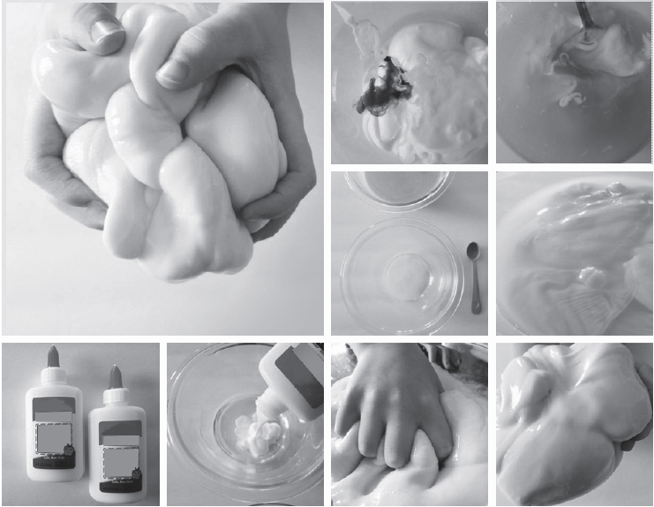

https://schelastic.wordpress.com/2013/07/02/homemade-flubber-recipe-for-kids/ (adapted)

