Unit 1 – Back to school | Cross Curricular

My name is: ___________________________________________________________________________

Safety @ school

1. Look and read.
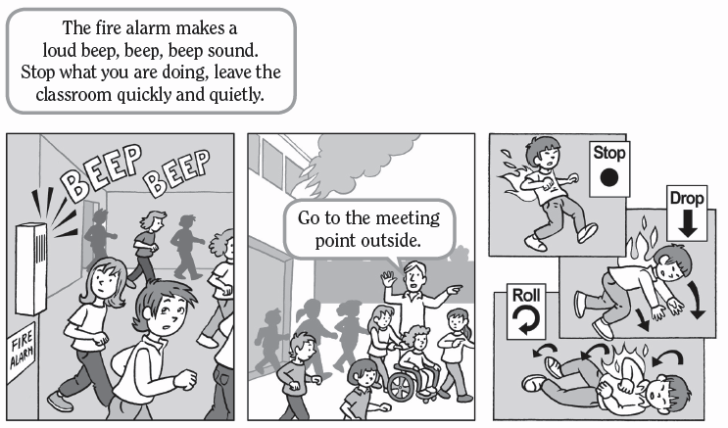

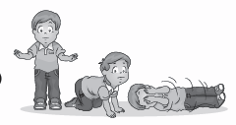

2. Read and match. Draw a line.

1. Students go to the meeting point outside.

a)

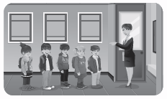

2. The fire alarm makes a beep, beep sound.

b)

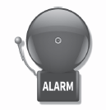

3. Stop, drop and roll!

c)

