End-of-second-term 5.º ano Listening Test

Name: ______________________________________________________ Class: ____ No.: __________
Date: _______________________________________________________ Score: __________________
Enc. Educação: ________________________________Teacher: ___________________________

- Listen and tick.
1. Who is Carol?

  A |   B |   C
2. Who is Jack?

  A |   B |   C
2. Whose coat is this?

A Sally’s | B Mary’s | C Anna’s
4. Where is Jack?

  A |   B | 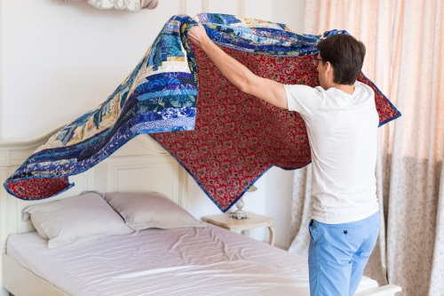  C
5. Who is Peter?

  A | 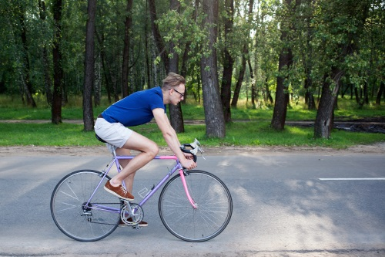  B | 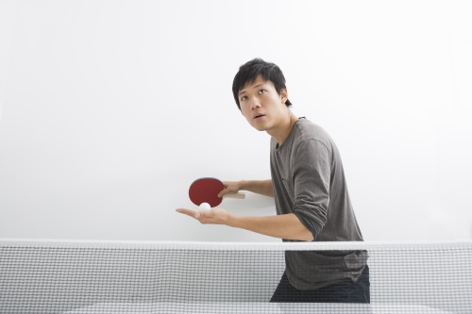  C

- Read the questions.

Listen and write one-word answers.
Example
What’s the boy’s name? His name is ___Mark____.

- What is Rachel wearing? She’s wearing a blue __________.
- What is Mark wearing? He’s wearing __________ and a blue shirt.
- Who has got blue eyes? __________________________________.
- What is she like? She’s _____________________________.
- What does Rachel like? She likes __________________________.



End-of-second-term 5.º ano Written Test

Name: ______________________________________________________ Class: ____ No.: __________
Date: _______________________________________________________ Score: __________________
Enc. Educação: ________________________________Teacher: ___________________________

Vocabulary
A. Look at the pictures about Trevor’s daily routine. Read and write True or False.

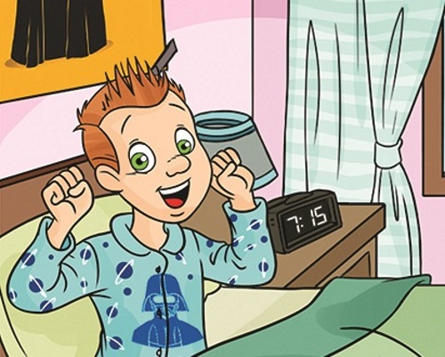 | 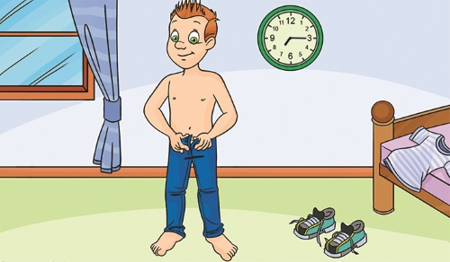 | 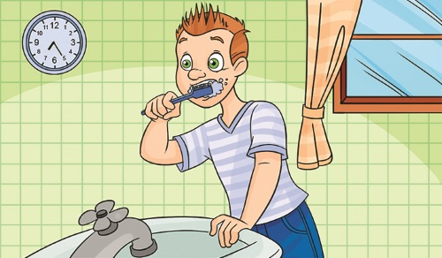
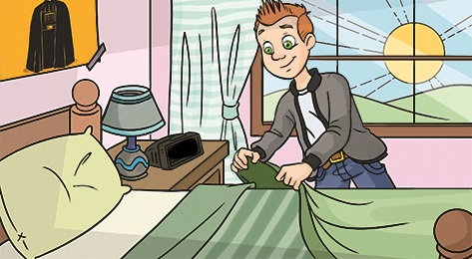 | 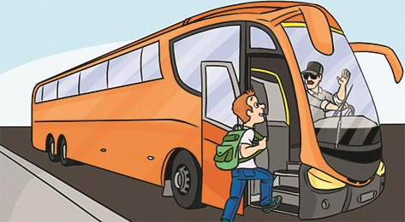 | 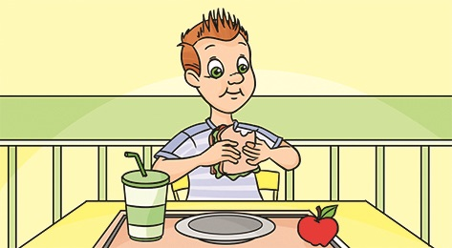  12:30
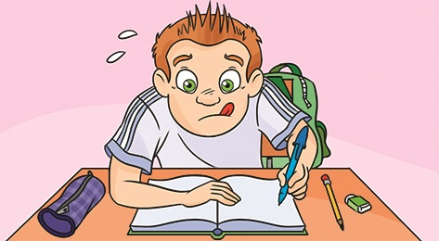  15:30 | 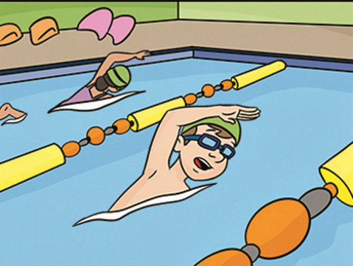  17:30 | 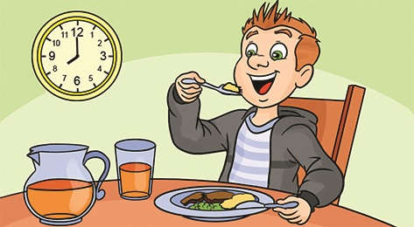

Example Trevor usually gets up at quarter past seven. ___True__
- He gets dressed at half past seven. ________
- He brushes his teeth after getting dressed. ________
- Trevor never makes his bed. ________
- He goes to school by car. ________
- Trevor has lunch at one o’clock. ________
- He does his homework before he goes swimming. ________
- He swims at ten to five. ________
- Trevor has dinner at eight o’clock. ________

B. Look at the picture. Read and write Yes or No.

Charlie
Jason
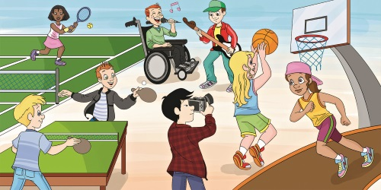
Sally
Debbie
Chang
Bill
Trevor
Kim

Example
The children are in the classroom. ___No__
- Sally is wearing a skirt. ________
- Debbie is playing football. ________
- Charlie is wearing a hat. ________
- Kim and Debbie are wearing shorts. ________
- Bill is wearing jeans and a T-shirt. ________
- Kim is singing. ________
- Jason is wearing shorts and a T-shirt. ________
- Trevor and Jason are wearing a jacket. ________
- Chang is taking pictures. ________
- Trevor is playing with Sally. ________
- Jason is playing the guitar. ________
- Chang has got sunglasses. ________

Reading
Read the text.

My daily life

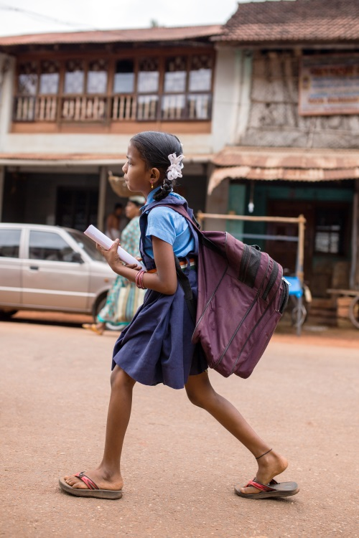
Aditi is eleven years old. She is from India and she lives in Gokarna. She always gets up very early in the morning. She wakes up at half past five and cleans her bedroom before her mother wakes up. Then she helps her mother prepare breakfast for her family. She has got six younger brothers and sisters. They all eat their breakfast and then she goes to school on foot. It takes her thirty minutes to get there.
Her mother stays at home with her brothers and sisters, but her father goes to work. He is a mechanic. He works in a small garage next to the house. He sometimes works at night, but he always has breakfast with the family.
At school Aditi studies a lot because she wants to be a doctor one day. She always has lunch in the school canteen. When she arrives home at four o’clock, she does her homework and then she rides her bike or plays basketball with her sisters.
In the evening they have dinner at half past six. After dinner they sometimes watch TV together. They all go to bed at nine o’clock.

A. Read the text and write true (T) or false (F).

- Aditi is 12 years old. ___________
- She has breakfast after she cleans her bedroom. ___________
- Her mother is a mechanic. ___________
- She rides her bike before she does her homework. ___________
- Aditi usually plays basketball in the afternoon. ___________

B. Answer these questions about the text.

- Where is Aditi from? ________________________________________________
- How many brothers and sisters has Aditi got? ____________________________
- How does she go to school? __________________________________________
- Where does she have lunch? _________________________________________
- What time does she go to bed? ________________________________________

Grammar

- Read the sentences and choose the correct option.

- Aditi has got ____________.
A brown eyes B eyes brown C browns eyes
- What ____________ like? She’s young and good-looking.
A is she B are she C does she look
- ____________ is blue and red.
A The bike of Aditi B Aditi’ bike C Aditi’s bike
- ____________ coat is this? It’s not mine.
A Who B Whose C What
- Hurry up, Aditi! ____________ your coat and go to school.
A Put on B Look for C Hang up
- ____________ are you sad? Because my test results are not good.
A Who B What C Why
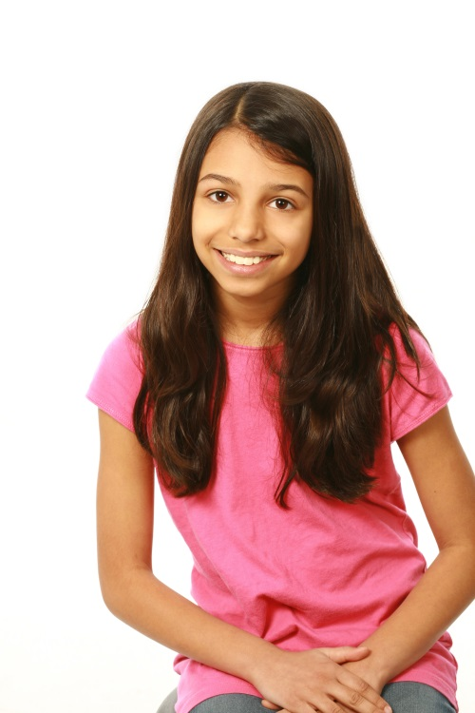
- I love ____________ the guitar.
A play B plays C playing
- It’s so hot today. Let’s jump ____________ the pool and swim.
A into B onto C out of
- Do you like playing football? No, ____________.
A I do B I don’t C she does
- What time ____________ get up?
A you do B do you C does you

- Complete the sentences with the words in the box.

      - Aditi, this is not our ball. _________ is red.
      - - Whose bike is this? Is it _______ ?
– Yes. It’s Anna’s.
I * you * hers * he
his * ours * mine
me * my * she

      - - Is this T-shirt yours?
- No, it’s not _______ . _______ T-shirt is yellow.
      - That’s my hat. Give it to ________.
      - What are ______ doing? _______ am drawing.
      - That’s my brother. __________ name is Jack. _______ is ten years old.
      - Aditi is from India and _______ has got many brothers and sisters.

C. Complete the sentences with the present simple or the present continuous.
Example
Aditi often plays (play) basketball, but now she is playing (play) football with her friends.
- Jack never ____________ (get) up early.
- Look, John ____________ (run) in the park. He ____________ (love) sport.
- I usually ____________ (watch) TV in the evenings, but today I ____________ (read) a book.
- Aditi and her sisters ____________ (not play) computer games at night.
- Aditi usually ____________ (go) to school on foot, but today she ____________ (ride) her bike.
- They sometimes ____________ (study) in the school library, but today they ____________ (study) at Aditi’s house.

Writing

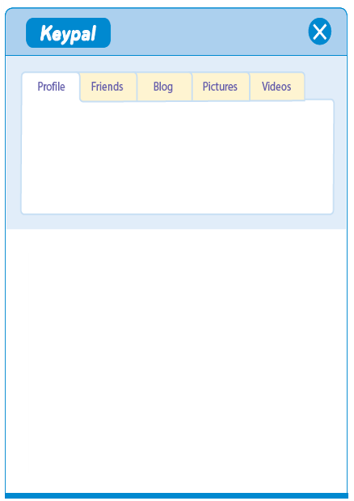
- Imagine you get this message from Aditi. Write back to her.
____________________________
Age: ________________________
Nationality: ___________________
Aditi Flin
Age: 11
Nationality: Indian
Hello,
My name is Aditi Flin and I’m 11 years old. I’m from India.
I’ve got long brown hair and brown eyes. I’m short and my friends say I’m funny. I’ve got six brothers and sisters.
Would you like to be my keypal?
Please write to me.
Aditi

__________________________
__________________________
__________________________
__________________________
__________________________

B. Choose one of the topics and write 20-30 words.

Option 1
Imagine this is your best friend. Describe him using the information in the box.


Name: Michael Smith
Age: 11
Hair: short / curly
Eyes: green
Personality: funny, smart
Clothes: blue sweater / trousers
Favourite activities: play the piano / sing

Option 2
Imagine you are Jack. Describe your daily routine.
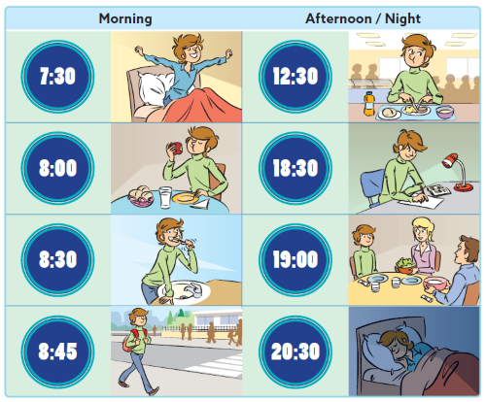
Option ______
__________________________________________________________________________
__________________________________________________________________________
__________________________________________________________________________
__________________________________________________________________________
__________________________________________________________________________

