Name
UNIT 1 WE ARE FAMILY Test A
Date |  | Score |  | Teacher

Enc. de Educação
- Listen and draw a line.
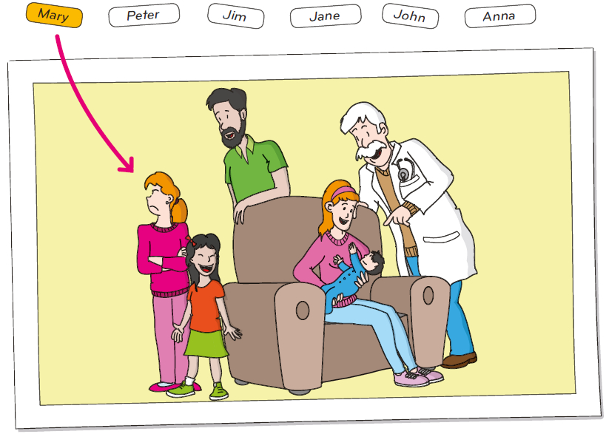
- Listen and tick ().
Example: What’s David’s surname?
 | Jones |  | James |  | Jackson
- How is David today?
 |  |  |  |  | 

- How old is Emma?
 | 12 |  | 13 |  | 14

- Who are they?
 |  |  | 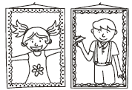 |  | 

- Which photo has Kate got?
 | 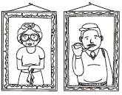 |  |  |  | 
- Who is Michael?
 | 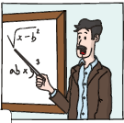 |  |  |  | 

- Read the questions.
Listen and write one-word answers.

Example: What’s the girl’s name? Her name is Natalie.

- What’s the boy’s name? His name is ____________.
- How old is Natalie? She is ________________.
- Where is Natalie from? She is from ____________.
- Who is Paul? He is Natalie’s __________.
- How old is Paul? He is _________________.

- Look and read. Then write the number in the box.
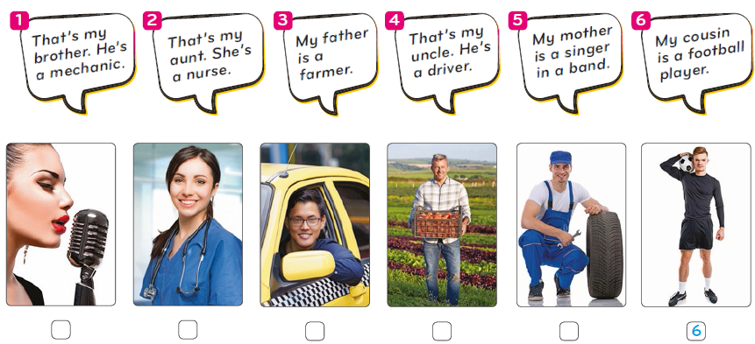

- Read the dialogue and choose the best answer.
Example: Hello! |  | a) Goodbye!  b) Hi!  c) See you!
1. What’s your name? |  | a) Yes, I’m George.  b) I’m happy.  c) George.
2. Nice to meet you, George.  How are you? |  | a) No, I’m not.  b) I’m great.  c) That’s my sister.
3. Where are you from? |  | a) Yes, I’m Scottish.  b) Scottish.  c) Scotland.
4. Have you got any brothers  or sisters? |  | a) Yes, two brothers.  b) No, I’m not.  c) I’m great, thanks.
5. Is your dad a football player? |  | a) He is my brother.  b) No. He’s a mechanic.  c) Yes, he has.

- Look, read and write True or False.
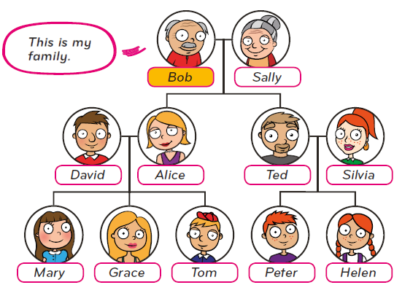

Example: David is my brother. False

- Sally is my daughter. ___________
- Ted is my son. ___________
- My grandson Tom has got two sisters. ___________
- Mary and Helen are cousins. ___________
- I’ve got three children. ___________

- Look at the picture and write the correct word. Some are not necessary.

is she
am hisa
are her
have got him
has got my
he


My name is Paul. I (1) ________ ten years old.
This is a picture of my family. I (2) ________ two sisters.
This is my father. (3) ________ is a teacher. (4) ________
name is Michael. My mother is a doctor. (5) ________ name
is Katy.


- Look at the information. Complete the dialogue.

First name | Harry
Last name | James
Country | Ireland
Age | 13
Parents | John (pilot), Grace (secretary)

I’m Harry James.

1. ________________.
2. ________________.
3. ________________.
4. ________________.
5. ________________.
Example: What’s your name?

1. How old are you?
2. What’s your nationality?
3. Who is Grace?
4. What’s her job?
5. Who is John?

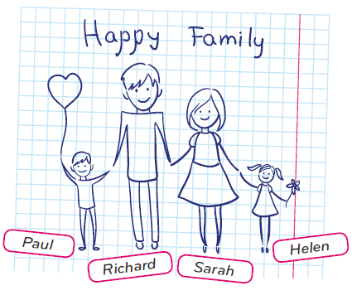
- Read and complete the text.

Name | Helen
Age | 10
Nationality | American



My (1) ________ is Helen. I’m (2) ________
years old and I’ (3) ________ American.
This is a picture of my (4) ________ .
My parents (5) ________ Richard and Sarah. My father is a
police offificer and my mother (6) ________ a photographer.
I’ve got a (7) ________ . His (8) ________ is Paul.
And you? (9) ________ you got any brothers
or (10) ________ ?


- Write a text about your family.
(20 to 30 words)

Name
Age
Nationality

______________________________________________________________________________________________________________________________________________________________________________________________________________________________________________________________________________________________________________________________________________________

Well done!

