UNIT 2 HOME IS WHERE THE HEART IS Test A
Name

Date |  | Score |  | Teacher

Enc. de Educação
- Listen and draw a line.
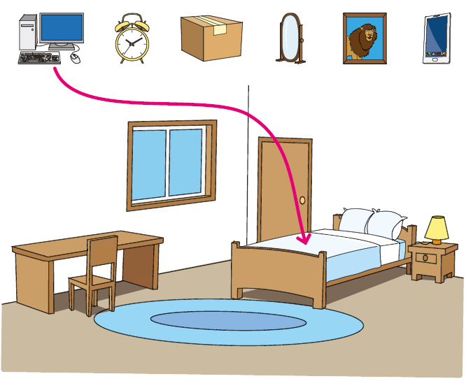
- Listen and tick ().
Example: Where is Paul’s phone?

 | 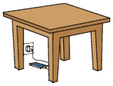 |  | 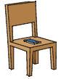 |  | 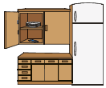

- Where is Peter’s ball?

 |  |  | 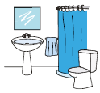 |  | 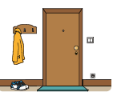

- Where is Peter’s mum?

 | 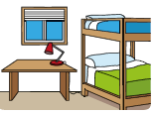 |  | 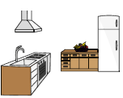 |  | 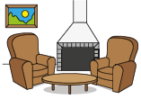
- Who has got a house with a garden?

 | Lucy |  | Ann |  | Paul
- Which is Sally’s phone?

 | 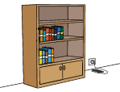 |  | 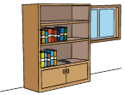 |  | 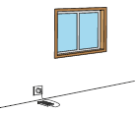
- Who is John?

 | 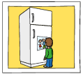 |  | 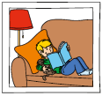 |  | 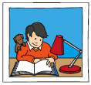
- Where can I put these things in the house?
Listen and write a letter in each box.
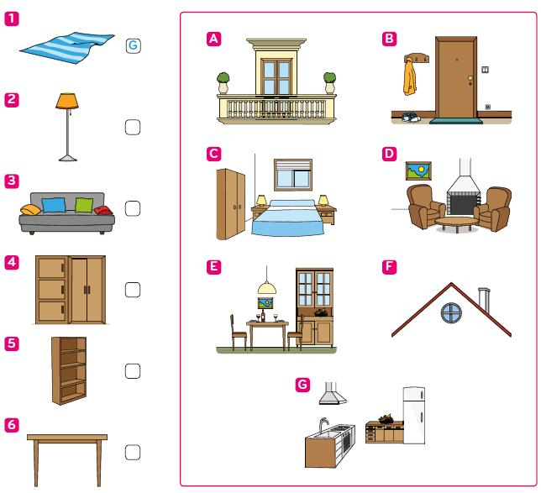
- Look and read. Then write the number in the box.
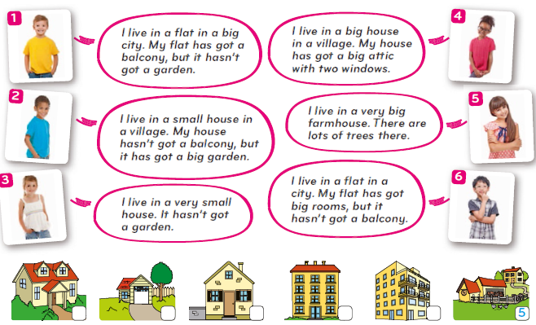

- Read the dialogue and choose the best answer.
Example: Hello, Jane. |  | a) Bye.  b) No, I’m not.  c) Hi, there.
1. How are you today? |  | a) I’m really happy.  b) I’m Ben’s sister.  c) I’m going to school.
2. Happy? Is it your birthday today? |  | a) Yes, I’ve got a brother.  b) No. I’ve got a new house.  c) Yes, I am.
3. Oh! Where’s your house? |  | a) No, that’s my house.  b) It’s that yellow one over there.  c) I like my home.
4. Is there a window in the attic? |  | a) Yes, there is.  b) No, there is.  c) Yes, I am.
5. Is your mum at home? |  | a) Yes, she is at school.  b) No, she hasn’t.  c) No, only my dad’s there.

- Look, read and write Yes or No.
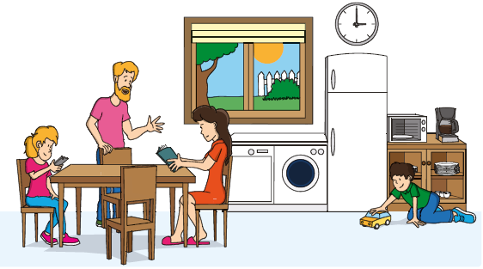
Example: The father is sitting next to the chair. No

- There is a clock above the fridge. ____________
- The mother is behind the chair. ____________
- There are fifive chairs. ____________
- There is a cupboard below the window. ____________
- The boy is playing in front of the cupboard. ____________

- Look at the picture and write one word in each space

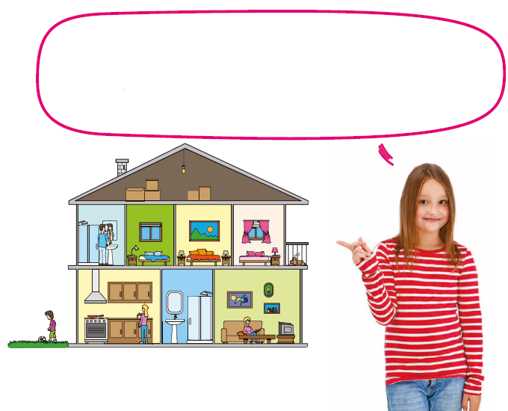

My name is Suzy. This is a picture of my house. I am in the (0) kitchen.
There are three (1) _________ upstairs where we sleep. My father is in the
(2) _________ brushing his teeth and my mother is in the (3) _________
on the sofa watching television. My brother is playing football in the
(4) _________ . My dog is sleeping on the (5) _________.

- Look at the picture. Read the questions and write one word.
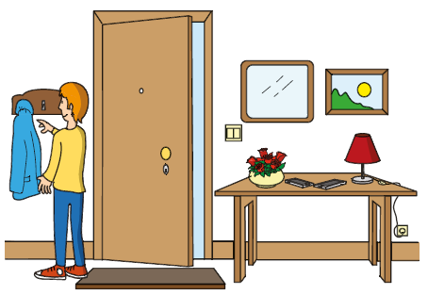
Example: Where are the phones? They are on the table.

- Where is the boy? He’s in the _________.
- How many phones are there? There are _________ phones.
- What can you see above the lamp? It’s a _________.
- Where are the flflowers? They’re below the _________.
- Where’s the mat? It’s in front of the _________.

- Read and complete the text.
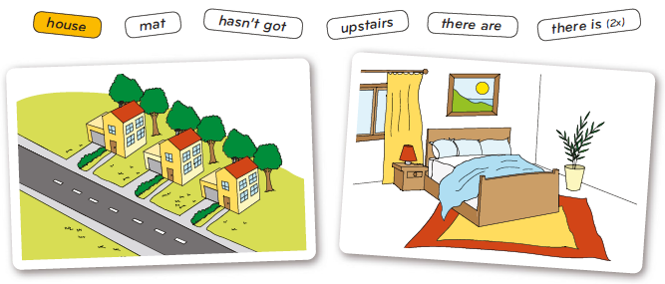
Example: This is a picture of my house.
(1)_________ three houses on my street. My house has got two floors, but it
(2)_________ a basement. (3) _________ a big garden behind my house and a
small garage next to the house. My house has got two bedrooms (4)_________.
My favourite room is my bedroom. (5) ______ a big (6) ______ under my bed.
There is a picture on the wall above my bed.

- Write a text about your house and your favourite room.
(20 to 30 words)

______________________________________________________________________________________________________________________________________________________________________________________________________________________________________________________________________________________________________________________________________________________

Well done!

