Name
UNIT 3 LOOKING GREAT! Test A
Date |  | Score |  | Teacher

Enc. de Educação
- Listen and tick ().
Example: Who is Peter’s father?

 | 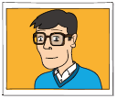 |  |  |  | 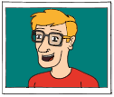
- What is Sarah wearing?
 |  |  |  |  | 
- Who is Tom?
 | 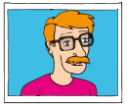 |  | 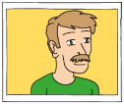 |  | 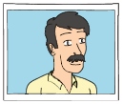
- Which is Lucy’s T-shirt?
 | 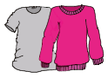 |  | 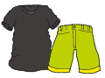 |  | 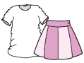
- What is Paul wearing?
 |  |  |  |  | 
- Whose hat is this?
 | John’s |  | Paul’s |  | David’s

- Look at the photos.
Listen and write a number in each box.
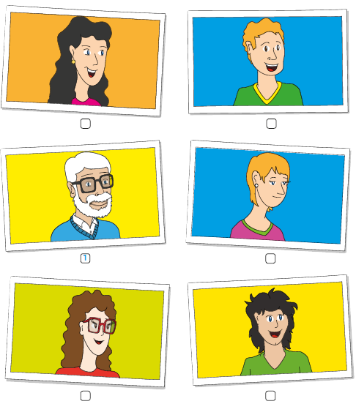

- Read the questions.
Listen and write one-word answers.

Example: Who is the tall boy? Jack.

- Whose sweater is this? It’s ____________.
- Who has got green eyes? _______________ .
- Which coat is Sally’s? The one ________.
- What is blue? Sally’s _________.
- Which girl has got curly hair? It’s ____________.

- Look and read. Then write the name.
1.
2.
3. | Emma
4.
5.
6.
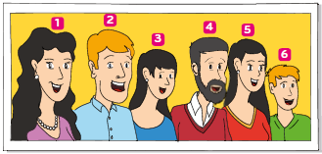
- John is Anne’s son. He’s got short fair hair.
- Emma’s got straight black hair. She’s Anne’s daughter.
- Uncle Bob has got short black hair.
- George is Emma and John’s dad. He’s got short fair hair.
- John and Emma’s uncle has got a beard.
- The woman with curly hair is John’s mother.
- John’s standing next to his aunt Grace.

- Read the dialogue between Michael and his mother.
Choose the best answer.

Example: Michael, where are you? |  | a) No, I’m not.  b) Yes, I have.  c) I’m here in the bedroom.
1. Michael, is this your coat? |  | a) Yes, it is, mum.  b) No. I’d like more bananas.  c) Yes, here you are.
2. So, hang it up! Your room is  a mess! |  | a) I’m sure.  b) OK, sorry!  c) This is your room.
3. Are these socks yours? |  | a) Yes, I am.  b) No, I haven’t.  c) No, they’re Lucy’s.
4.Where is she? |  | a) Yes, she is.  b) I don’t know, mum.  c) No, she hasn’t.
5. Are these your socks, Lucy? |  | a) Yes, they are.  b) Sorry. Time to tidy up!  c) He’s wearing it.

- Look, read and write True or False.

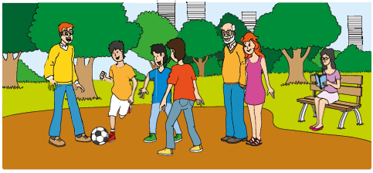

Example: The old man has got a moustache. True

- The girl is wearing a skirt. _______________
- There are two boys wearing trousers. _______________
- The mother has got blonde hair. _______________
- There is an old man next to the girl. _______________
- The mother is wearing glasses. _______________

- Read and complete the dialogue. Use the words in the box. Some words are not necessary.
Jane Tom, is this your T-shirt?
Tom No, it’s not (1)____________.
Jane Whose T-shirt is it?
my who
your her
what him
is Michael’s
are mine
yours
Tom It’s (2) ____________.
Jane (3) ____________ is Michael?
Tom Michael is that boy over there.
Jane (4) ____________ he wearing a jacket?
Tom No, that’s Peter. Michael is wearing a
sweater. And he’s the one wearing
glasses. Can you see (5) ____________?
Jane Oh! Yes, I can.

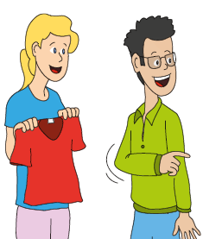

- Look at the picture. Read the questions and write one-word answers.
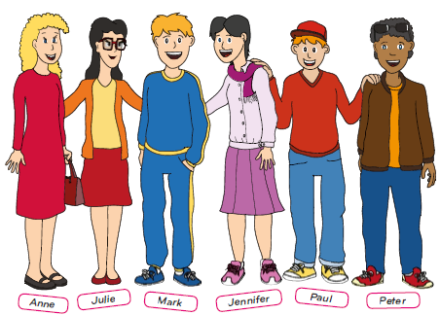

Example: Where are they? They are at school.

- Who’s wearing a scarf? ____________.
- Which girl has got long straight hair? ____________.
- What’s Anne wearing? She’s wearing a ______ and black shoes.
- What’s Paul wearing on his head? He’s wearing a ____________.
- What has Anne got in her hand? She’s got a ____________.

- Look at the picture and write three sentences about the girl.


Topics:
appearance/clothes

This is Amy. She is thirteen years old.
______________________________________
______________________________________
______________________________________
______________________________________
______________________________________

- Who is very important to you?
Write about this person.
(20 to 30 words)
- Say who he/she is (name; age; family/friend);
- Describe him/her (appearance; personality);
- Explain why he/she is important to you.
____________________________________________________________________________________________________________________________________________________________________________________________________________________________________________________________________________________________________________________________________________________________

Well done!

