Name
UNIT 4 HAVE A NICE DAY Test A
Date |  | Score |  | Teacher

Enc. de Educação
- Listen and draw a line.
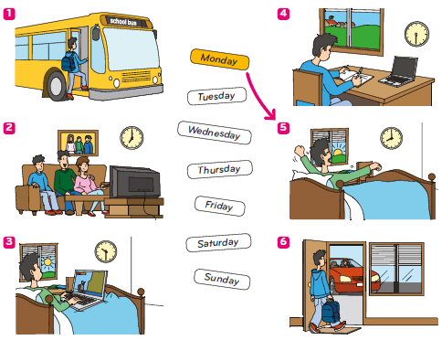
- Listen and tick ().
Example: What has Sam got to eat?

 |  |  |  |  | 
- Where is Sam?
 |  |  |  |  | 

- Who is Sarah?
 |  |  |  |  | 
- Who is John?
 |  |  | 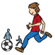 |  | 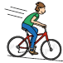
- What is Kate doing?
 |  |  |  |  | 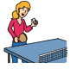
- Who is Emma?
 |  |  |  |  | 
- Read the questions.
Listen and write one-word answers.
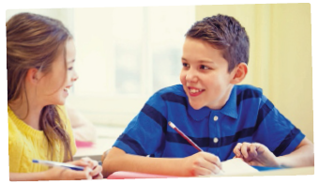

Example: What’s the girl’s name? Her name is Susan.

- Why is Paul happy? Because it’s Friday and he plays
_____________________________.
- Which is Paul’s favourite day of the week? His favourite day is ____________.
- How does Paul go home on Fridays? He goes home by ______________.
- Who’s picking Paul up? His __________________________.
- What does Paul do before tennis? He does his ___________________.

- Look and read. Then write the number in the box.
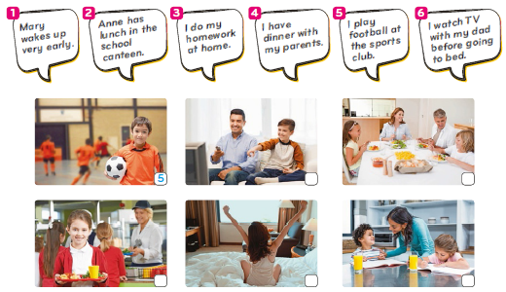

- Read the dialogue and choose the best answer.

Example: Hello! It’s Anna! |  | a) Yes, I am.  b) No, she doesn’t.  c) Hi, Anna!
1. Sorry to call so late. Can we talk? |  | a) Of course. What’s the matter?  b) Yes, he can.  c) I’m fifine, thank you.
2.What are you doing now? |  | a) I get up at six.  b) I do my homework every day.  c) I’m reading a book.
3. Is it homework? |  | a) No, I just like reading.  b) Yes, I do.  c) Yes, please.
4. I prefer playing computer games.  Do you like playing computer games? |  | a) Yes, I have.  b) Yes, I am.  c) Yes, I do.
5.Well, it’s ten now. I’m going to bed.  What time do you usually go to bed? |  | a) At half past ten.  b) After reading this chapter.  c) No, I don’t.

- Read the text about Michael’s father and write Yes or No.
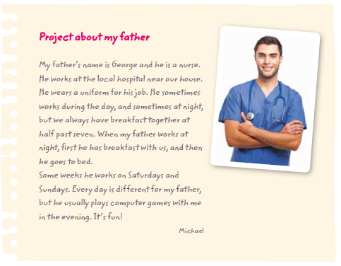
Example: Michael’s father is a teacher. No

- George always gets up at the same time. ____________
- Michael and his father have breakfast at 7:30. ____________
- George always works on Saturdays and Sundays. ____________
- Every day is the same for George. ____________
- Michael’s father never plays computer games with him. ____________



- Read the text and write the correct word.
is have
does wakes
house dinner
usually goes
doesn’t her
bed

What a girl!

Nadine’s story is typical to most Burkinabe girls, in
Africa.
Nadine (0) is 12 years old and she is in the 5th grade.
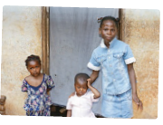
She (1) _________ up at 4 am every day to clean her
small (2)_________ before her father wakes up. Then
she goes outside to get water for (3)_________
family. She then prepares breakfast. Her brothers and
sisters (4)_________ breakfast fifirst and then Nadine
eats a little. After washing up, she (5)__________ to
school by bike. It takes her 20 minutes to get there.
She (6)_________ arrives just in time.
When she arrives home in the evening, they have
(7)______ together and Nadine washes the dishes. By this time it’s already dark.
Nadine’s family (8)_______ have electricity, so she uses a candle, and she quickly
(9)________ her homework and studies. She goes to (10)________ at nine and
wakes up a few hours later to start the whole cycle all over again.
Dictionary: candle – vela

- Look at the picture. Answer the questions with one-word answers.
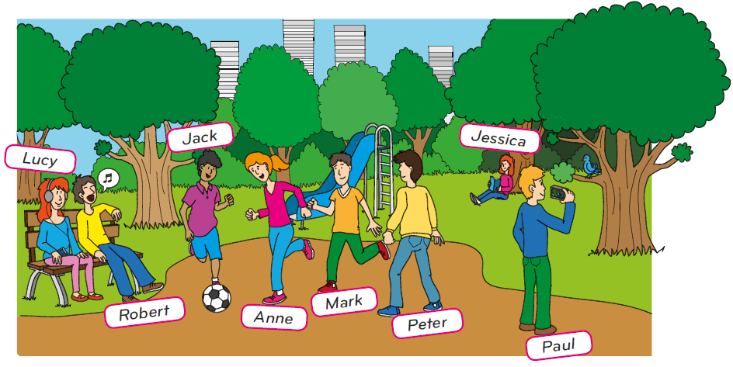
Example: Where are they? They’re in the park.
- Who is reading a book? _________.
- How many children are playing football? There are _________ children.
- What is Lucy doing? She’s _________ to music.
- Who is taking photos? _________.
- What is Robert doing? He’s _________.

- Read the questions and answer.

Example: Have you got any brothers or sisters? Yes, I have.

- What time do you get up? _________________
- How do you go to school? _________________
- Do you watch TV in the morning? _________________
- Does your best friend have lunch with you? _________________
- What do you do in the evening? _________________
- Do you like dancing? _________________
- Are you playing the guitar now? _________________
- What are you doing now? _________________
- What do you like doing in your free time? _________________
- What do you like doing after dinner? _________________

- What’s your favourite day?
Write a text about what you do on your favourite day.
(20 to 30 words)
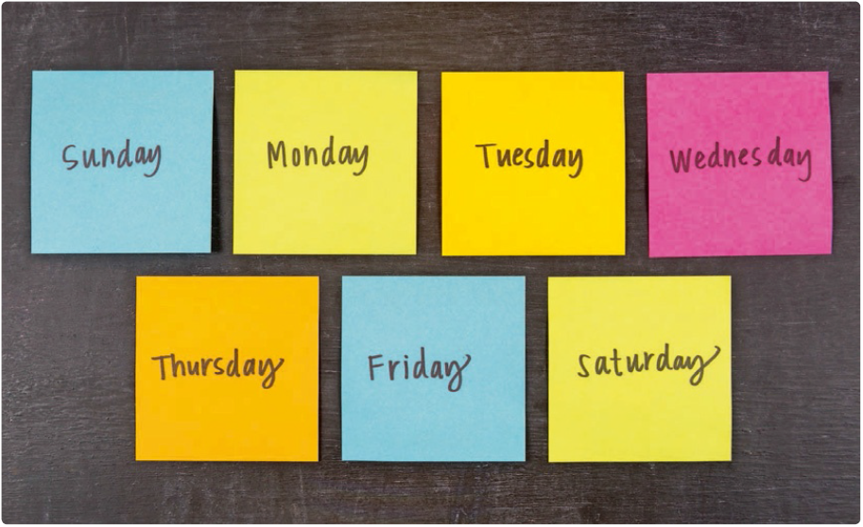
____________________________________________________________________________________________________________________________________________________________________________________________________________________________________________________________________________________________________________________________________________________________

Well done!

