Name
UNIT 5 LET’S PARTY Test A
Date |  | Score |  | Teacher

Enc. de Educação
- Listen and tick ().
Example: What’s Anne favourite drink?

 |  |  | 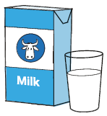 |  | 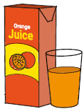
- Who is Mary?
 | 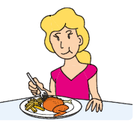 |  |  |  | 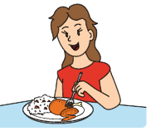
- What does Harry eat for lunch?
 | 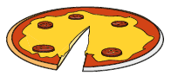 |  | 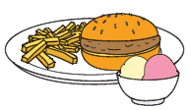 |  | 
- What’s Jack’s favourite food?
 | 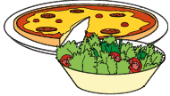 |  | 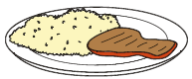 |  | 
- Which is Sarah’s favourite ice cream?
 |  |  |  |  | 

- What does Peter’s mum need?
 | 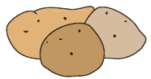 |  | 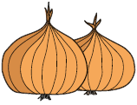 |  | 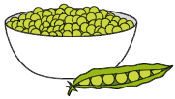

- What does each person buy?
Listen and write a letter in each box.
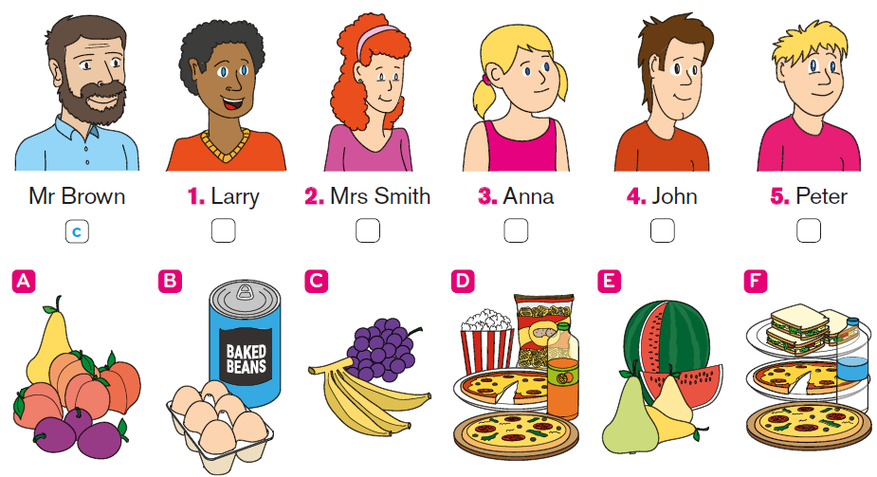

- Read the questions.
Listen and write one-word answers.

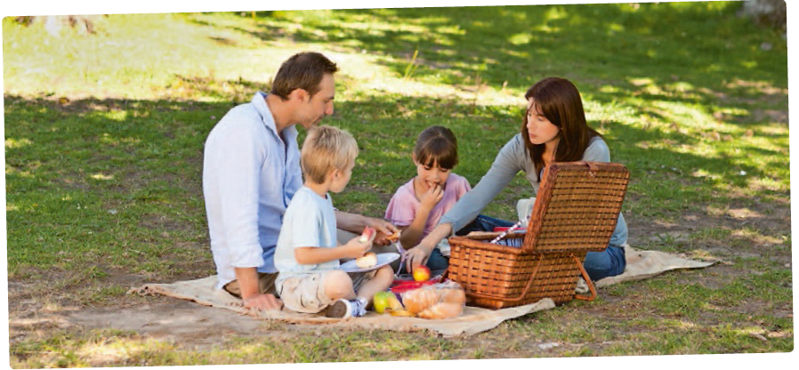

Example: What time is it? It’s one o’clock.

- Who is hungry? It’s _________________.
- How many sandwiches are there? There are __________ sandwiches.
- What does the boy drink? He drinks _________________.
- Which fruit does the girl want? She wants a _________________.
- What’s in the paper box? It’s a _________________.

- Look and read. Then circle the correct option.

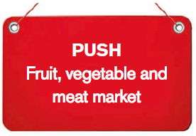
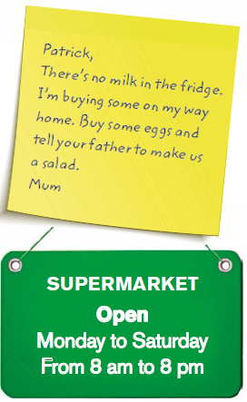
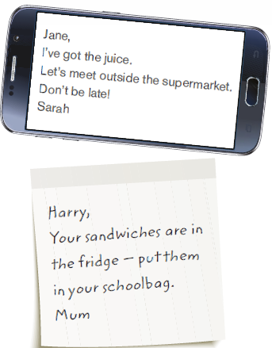
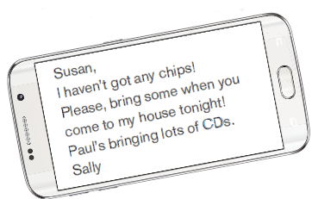

e.g. Which one is correct?

a) Pull to get into the supermarket.
b) You can buy food here.
c) There isn’t any fruit here.

- Patrick’s mum wants him to get some…

a) salad
b) milk
c) eggs

- The supermarket…

a) is open every day.
b) opens at nine.
c) is closed on Sundays.

- The text message says:

a) There isn’t any juice left.
b) Jane has got the juice.
c) They don’t need to buy juice.

- What is Harry’s mum telling him to do?

a) Make sandwiches for lunch.
b) Take the sandwiches with him.
c) Put the sandwiches in the fridge.

- Sally is contacting Susan because she…

a) wants Susan to bring food with her tonight.
b) is inviting her to her house.
c) wants Susan to bring some music for tonight.

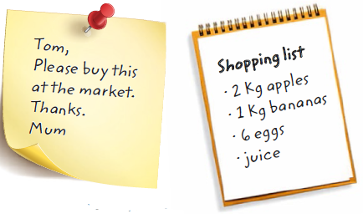
- Tom is at the market with a
shopping list. Read the dialogue
and choose the best answer.

Example: Hi, can I help you? |  | a) No. I’m not sure.  b) Yes, please. I’d like two kilos of apples.  c) That’s a great help.
1. Here you are. Anything else? |  | a) No. I’d like more bananas.  b) I also need some bananas.  c) Yes, here you are.
2. How many do you want? |  | a) I’m 15.  b) Yes, I do.  c) Let’s see… one kilo, please!
3. Right. What about this cheese? |  | a) Yes, I do.  b) Let’s go to the market.  c) No, it’s not on the list.
4. Is that all? |  | a) I’m not sure. Let me check the list.  b) No, there isn’t.  c) Yes, he is.
5. Do you want a watermelon?  It’s on special today! |  | a) This is my shopping list.  b) Yes, they do.  c) How much is it?

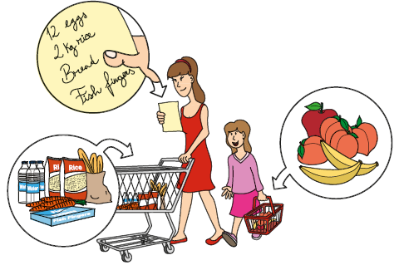
- Look, read and write
True or False.

Example: They are in the supermarket. True

- The girl hasn’t got any apples in her basket. __________
- There are four peaches in the basket. __________
- There are some carrots in the shopping cart. __________
- There isn’t any bread on the shopping list. __________
- There is meat in the shopping cart. __________
- Read the text and complete it with the correct words from the box.
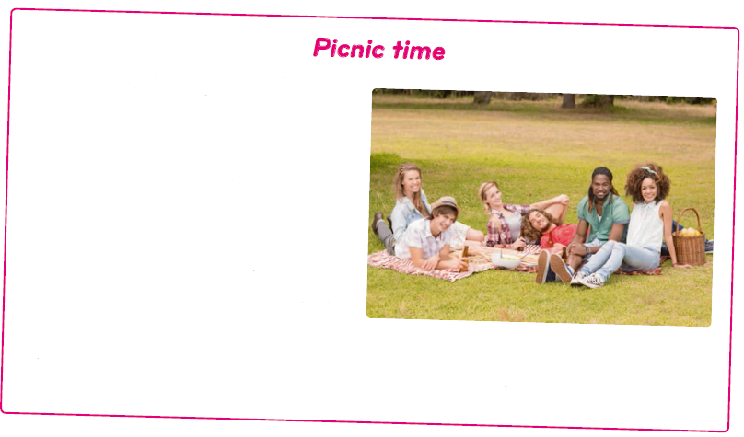
Picnics (0) are always fun. We can
have (1)__________ at the picnic the
beach or in the park.
We can make (2)__________ ham
and cheese sandwiches, but chicken
sandwiches are my favourite. We
always take fruit on picnics like
mangos, (3)__________ or bananas.
But I don’t usually eat
(4) __________ fruit. Many people like to take burgers and crisps.
People usually take (5)__________, lemonade or orange juice to drink.

- Look at the picture. Read the questions and write two-word answers.
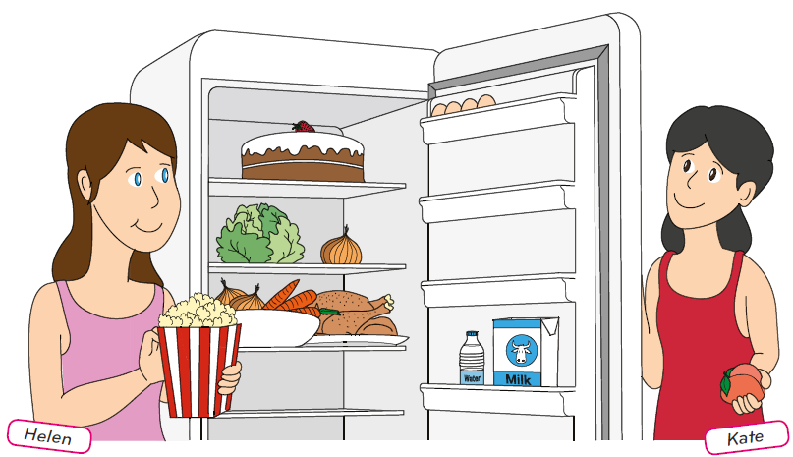

Example: Where is the milk? It’s next to the water.

- What is Kate holding? She’s holding __________.
- How many carrots are there? There __________ carrots in the fridge.
- What’s above the chicken? It’s __________.
- What’s Helen eating? She is __________.
- Where’s the strawberry? It’s on __________.
- It’s your birthday on Saturday. Write a card inviting a friend.
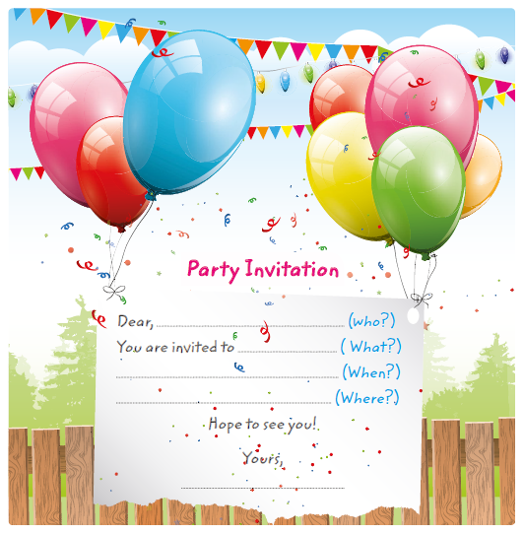

- Some of your friends are coming to your house to watch a film.
Write a note to your mum.
(20 to 30 words)
- Ask her to add three things to the shopping list;
- Explain why.
