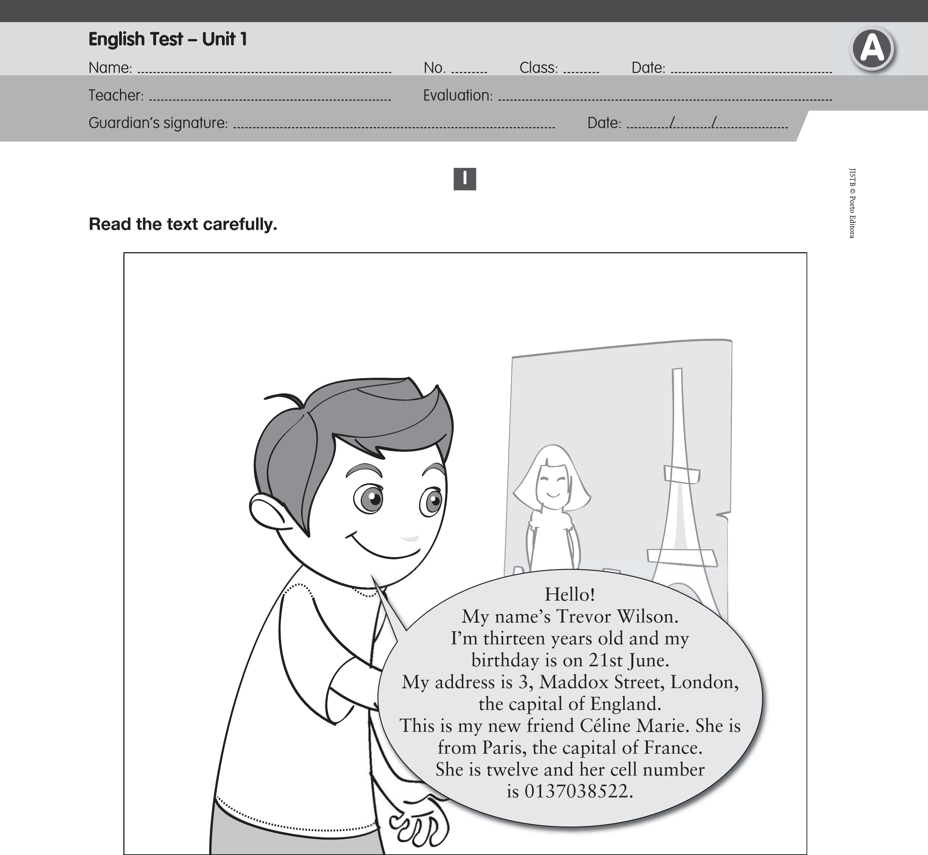
Answer about the text.

- True (T) or false (F)?
  - Trevor is English. 3. Céline is from England.
2. He is thirteen. 4. Her surname is Marie.

- Answer the questions.

1.
How old is Trevor?
2.
What’s his address?
3.
Is he Portuguese?
4.
Is Céline from Paris?
5.
What’s her cell number?

II

A. Write the cardinal numbers in full.
12 21 35 47
54 68 90 100

B. Complete the grid.

Country |  | Nationality
Australia
 | English
France
Portugal

III

A. Ask Céline questions.
1. ? My first name is Céline.
2. ? I’m twelve years old.
3. ? It’s 0137038522.

B. Fill in the gaps with the prepositions: in / on.
- My birthday is ………… February.
- The English test is ………… Monday.
- Christmas is ………… 25th December.
- The name of the film is “Football ………… 2025”.

Complete the sentences. Use the verb “To be”.
- ………… you ten years old? No, I ………… .
- We are from Australia. We ………… from China.
- She ………… Brazilian and he ………… Portuguese.
- How old ………… they?

D. Fill in the gaps with the possessive adjectives.
- She is Betty. ………… surname is Stuart.
- Carlos is Portuguese. ………… flag is green, red and yellow.
- We are Russian. ………… teacher is Russian too.
- I’m Tom and ………… surname is Bolton.








JI5TB © Porto Editora
Complete Lakshima’s balloon. Write complete sentences.
IV
Name: Lakshima
Age: 14
Country: India
Nationality: Indian
Address: 16, Ring Road, Delhi
Phone number: 7724197508
V
Hi, everybody!
My

Listening Exercises

A. Tick the correct answer. B. Circle the numbers you hear.
a. Fourteen.
a. 1st / 11th / 31st
b. 15 / 5 / 25
c. 2nd / 12th / 42nd
Fine, thanks.

b. No, I’m not.
I am thirteen years old.

c. She is Indian.
She is French.

C. Write the words you hear.

a. …………………………  D. Write the letters you hear. | b. ……………………… | c. …………………………
a. ………………………… | b. ……………………… | c. …………………………

Good work!
Your English teacher

