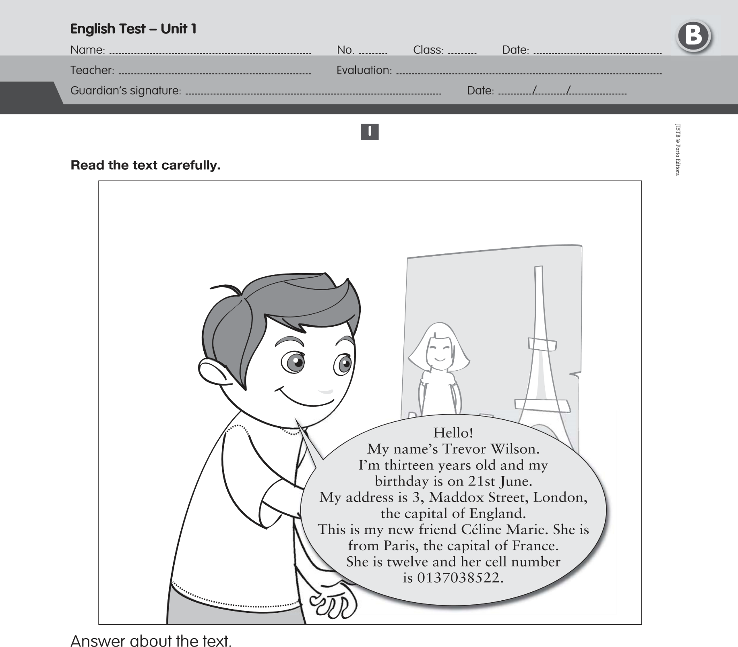
Answer about the text.

A. True (T) or false (F)?

1. Trevor is English. 3. Céline is from England.
2. He is thirteen. 4. Her surname is Marie.

B. Choose the correct answer.
1. How old is Trevor?
a) He is three. b) He is thirty. c) He is thirteen.
2. What’s his address?
a) It’s 3, Maddox Street. b) It’s 3 London Street. c) Yes, it is.
3. Is he Portuguese?
a) Yes, he is. b) He is English. c) No, he isn’t.
4. Is Céline from Paris?
a) No, she isn’t. b) Yes, she is. c) She is from Paris.
5. What’s her cell number?
a) It’s 3, Maddox Street. b) It’s 0137038522. c) No, it isn’t.
II
- Match the numbers with the words.
12 • • ninety
21 • • twenty-one
35 • • thirty-five
47 • • sixty-eight
54 • • one hundred
68 • • twelve
90 • • forty-seven
100 • • fifty-four
B. Complete the grid.
-ish -ese -ian -an

Country | Nationality
Australia | Austral
England | Engl
China | Chin
Portugal | Portugu
III
A. Ask Céline questions.
1. What’s your ………………………………………..…………………? My first name is Céline.
2. How …………………………………………………………..… are you? I’m twelve years old.
3. …………………………………………………… your cell phone number? It’s 0137038522.

B. Fill in the gaps with the prepositions: in / on.

1. My birthday is ……… February.
2. The English test is …...…. Monday.
3. Christmas is ……... 25th December.
4. The name of the film is “Football …….... 2025”.

C. Complete the sentences with: am not / are / is / aren’t / are / is.
- ………..... you ten years old? No, I ………..... .
- We are from Australia. We ……………. from China.
- She ………..... Brazilian and he ………..... Danish.
- How old ………..... they?

D. Fill in the gaps with: his / her / my / our.
- She is Betty. ………..... surname is Stuart.
- Carlos is Brazilian. ………..... flag is green, blue, white and yellow.
- We are Russian. ………..... teacher is Russian too.
- I’m Tom and ………..... surname is Bolton.







Complete Lakshima’s balloon. Write complete sentences.
IV
Name: Lakshima
Age: 14
Country: India
Nationality: Indian
Address: 16, Ring Road, Delhi
Phone number: 7724197508
Hi, everybody!
My name is
and I’m
years
I’m from
I am
. My address is
and my
phone number
.
V
Listening Exercises

A. Tick the correct answer. B. Circle the numbers you hear.
a. Fourteen.
a. 1st / 11th / 31st
b. 15 / 5 / 25
c. 2nd / 12th / 42nd
Fine, thanks.

b. No, I’m not.
I am thirteen years old.

c. She is Indian.
She is French.

C. Write the words you hear.

a. ………………………….  D. Write the letters you hear. | b.…………………………. | c. ………………………….
a.…………………………. | b. ………………………. | c. ………………………….

Good work!
Your English teacher

