I
Read the text carefully.
/
/
Date:
Class:
No.
tion:
Evalu
/
/
Date:
English Test – Unit 2
Name:
No.
Class:
Date:
Teacher:
Evaluation:
Guardian’s signature:
Date
:
A
/
/
I
 |   This is the Bennett family. Tom Bennet is twelve years old and his sister Erika is eleven. They are students at Cardiff High School. They are from Cardiff, the capital of Wales. Kelly and Paul are their parents and Grace is their grandmother.  Grace is fifty-five years old and she is a teacher.  Paul is tall and he has got big blue eyes. He is an architect.  Kelly is short and slim. She is a photographer and today, she has got a famous singer in her photo studio: Alicia Keys.  Alicia has got long brown hair and brown eyes. She is slim and medium-height. She is wearing white jeans, a yellow top and pink shoes. She is really beautiful and a very nice person too!

Answer according to the text.
- True (T) or false (F)?
  - Tom is English. 4. Tom’s mother is short and slim.
  - Erika is the daughter. 5. Alicia Keys is ugly.
  - Kelly is a singer.
- Complete the family tree.
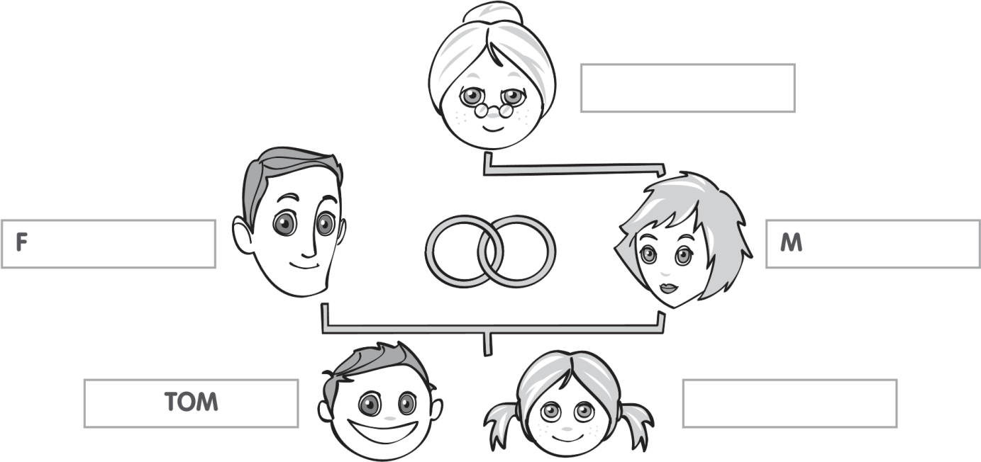
C.
Answer the questions.
1.
Where are Tom and Erika from?
2.
Who is Grace?
3.
What’s her job?
.
4
What’s Paul like?
5.
Has Tom got a sister?
6.
What is Alicia Keys wearing?
II
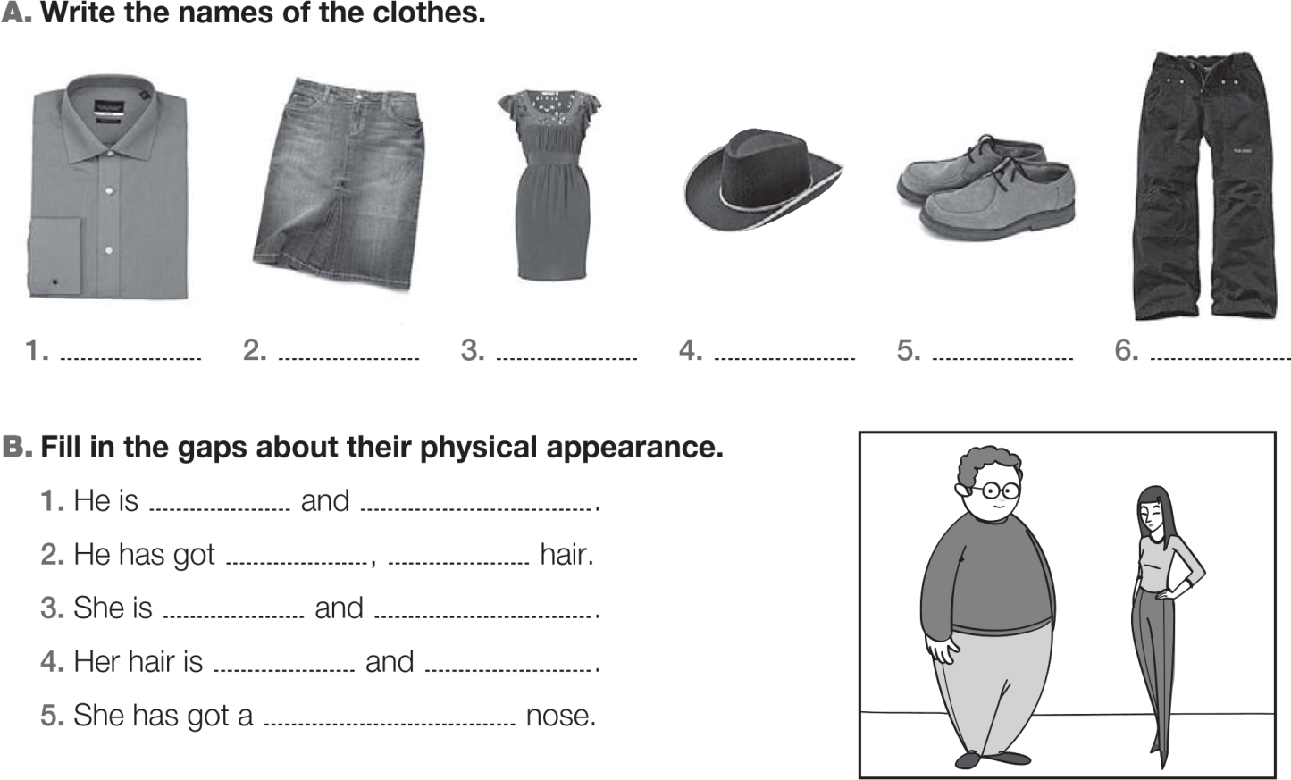
III
A. Complete with the / a / an or X.
1. Alicia Keys is from United States.
2. He is engineer.

3. She is hairdresser and they are police officers.

B. Fill in the gaps with the verb have got.
 | √ | X
Tom | guitar / CDs | dress
Erika | guitar / game | crocs
1.
Tom
a guitar and CDs but he
a dress.
2.
Erika
any crocs.
3.
They
guitars.
4.
you
.
a game, Erika? Yes, I

C. Rewrite the sentences and put the adjectives in the correct place.
- She has got a dress. (red)
- They are jeans. (blue)

D. Write sentences. Use and or but.
Anne | fat √ | short √
Paul | anorak √ | hat x

- Anne
- Paul
IV
Write a small text about yourself. Mention your name, age, two family members and their appearance.

