
I
/
/
Date:
Class:
No.
tion:
Evalu
/
/
Date:
English Test – Unit 2
Name:
No.
Class:
Date:
Teacher:
Evaluation:
Guardian’s signature:
Date
:
B
/
/
I
Read the text carefully.
 |   This is the Bennett family. Tom Bennet is twelve years old and his sister Erika is eleven. They are students at Cardiff High School. They are from Cardiff, the capital of Wales. Kelly and Paul are their parents and Grace is their grandmother.  Grace is fifty-five years old and she is a teacher.  Paul is tall and he has got big blue eyes. He is an architect.  Kelly is short and slim. She is a photographer and today, she has got a famous singer in her photo studio: Alicia Keys.  Alicia has got long brown hair and brown eyes. She is slim and medium-height. She is wearing white jeans, a yellow top and pink shoes. She is really beautiful and a very nice person too!

Answer according to the text.
- True (T) or false (F)?
  - Tom is English. 4. Tom’s mother is short and slim.
  - Erika is the daughter. 5. Alicia Keys is ugly.
  - Kelly is a singer.
- Complete the family tree.
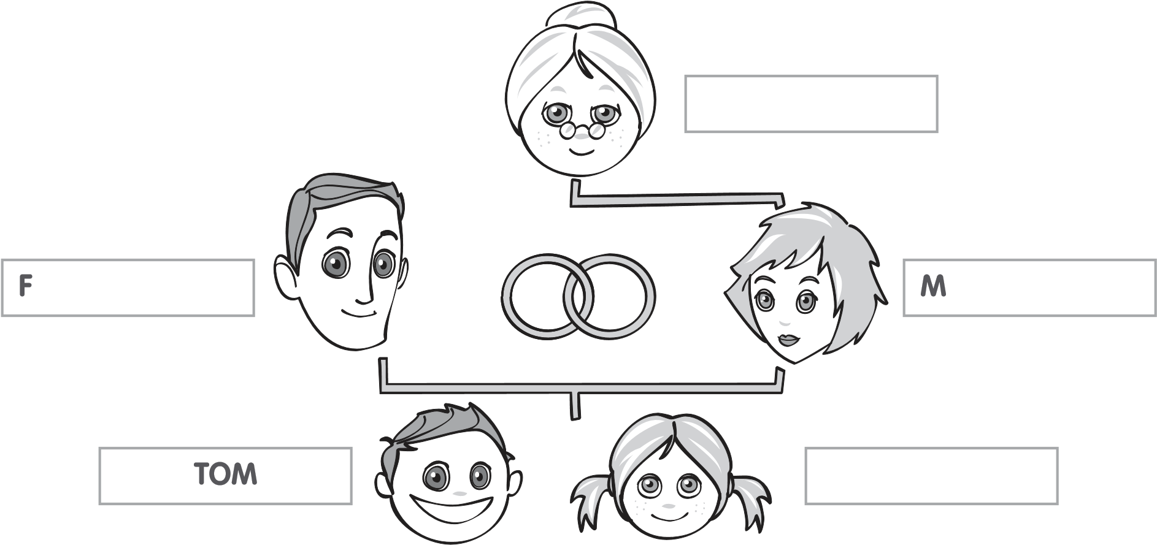

- Circle the correct answer.
1. Where are Tom and Erika from?
a) They are from Wales. b) They are from England. c) He is from Wales.
2. Who is Grace?
a) She is the mother. b) She is the sister. c) She is the grandmother.
3. What’s her job?
a) Grace is a teacher. b) Grace is a photographer. c) She is a singer.
4. What does Paul look like?
a) He is short. b) Paul is fat. c) He is tall.
5. Has Tom got a sister?
a) No, he hasn’t. b) He has a sister. c) Yes, he has.
6. What is Alicia Keys wearing?
a) She is wearing jeans. b) She is beautiful. c) She is wearing shoes.
II
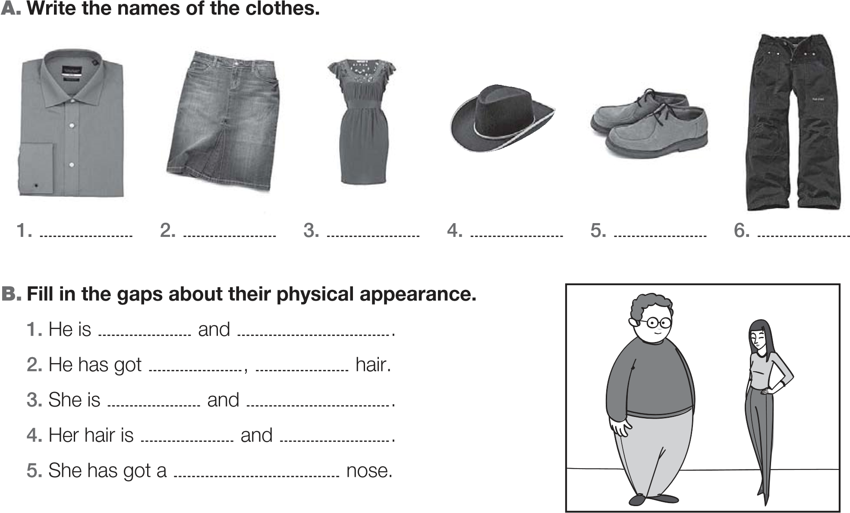
tall short medium-height fat thin straight curly big dark

III
tall medium-height fat thin straight curly big dark
A. Complete with the / a / an or X.
1. Alicia Keys is from United States.
2. He is engineer.

3. She is hairdresser and they are police officers.

B. Fill in the gaps with: have / got / have got / has got / hasn’t got
1.
Tom
a guitar and CDs but he
a dress.
2.
Erika
any crocs.
3.
They
guitars.
4.
you
.
a game, Erika? Yes, I
 | √ | X
Tom | guitar / CDs | dress
Erika | guitar / game | crocs

C. Rewrite the sentences and put the adjectives in the correct place.
- She has got dungarees. (red)
- They are jeans. (blue)

D. Write sentences. Use and or but.
Anne | fat √ | short √
Paul | anorak √ | hat x

- Anne is fat ……………. short.
- Paul has got an anorak ……………. he hasn’t got a hat.
IV
Complete the text about yourself. Mention your name, age, two family members and their appearance.

My name ……………………… and I am …………………………… years …………………………… .
This is my family. He is my …………………… . He is ………………… and ………………………… .
She is my ………………………. . She is …………………………… and ……………………………. .

V
Listening Exercises




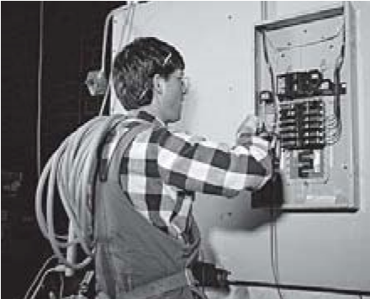


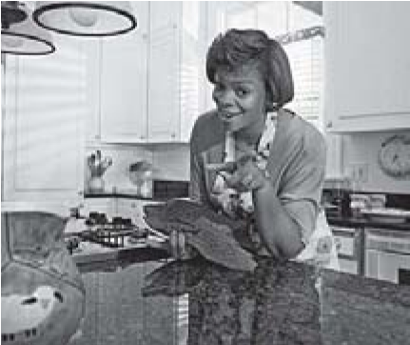



A. Tick according to what you hear. B. Number according to the sequence you
hear.
The monster has got – tick √
The monster hasn’t got – mark X
straight hair
hands
three arms
one leg
two feet
three eyes
one mouth
Good work!
Your English teacher

