I
Read the text carefully.
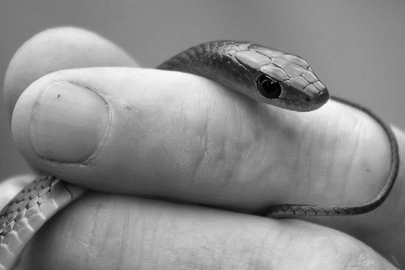

Kaly: Hi Scott! This is my friend Jamie. He is in our team.
Scott: Nice to meet you and welcome to the competition Jamie!
Jamie: Nice to meet you too!
Scott: Where is your friend Angie?
Kaly: She is in the music room. Music is her favourite subject.
Scott: What’s your favourite subject Jamie?
Jamie: It is Physical Education.
Scott: My favourite subject is Science. Our school laboratory is amazing!
Kaly: Really? What’s in the laboratory?
Scott: There are many wild animals: three big snakes, sharks, lions…
Jamie: Are there any giraffes?
Scott: No, there aren’t. They are in the zoo!!
Kaly: Are there any pets at your house Jamie?
Jamie: Yes, of course! In my garden there are rabbits, parrots and a black dog.
Kaly: Where is the laboratory Scott?
Scott: It’s near the music room. Let’s visit the laboratory?
Jamie: Yeah!

Vocabulary Check!
amazing – fantástico
Let’s visit – Vamos visitar

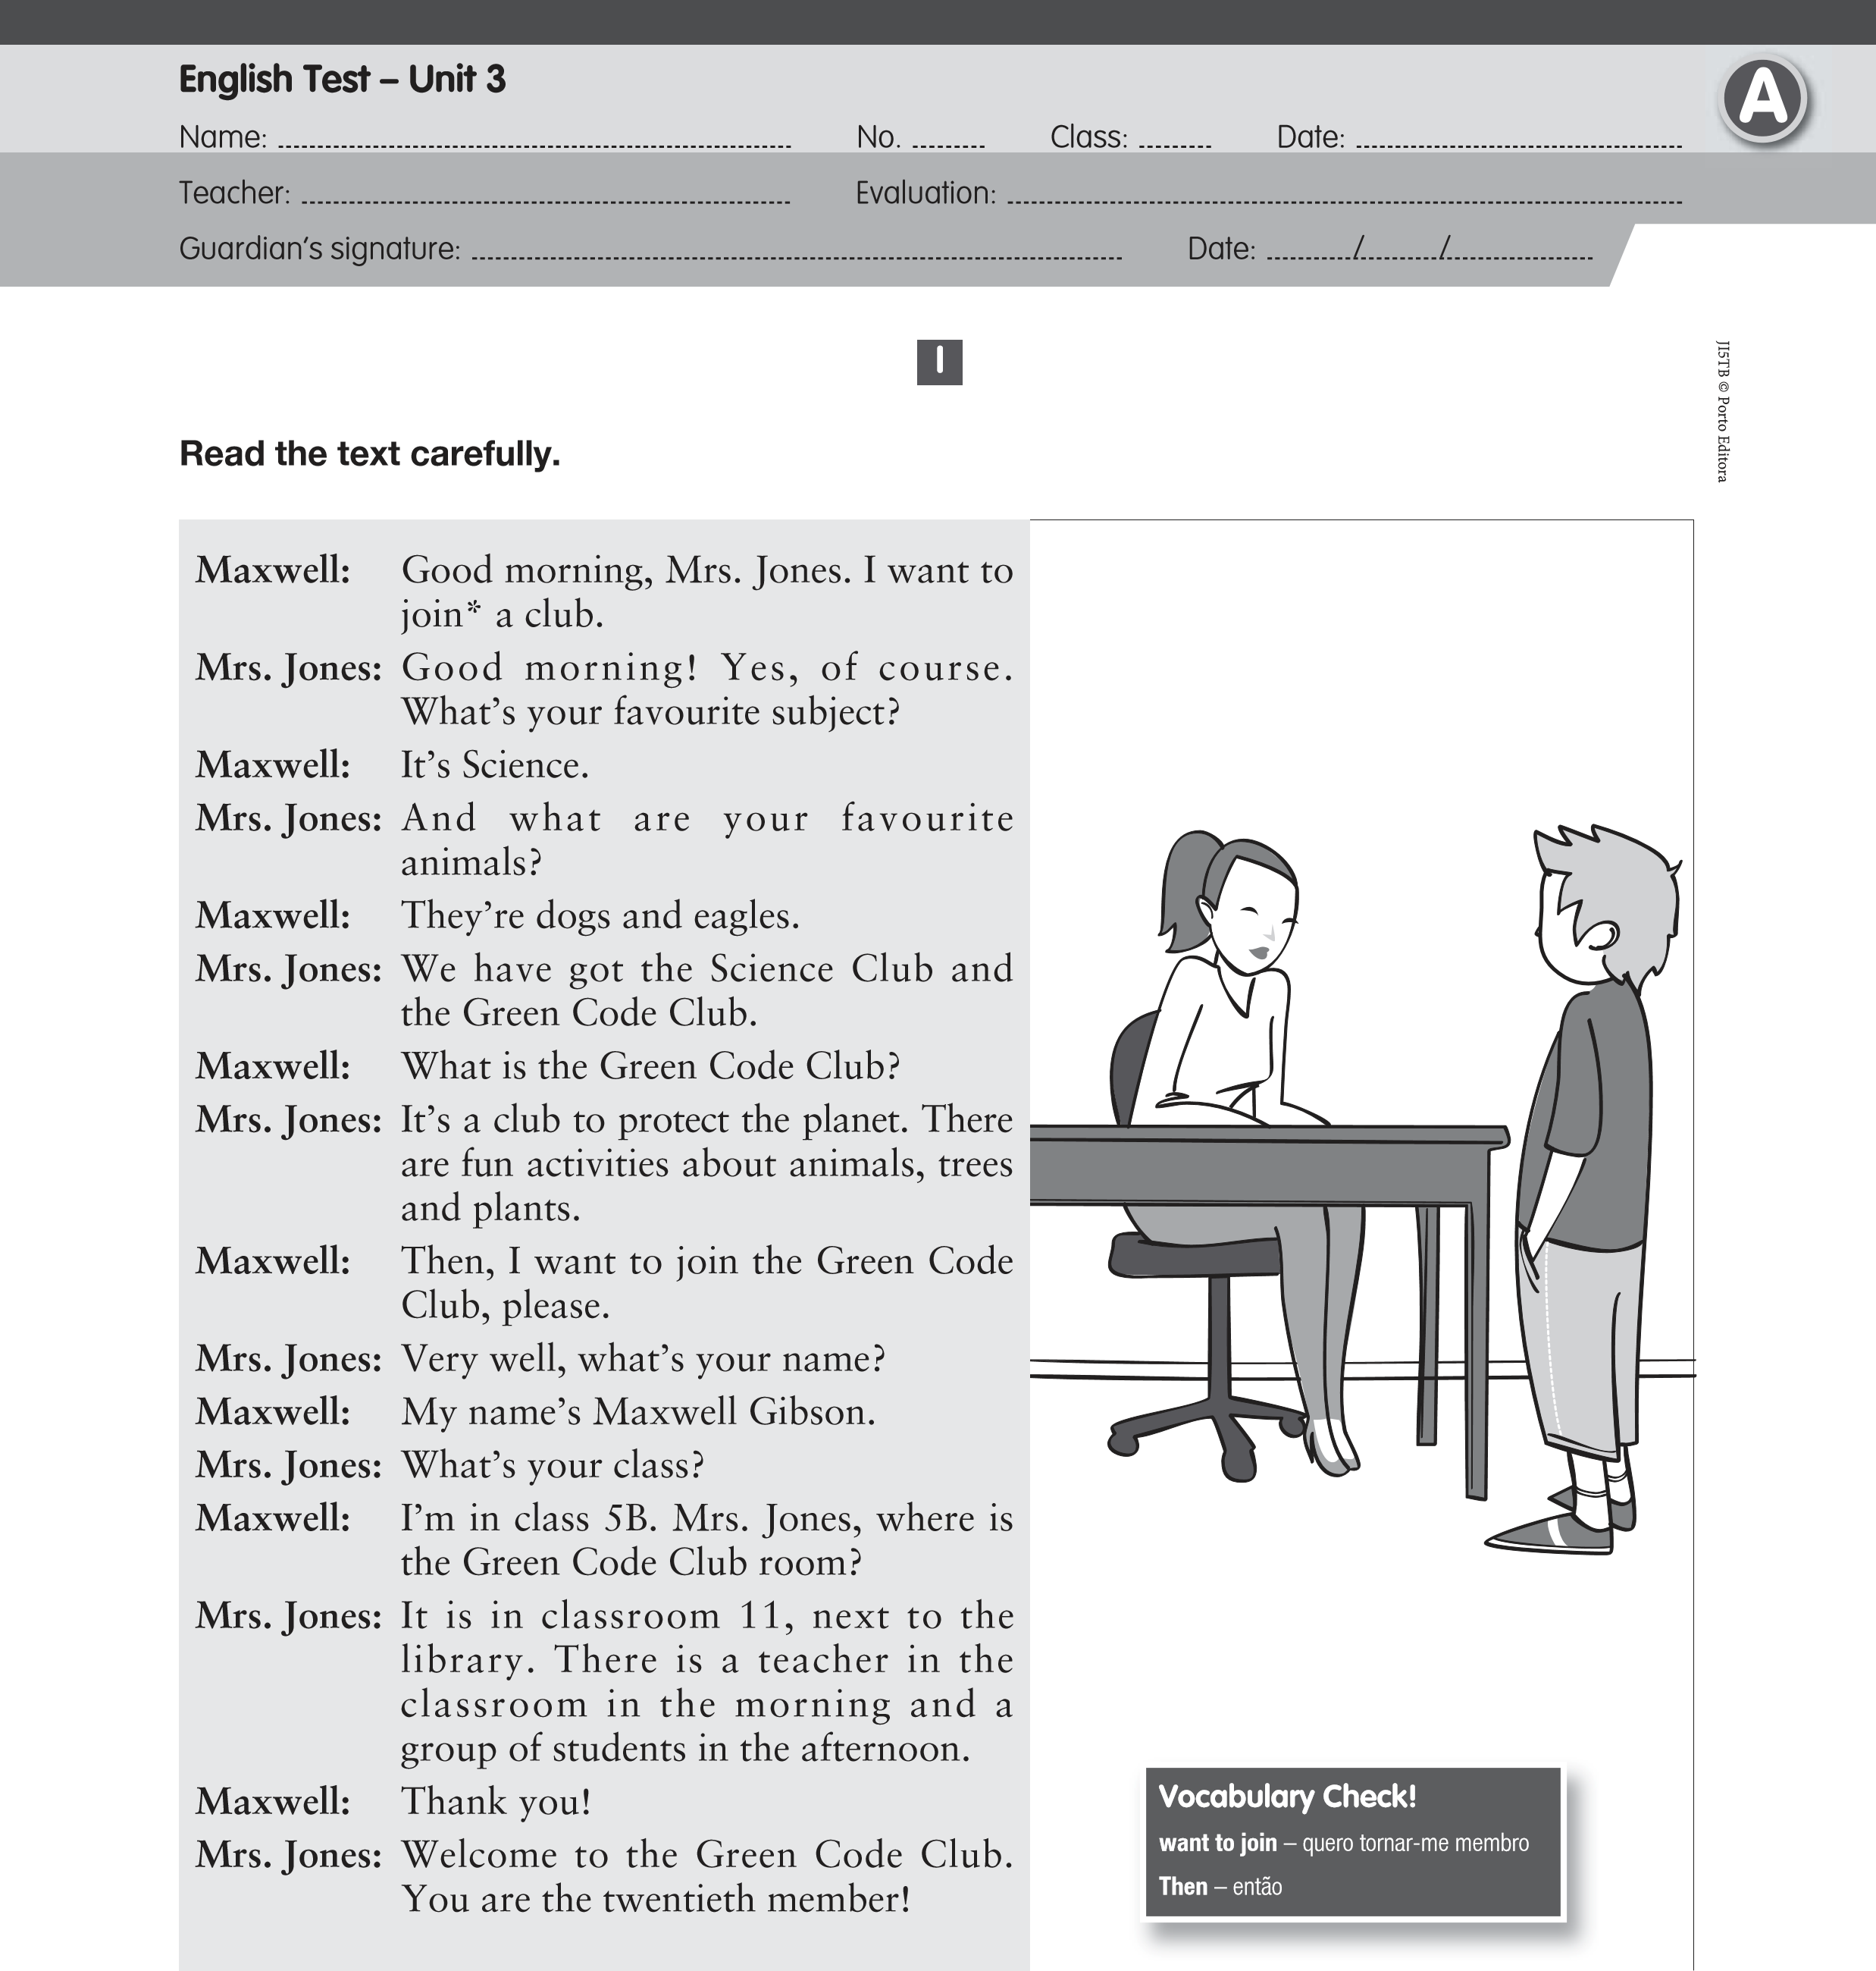
Now, answer about the text.

A. Complete the sentences with one word from the text.
1. There are .......................... animals in the laboratory.
2. Jamie has got one .......................... .
3. The ....................... are in the zoo.
4. There are rabbits in the .......................... .
5. The snakes are .......................... .

B. Answer the questions.
- Who is Jamie? …………………………………………………………………………………
- What’s his favourite subject? …………………………......……………………….…………
- Where is Angie? ……………………………………...........................................................
- Are there any dogs in the laboratory? …………………....................................................
- How many snakes are there in the laboratory? ..............................................................
C. Ask questions.
- .......................................................? Her favourite subject is Music.
- .......................................................? His favourite animal is the rabbit.
- .......................................................? They are in the laboratory.

II
A. Name the animals. B. Complete the crossword with classroom objects.
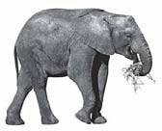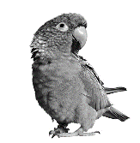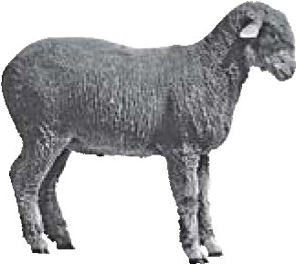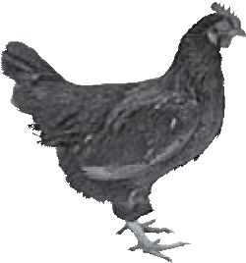
3.
6.
2.
5.
1.
4.
1
2
3
4
5
7
6

III
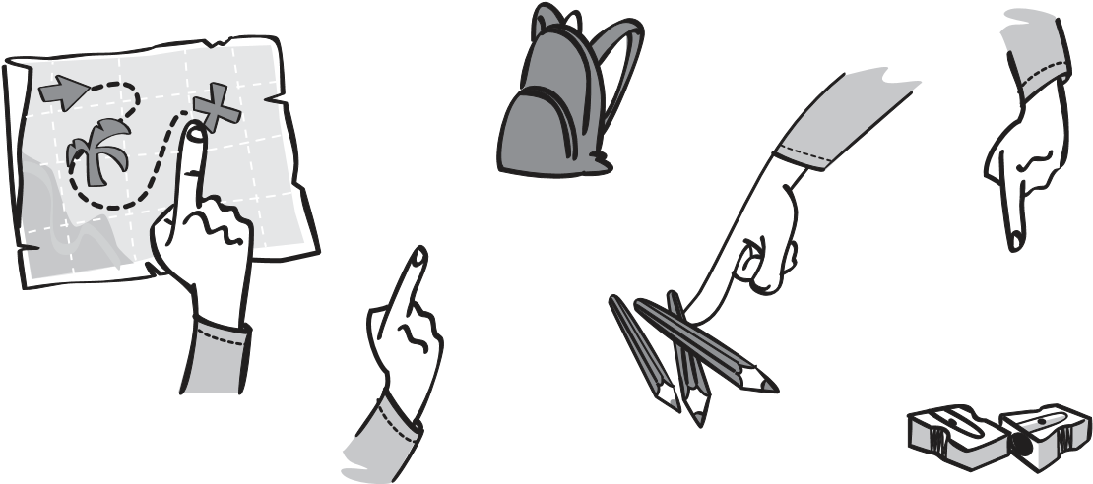
- Complete with this / these / that / those.
1. is a map.
2. is a schoolbag.
3. are crayons.
4. are pencil sharpeners.
- Use the verb there to be.
    - ……………………….. a book in the schoolbag.
    - ……………………….. three pencils on the table.
    - ……………………….. any snakes in the school? No, ……………………….. .
- Ask questions. Use “How many”.
1. ? I have got a hamster.
2. ? There aren’t any scissors.
3. ? There are two chinchillas.
IV
Answer about yourself.
    - What’s your favourite subject?
    - Have you got a pet?
    - Is there a laboratory in your school?
    - How many music rooms are there in your school?

V

Listening Exercises
A. Number the objects according to the sequence you hear.







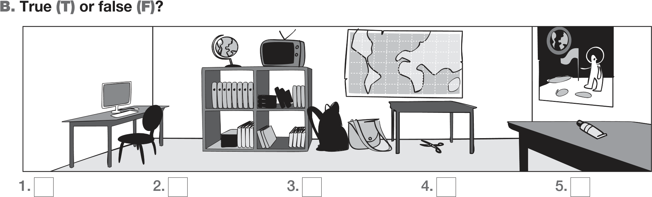

Good work!
Your English teacher

