
I
English Test – Unit 4
Name:
Date:
Class:
No.
Teacher:
Evaluation:
Guardian’s signature:
Date:
A
/
/
I
Read the text carefully.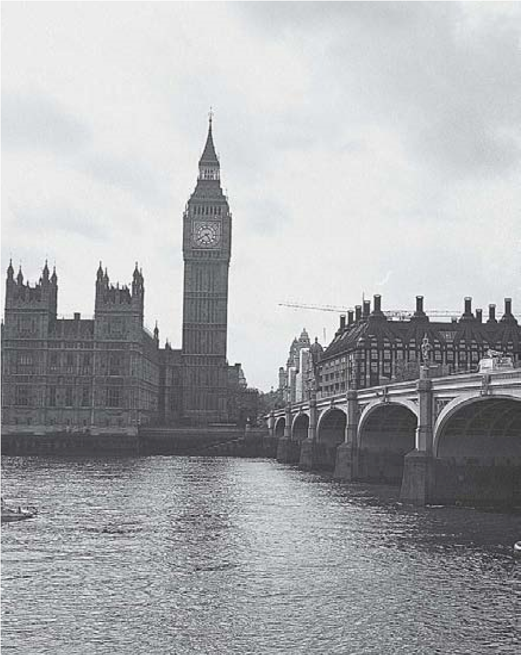
Dear mum and dad,
How are you? I’m fine. London is a beautiful
city with large parks.
I am in the City of London School. It is a big
school next to the river Thames. In this school
there are fifty classrooms, three libraries and a
lovely garden, of course. I like the school canteen.
The food is delicious.
My bedroom is very modern. There is a big
yellow bed, three blue rugs and a lamp but there
isn’t a television set.
I have got some new friends, a Portuguese student,
called Angie, an Ukrainian girl, Kalyna, and Scott, an
English boy. Kalyna doesn’t like fruit and Scott is a
veggie. He doesn’t like steak.
Love,
Jamie
Answer about the text.
A.
Correct the sentences.
1
.
Jamie is not fine.
2.
In the school there are five classrooms.
3
.
The school is near the river Thames.
4
.
Her bedroom is very modern.

- Answer the questions.

1.
Where is Jamie?
2.
Does he like the school canteen?
3
.
How many libraries are there?
4
.
Has he got new friends?
5.
Who is Angie?
6.
Whose bedroom is it?
- Ask questions.
1. ? It’s Jamie’s school.
2. ? There is a lovely garden.
3. ? No, she doesn’t like fruit.
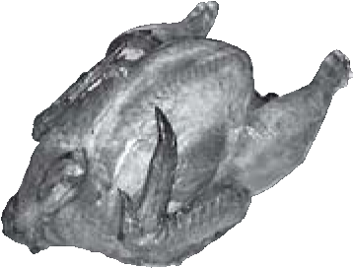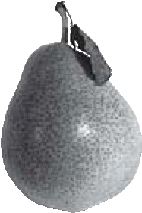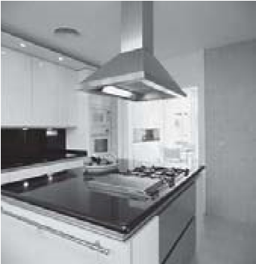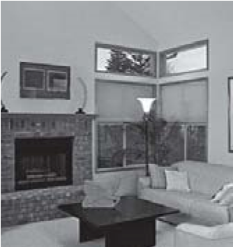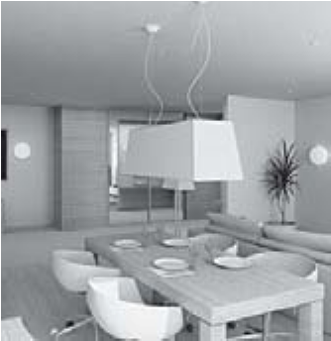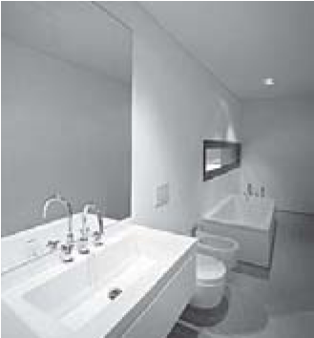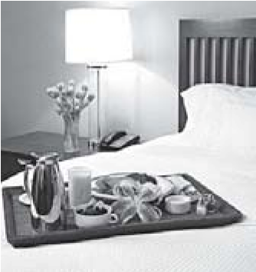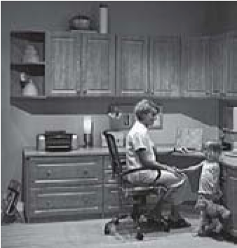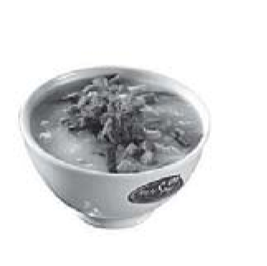
A.
Name the parts of the house.

II
1.
2.
3.
4.
5.
6.
B.
Look at the pictures. Number the words.
1.
juice
milk
2.
chicken
hot dog
3.
yoghurt
soup
4.
water
tea
5.
bread
cake
6.
apple
pear
1.
2.
3.
4.
5.
6.
III
A. Look at the picture. Complete the sentences with the verb to like.
- Helen ………………………. oranges and fish but she ………………………. carrots.
- John ………………………. cake.
- Cathy and Matt …………………. water and steak but they …………………… chips.
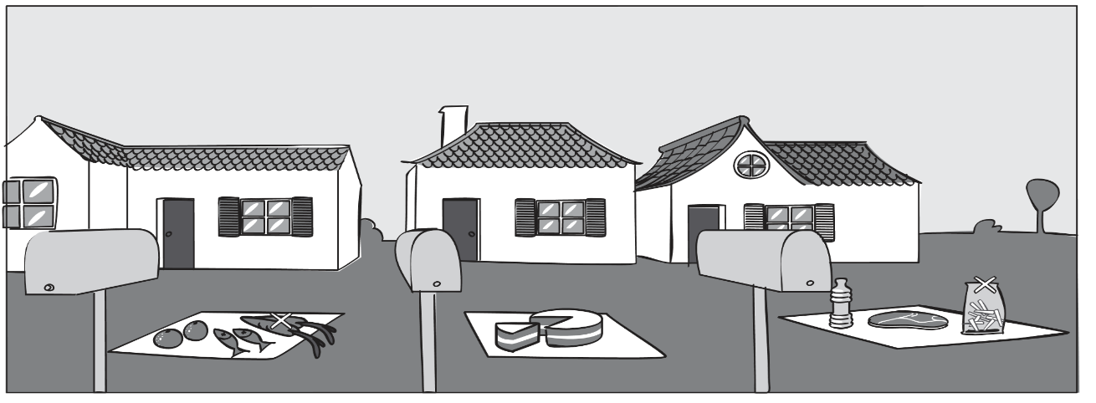

Cathy and Matt
John
Helen

B. The possessive case. Use ’s or ’ .
1. Helen ……….. house is nice.
2. It is the parents ……….. garden.
3. The TV set is Jamie ……….. and Tom ………... .
4. It is Tomás ……….. computer.

C. Write the plural.

- apple – ……………………………
- knife – ……………………………
- bus – ……………………………..
- peach – ……………………………
- baby – ……………………………..
- sandwich – ……………………….

IV
Write a small text about your house. Mention: the type of house, number of floors, the furniture in the study and in the kitchen.
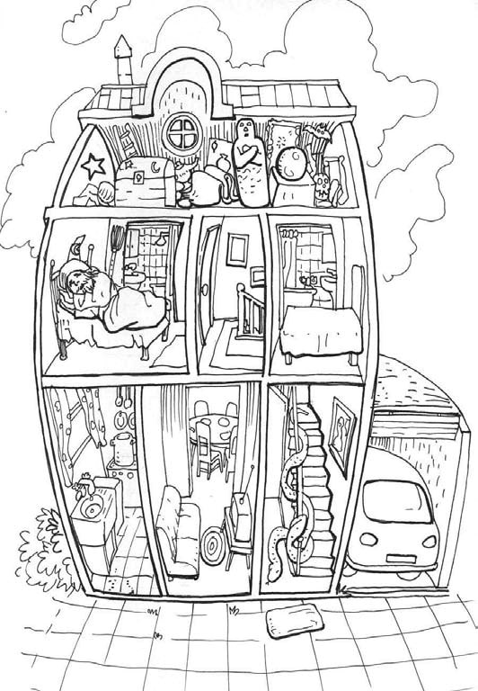
……………………...……………………………………………………………………………………………..………………………………………………………………......................…………….....................................................................................................................................................................
V

Listening Exercises
- Look at the picture.
True (T) or false (F)?

- 4.

2. 5.

3. 6.

- Number the objects in the order you
hear them.

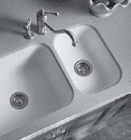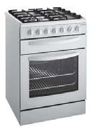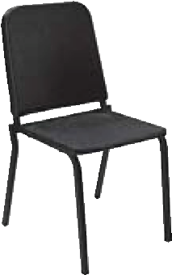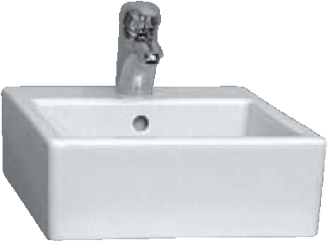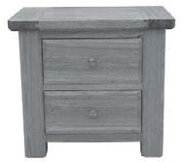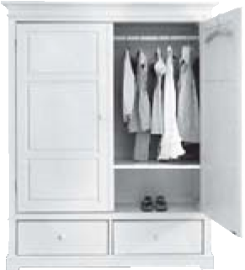
Good work!
Your English teacher

