
I
English Test – Unit 4
Name:
Date:
Class:
No.
Teacher:
Evaluation:
Guardian’s signature:
Date:
B
/
/
I


Read the text carefully.
Dear mum and dad,
How are you? I’m fine. London is a beautiful
city with large parks.
I am in the City of London School. It is a big
school next to the river Thames. In this school
there are fifty classrooms, three libraries and a
lovely garden, of course. I like the school canteen.
The food is delicious.
My bedroom is very modern. There is a big
yellow bed, three blue rugs and a lamp but there
isn’t a television set.
I have got some new friends, a Portuguese student,
called Angie, an Ukrainian girl, Kalyna, and Scott, an
English boy. Kalyna doesn’t like fruit and Scott is a
veggie. He doesn’t like steak.
Love,
Jamie

Answer about the text.
A.
Correct the sentences.
1
.
Jamie is not fine.
2.
In the school there are five classrooms.
3
.
The school is near the river Thames.
4
.
Her bedroom is very modern.

- Circle the correct answer.
- Where is Jamie?
a) He is in Pongola. b) He is in London. c) Yes, he is.
- Does he like the school canteen?
a) No, he doesn’t. b) He likes the food. c) Yes, he does.
- How many libraries are there?
a) There are three. b) There are thirty. c) There are fifty.
- Has he got new friends?
a) No, he hasn’t. b) Yes, he has. c) Yes, he does.
- Who is Angie?
a) She is a friend. b) She is the sister. c) Yes, she is a friend.
- Whose bedroom is it?
a) It’s Angie’s. b) It is mum’s. c) It’s Jamie’s.
C. Complete the questions. Use: Does / How many / Whose.

- ………………………… school is it? It is Jamie’s school.
- ………………………… gardens are there? There are two gardens.
- ………………………… she like fruit? No, she doesn’t like fruit.

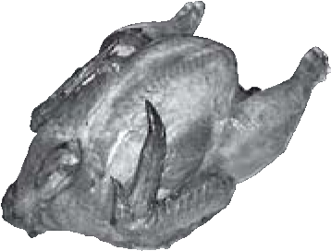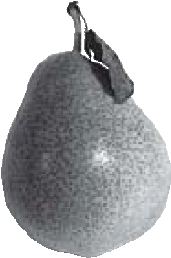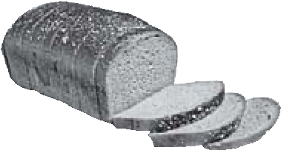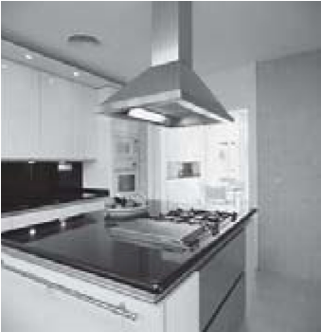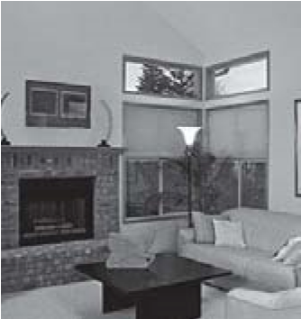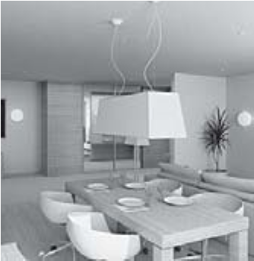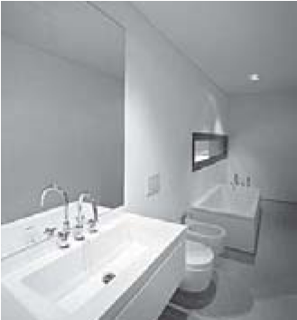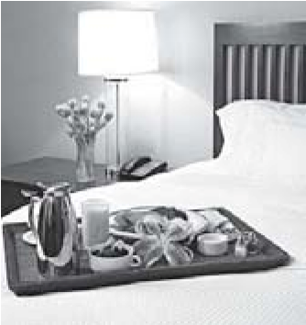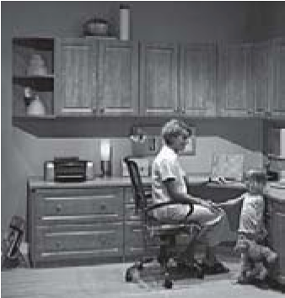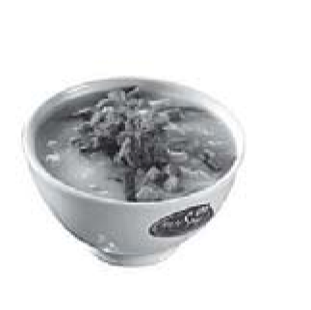
bedroom kitchen study bathroom dining room living room
A.
Write the words under the pictures.

II
1.
2.
3.
4.
5.
6.
B.
Look at the pictures. Number the words.
1.
juice
milk
2.
chicken
hot dog
3.
yoghurt
soup
4.
water
tea
5.
bread
cake
6.
apple
pear
1.
2.
3.
4.
5.
6.
III
A. Look at the picture. Complete the sentences with: like / likes / likes / don’t like / doesn’t like.
- Helen ……………… oranges and fish but she ……………… carrots.
- John ………………cake.
- Cathy and Matt ……………… water and steak but they ……………… chips.
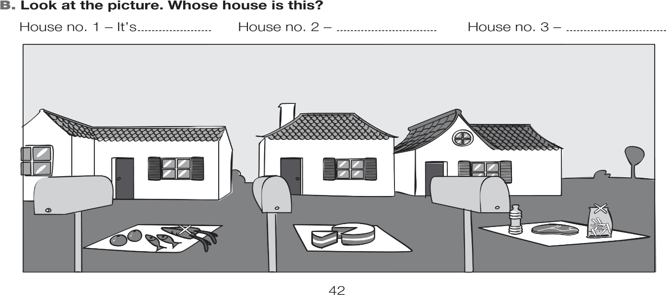

Cathy and Matt
John
Helen

B. The possessive case. Use ’s or ’ .

1. Helen ……… house is nice.
2. It is the parents ……… garden.
3. The TV set is Jamie ……… and Tom ……… .
4. It is Tomás ……… computer.

C. Plural. Circle the correct option.

- apple / apples
- knifes / knives
- buses / bus
- peachs / peaches
- babies / babes
- sandwiches / sandwich

IV
Write a small text about your house. Complete the sentences.
My house is a ………………………………………………….……………………. . (Type of house)
There ……………………………………… floors.
In the study there is ………………………………… and ………………………………….(furniture)
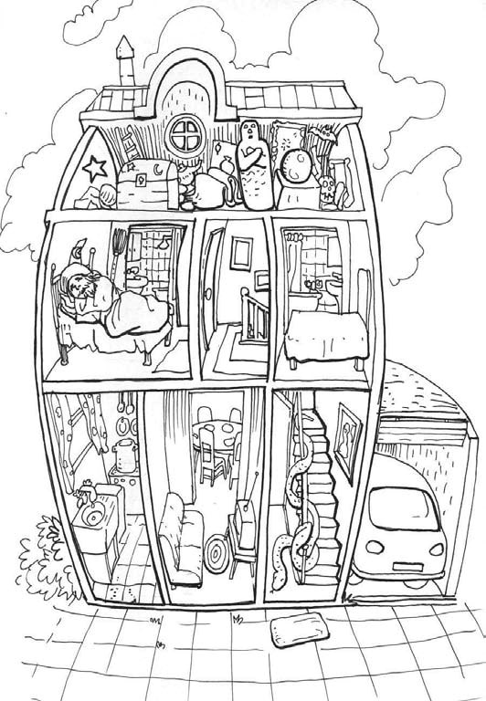
In the kitchen there is a ……………….…………… and a ………...………….…………. (furniture)

V

Listening Exercises
- Look at the picture.
True (T) or false (F)?

- 4.

2. 5.

3. 6.

- Number the objects in the order you
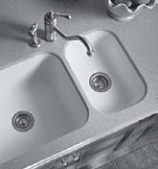

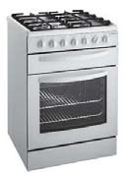

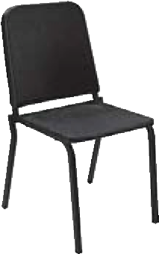

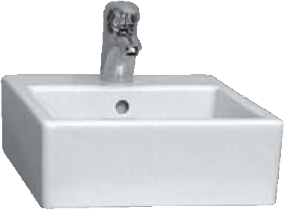
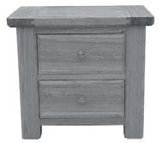
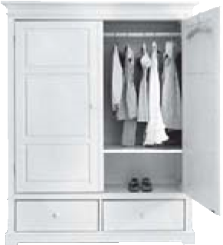
hear them.
Good work!
Your English teacher

Your English teacher

