

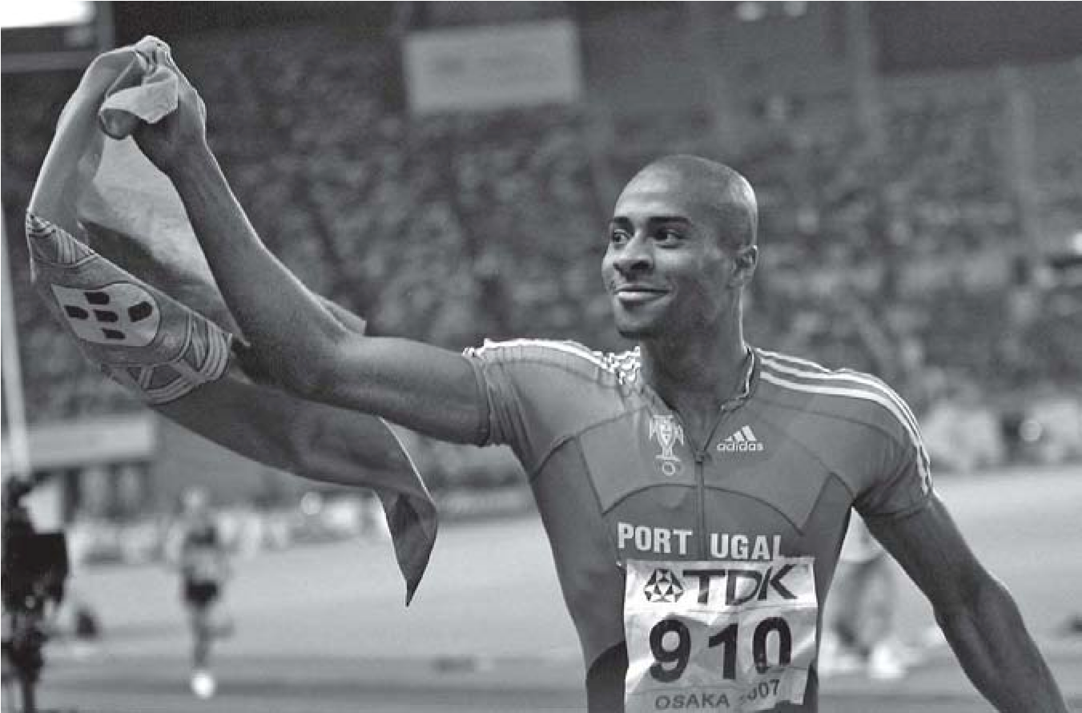
Nelson Évora is a famous Portuguese athlete. He is an Olympic champion too.
Nelson gets up at seven o’clock and has breakfast: milk, bread and fruit. After breakfast he goes to the stadium by car. He has got a beautiful new car.
At 12:00 a.m. he has lunch in the canteen of the stadium and he goes home.

Class:
Date:
/
/
No.
tion:
Evalu
/
/
Date:
English Test – Unit 5
Name:
Class:
No.
Date:
Teacher:
Evaluation:
Guardian’s signature:
Date
:
B
/
/
Read the text carefully.
I
Now answer about the text.

In the afternoon he watches TV and plays table tennis with his friends. Nelson can play table tennis but he can’t surf.
At 6 p.m. he goes to the stadium again.
Nelson has dinner with his family and at 10:00 p.m. he goes to bed. On Saturdays he has dinner with his friends. Nelson likes steak and mashed potatoes but he doesn’t like fish and chips. He prefers healthy food!
A. Complete the sentences about Nelson Évora.
1. Nelson goes to the stadium by……………………….....................................................................
2. Nelson can …………………………..............................................................................................
3. He can’t ……………………………................................................................................................
4. He goes to bed at ………………...................................................................................................
5. The athlete doesn’t like ………………...........................................................................................

B. Answer the questions.
1. How does he go to the stadium?
a) He goes by bike. b) He doesn’t go. c) He goes by car.
2. When does he go to the stadium?
a) In the afternoon. b) After breakfast. c) After dinner.
3. What time does he get up?
a) At 7 a.m. b) At 7 p.m. c) At twelve o’clock.
4. Where does he have lunch?
a) At home. b) At 12 a.m. c) In the canteen.
5. Can he surf?
a) No, he can’t. b) Yes, he can. c) He can play table tennis.

C. Complete the questions.
- ……………… you play table tennis? Yes, I can.
- ………………you like fish? No, I don’t.
- What ……………… do you go to bed? I go to bed at 10:00 p.m.

II
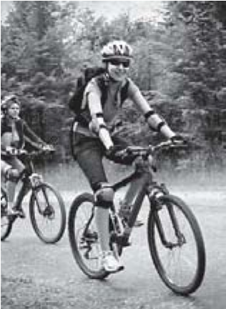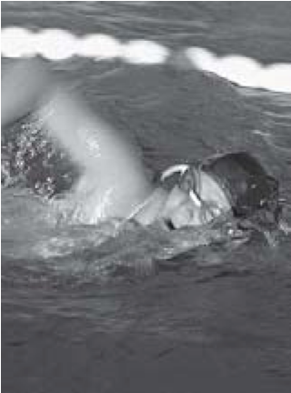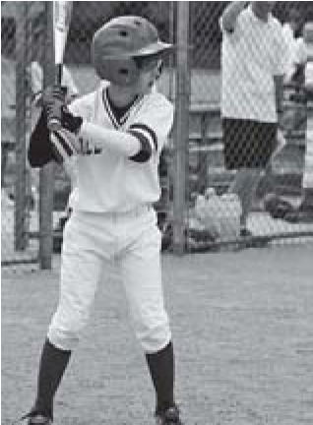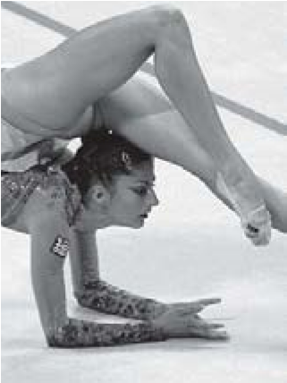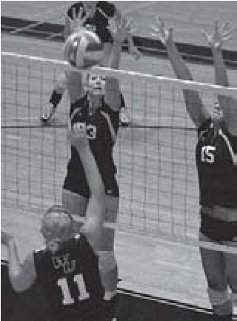  A.  Name the sports. Choose the correct words.  1.  2.  3.  4.  5.
  jogging
  basketball volleyball
  swimming
  motorcycling
  gymnastics cycling
  baseball athletics

III
A. Complete the sentences using at, before, after or in.
- You get dressed ……………… breakfast.
- They have lessons……………… the morning.
- ……………… 1:00 o’clock I have lunch ……………… home.
- ……………… dinner Mary goes to bed.
B. Fill in the gaps with the correct action.
plays has does has goes

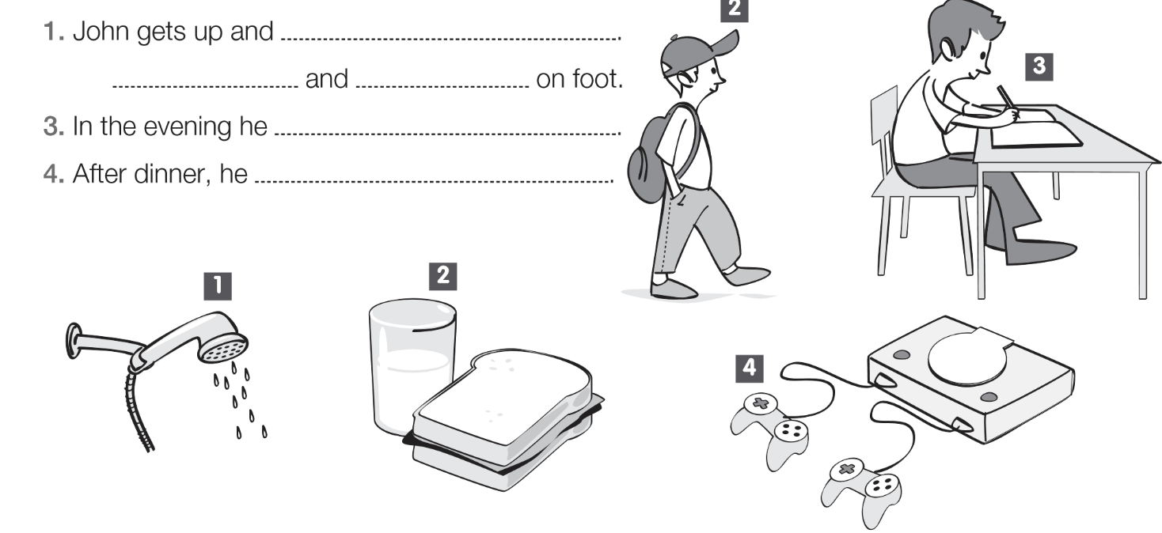

C. Write the sentences in different forms.

Affirmative | Negative | Interrogative
1. You go to the stadium.
2. |  | Does he have dinner?
3. | She doesn’t play golf.

IV

A. Fill in the card about yourself.
Favourite sports:

Can:
Can’t:
Daily routine (3 actions):

B. Now, complete the text using the information in the box.
My favourite sports are ……………………………………… and ……………………….………………
I can …………………………………….. but I can’t ……………………………………….……………..
………………………………………………………………………………….………………………………

V
Listening Exercises
A. Draw the hands on the clocks.
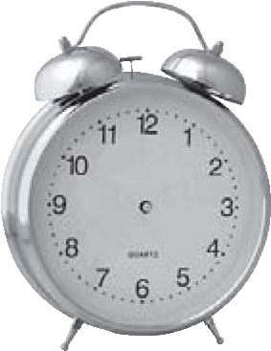
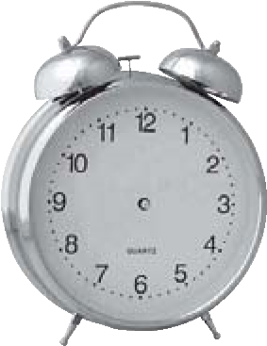
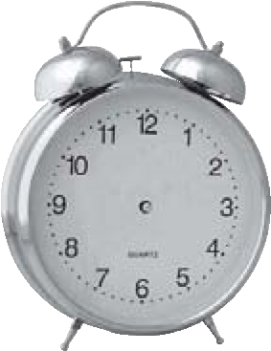
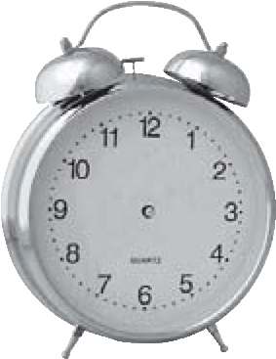

1 2 3 4
B. Circle the correct option.
- some / any 2. some / any 3. some / any

C. Daily routine actions. Tick the actions you hear.
has dinner has a shower has lunch has a snack has breakfast has classes gets up goes to bed goes to school goes home plays PSP
does the homework watches TV gets dressed
Good work!
Your English teacher

