
I
/
/
Date:
Class:
No.
tion:
Evalu
/
/
Date:
English Test – Unit 6
Name:
No.
Class:
Date:
Teacher:
Evaluation:
Guardian’s signature:
Date
:
B
/
/


Read the text carefully.
Vocabulary Check!
rest – descansar
It’s Friday morning and it’s rainy in Liverpool.
Jonathan’s father goes to work by car. He can’t go on foot. His mother is at a dance lesson. Jonathan is at home, he isn’t fine. He can’t go to school today.
Before lunch Jonathan phones his father.
Jonathan: Dad, may I go to Tom’s house?
Father: No, you may not. You may play PSP. It’s your favourite hobby!
Jonathan: But dad, my PSP doesn’t work!
Father: You may chat on Messenger or read a book! Remember, rest! Your lunch is in the fridge.
In the afternoon Tom phones Jonathan.
Jonathan: Hello??
Tom: It’s Tom! Where are you?
Jonathan: I’m at home! I’m not fine.
Tom: Can you ride a bike?
Jonathan: No, I can’t. Can you chat on Messenger?
Tom: Of course I can.
Jonathan: Great!

Answer about the text.
A. True (T) or false (F)? Correct the false sentences.
- It’s sunny in Liverpool. .........................................................................

- His mother is at work. ...............................................................................

- Jonathan isn’t fine. ...............................................................................

- He may go to Tom’s house. ...............................................................................

- Lunch is in the fridge. ...............................................................................

B. Answer the questions.
- What’s the weather like in Liverpool?
a) It’s sunny. b) It’s rainy. c) It’s Friday.
- What is Jonathan’s favourite hobby?
a) It’s playing PSP. b) It’s riding a bike. c) It’s reading a book.
- Where is Jonathan?
a) At Tom’s house. b) At school. c) At home.
- May he go to Tom’s house?
a) No, he may not. b) He goes to Tom’s house. c) Yes, he may.
C. Complete the questions.
1. ................... do you go to work? I go to work by car.
2. .................... is the weather like? It’s rainy and cold.
3. …………….. your favourite hobby? My favourite hobby is riding a bike.

II
- What’s the weather like? Answer according to the picture.
It’s stormy. It’s rainy. It’s windy. It’s snowy. It’s cloudy.

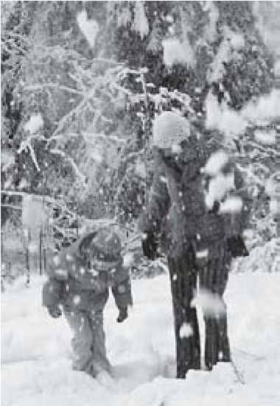

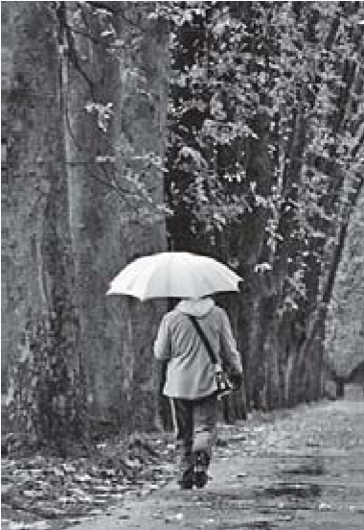
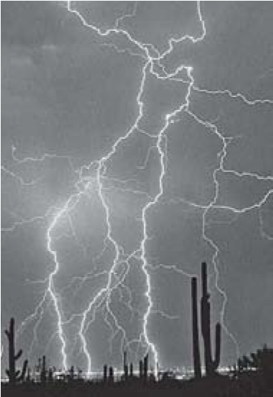

1.
2.
3.
4.
5.

- Look at the pictures and complete the sentences.
aeroplane motorbike bus foot
by / on

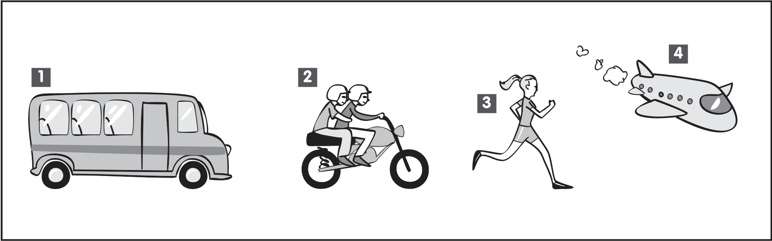
- He goes to school …………………… …………………… .
- They go to work …………………… …………………… .
- She goes to the gymnasium …………………… …………………… .
- I go to Spain …………………… …………………… .

III
A. Imperative form. Order the words and form sentences.
1. door / please / open / the ........................................................................................................
2. attention / students / pay / please ..........................................................................................
3. homework / Scott / do / the ………………………..………………………………………………

B. Write the sentences in the negative form.
1. Stand up! ................................................................................................................................
2. Jack, watch TV.. ......................................................................................................................
3. Kaly, read the book!. ................................................................................................................

C. Use the verb MAY. Ask questions or give answers.
1. ................................................. she go to the beach? No, she . .............................................. .
2. You ............................................... surf the net but your friend ............................................... .
3. ................................................. I go to the cinema? Yes, you ................................................. .

IV
Listening Exercises

A. Look at the picture. True (T) or false (F)?

1. 4.

2. 5.

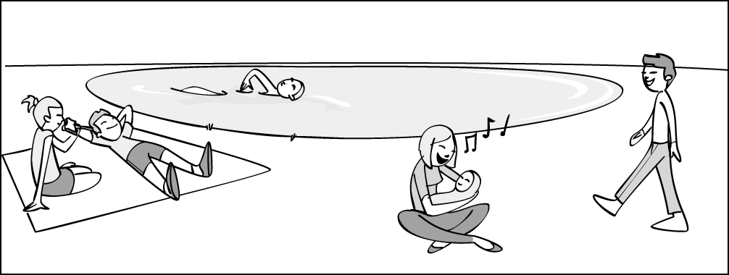
3. 6.
Tom
Mrs. Norris
Sally
Trevor
Steve

Good work!
Mrs. Norris
Your English teacher
Trevor
Mrs. Norris

