Teste A
Objetivos/Competências | Conteúdos | Estrutura | Cotações | Critérios de classificação
VOCABULARY  Aplicar o vocabulário da unidade.  25% | Vocabulário relacionado com a unidade 2 | A. Procurar o nome dos animais domésticos na sopa de letras | 5 x 1 = 5 | Erros de ortografia: - 0,5 pontos  Resposta errada: 0
VOCABULARY  Aplicar o vocabulário da unidade.  25% | Vocabulário relacionado com a unidade 2 | B. Legendar as imagens dos animais selvagens | 5 x 2 = 10 | Erros de ortografia: - 0,5 pontos  Resposta errada: 0
VOCABULARY  Aplicar o vocabulário da unidade.  25% | Vocabulário relacionado com a unidade 2 | C. Escrever o plural dos nomes | 5 x 2 = 10 | Erros de ortografia: - 0,5 pontos  Resposta errada: 0
READING COMPREHENSION  Compreender o texto na globalidade e em detalhe.  25% | Texto relacionado com a unidade | A. Dizer se as frases são verdadeiras ou falsas. Corrigir as frases falsas segundo o texto | 5 x 2 = 10 | Erros de ortografia : - 0,5 pontos  Erros de ortografia + estrutura: - 1 ponto  Resposta errada: 0
 | Texto relacionado com a unidade | B. Responder a questões sobre o texto | 5 x 3 = 15
GRAMMAR  Aplicar os itens gramaticais tratados.  25% | Indefinte article:  a, an, | A. Completar espaços | 10 x 1 = 10 | Erros de ortografia: - 0,5 pontos  Erros de ortografia + estrutura: - 1 ponto  Resposta errada: 0
GRAMMAR  Aplicar os itens gramaticais tratados.  25% | Possesives | B. Reescrever as frases | 5 x 1 = 5
GRAMMAR  Aplicar os itens gramaticais tratados.  25% | Verb to Have (got) (affirmative) | C. Escrever as frases | 5 x 1 = 5
GRAMMAR  Aplicar os itens gramaticais tratados.  25% | Verb to Have (got) (negative) | D. Reescrever as frases na negativa | 5 x 1 = 5
WRITING  Produzir um enunciado escrito guiado e um livre.  25% | Tema:  Identidade pessoal  Favourite animal | A. Completar um diálogo | 5 x 2 = 10 | Erros de ortografia irrelevantes + estrutura organizada e coerente - 11 - 15 pontos  Erros de ortografia + estrutura pouco organizada  6 - 11 pontos  Erros de ortografia + estrutura bastante desorganizada: - 1 - 6 pontos  Frases incoerentes sem estrutura: 0 pontos
 | Tema:  Identidade pessoal  Favourite animal | B. Escrever um texto | 5 x 3 = 15
Teste B
Objetivos/ Competências | Conteúdos | Estrutura | Cotações | Critérios de classificação
VOCABULARY  Aplicar o vocabulário da unidade.  25% | Vocabulário relacionado com a unidade 2 | A. Procurar o nome dos animais domésticos na sopa de letras | 5 x 1 = 5 | Erros de ortografia: - 0,5 pontos  Resposta errada: 0
VOCABULARY  Aplicar o vocabulário da unidade.  25% | Vocabulário relacionado com a unidade 2 | B. Legendar as imagens dos animais selvagens | 5 x 2 = 10 | Erros de ortografia: - 0,5 pontos  Resposta errada: 0
VOCABULARY  Aplicar o vocabulário da unidade.  25% | Vocabulário relacionado com a unidade 2 | C. Escrever o plural dos nomes. | 5 x 2 = 10 | Erros de ortografia: - 0,5 pontos  Resposta errada: 0
READING COMPREHENSION  Compreender o texto na globalidade e em detalhe.  25% | Texto relacionado com a unidade | A. Corrigir as frases segundo o texto – true or false | 5 x 2 = 10 | Erros de ortografia : - 0,5 pontos  Erros de ortografia + estrutura: - 1 ponto  Resposta errada: 0
 | Texto relacionado com a unidade | B. Responder a questões sobre o texto. | 5 x 3 = 15
GRAMMAR  Aplicar os itens gramaticais tratados.  25% | Indefinite Articles:  a, an, | A. Completar espaços | 5 x 1 = 5 | Erros de ortografia: - 0,5 pontos  Erros de ortografia + estrutura: - 1 ponto  Resposta errada: 0
GRAMMAR  Aplicar os itens gramaticais tratados.  25% | Possessives | B. Rodear o possessive correto | 5x2=10
GRAMMAR  Aplicar os itens gramaticais tratados.  25% | Verb to Have (got) (affirmative) | C. Reescrever a frase de forma correta | 5 x 1 = 5
GRAMMAR  Aplicar os itens gramaticais tratados.  25% | Verb to Have (got) (negative) | D. Reescrever as frases | 5 x 1 = 5
WRITING  Produzir um enunciado escrito guiado e um livre.  25% | Tema:  Identidade pessoal  Favourite animal | A. Completar um diálogo | 5 x 2 = 10 | Erros de ortografia irrelevantes + estrutura organizada e coerente - 11 - 15 pontos  Erros de ortografia + estrutura pouco organizada  6 - 11 pontos  Erros de ortografia + estrutura bastante desorganizada: - 1 - 6 pontos  Frases incoerentes sem estrutura: 0 pontos
 | Tema:  Identidade pessoal  Favourite animal | B. Escrever um texto | 5 x 3 = 15
Matriz do teste Unit 2

Unit 2 Test A

School:_______________________________________________________________________________
Name:_____________________________________________________ Class:_______ Nr:___________
Date:______________________________________________________ Score:_____________________
Enc. Educação:____________________________________________Teacher:__________________

Vocabulary

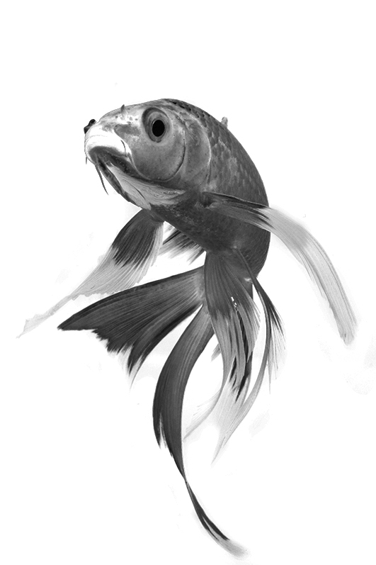
- Find the names of these pets in the word search.
F | I | S | H | P | A | E | T
B | M | O | A | E | R | Y | U
D | D | F | M | C | A | T | R
O | Q | W | S | U | I | O | T
G | B | N | T | U | I | T | L
Z | X | T | E | O | I | U | E
O | I | Y | R | G | H | L | J
I | A | E | R | B | I | R | D
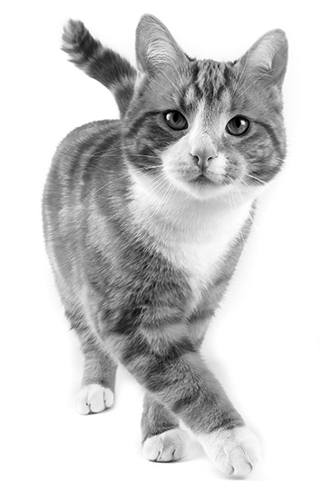
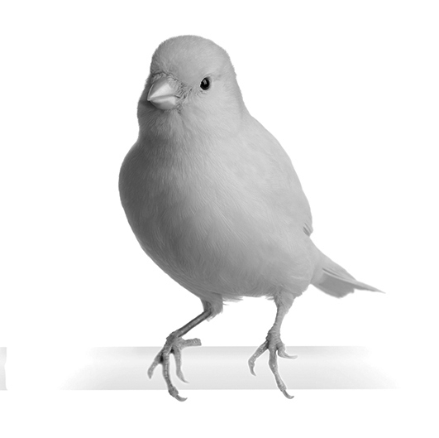
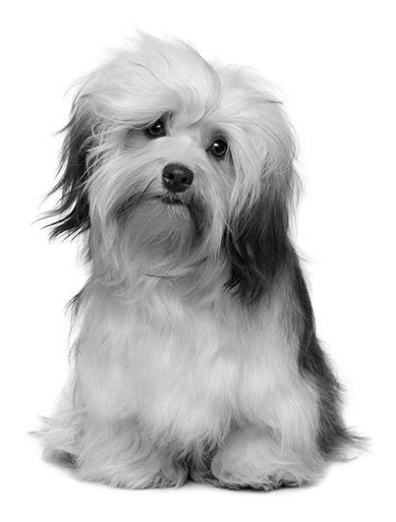

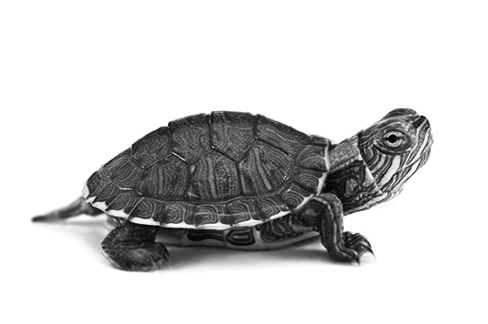

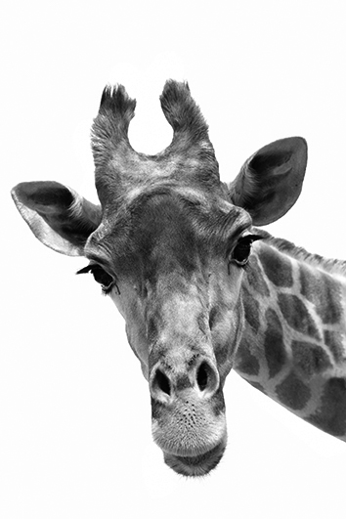
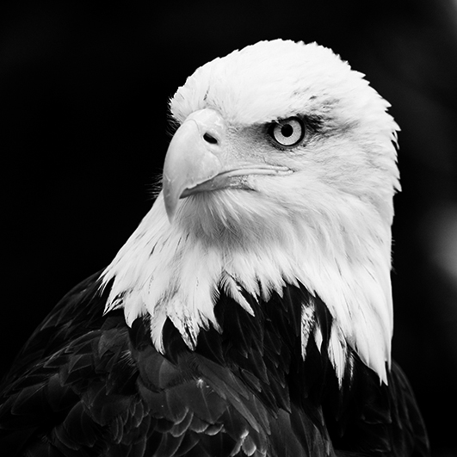
- Complete with the names of the wild animals.
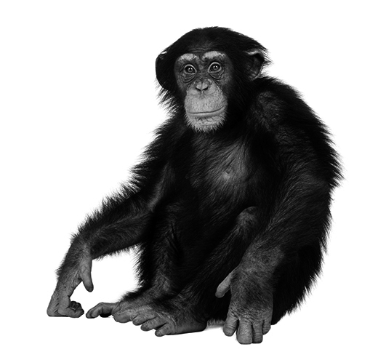
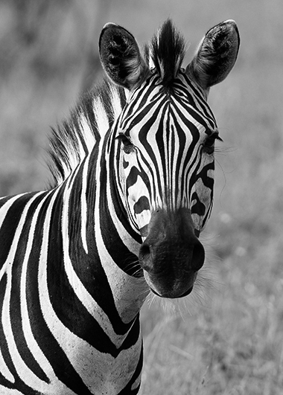
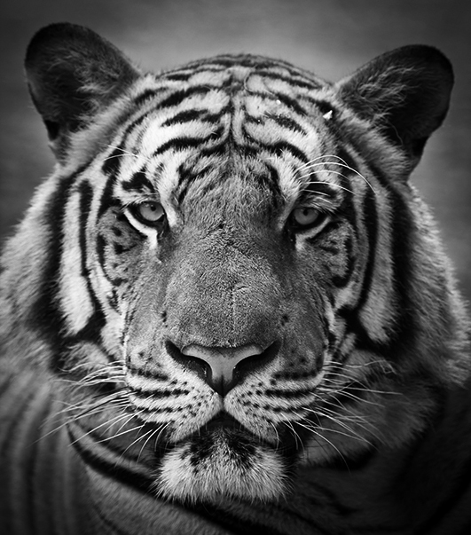
1.________________ 2. _____________ 3. ____________ 4. _______________ 5. ________________

- Write the plural of the animals.

e.g. bear bears 2. giraffe ___________ 4. dog ____________
1. cat __________ 3. elephant ___________ 5. owl _____________

Reading Comprehension

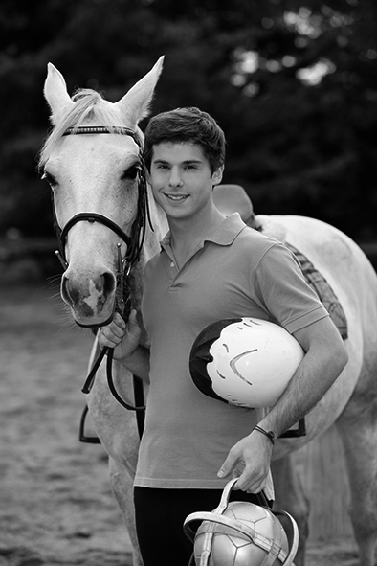
Hi there, my name is Mark. I’m German. I am twelve years old. This is my pet. He is a horse, a white horse. I love animals. His name is Thunder.
This is a picture of my sister, Carolina. She is ten. She has got a dog. She loves dogs. It is white, black and brown.
The other picture is from my grandparents. They are from Spain. They are sixty years old.
They also love animals. Their pet is a cat. It’s Nikita.

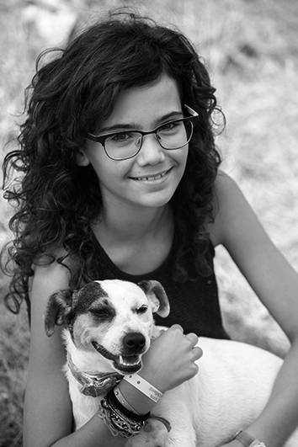

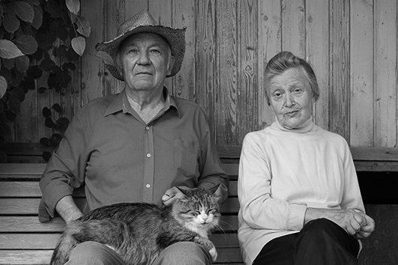

- Write true (T) or false (F). Correct the false sentences according to the text.

- Mark is 11 years old. ____________________________________________
- The horse’s name is Thunder. _____________________________________
- Carolina hasn’t got a dog.__________________________________________
- Their grandparents pet is a turtle.____________________________________
- Carolina is Mark’s friend. _________________________________________

- Answer the questions about the text.

- What’s Mark’s nationality?___________________________________
- How old is Mark?____________________________________________
- What colour is Thunder?_______________________________________
- How old is Carolina?___________________________________________
- Where are his grandparents from?________________________________

Grammar
- Complete with a, an or .

- ____ owl 6. _____ cat
- ____ lion 7.______ snakes
- ____ dogs 8. ______ ox
- ____ elephant 9. _____ ostrich
- ____ giraffe 10. _____ chickens

- Rewrite the sentences with the correct possessive.
e.g. I have got a fish. It’s my fish.

- Mark has got a horse. ___________________________________
- The giraffe has got a long neck. ______________________________
- She has got a turtle. _____________________________________
- We have got a cat. ______________________________________
- They have got three parrots ________________________________

- Write the sentences with the verb ‘to have (got)’.
e.g. Jason / a brown dog. Jason has got a brown dog.

- João / a frog __________________________________________
- Maria and I / a pet ______________________________________
- She / gold fish _________________________________________
- The children / a cat ______________________________________
- You / an animal in the house________________________________

- Write these sentences in the negative.

- Julie and Jack have got three horses. ____________________________________
- I have got a snake.____________________________________________________
- My mother has got chickens. _____________________________________________
- We have got lots of pets. ______________________________________________
- He has got a baby giraffe.________________________________________________

Writing

A. Imagine you are talking with Mark. Complete the conversation.
YOU: (1) Hi, __________________________?
MARK: Hello! My name is Mark.
YOU: (2) _____________________________?
MARK: I’m 12 years old.
YOU: (3) ___________________________?
MARK: I’m from Germany.
YOU: (4) ____________________________?
MARK: Yes, I have. I’ve got a horse.
YOU: (5) ____________________________?
MARK: His name is Thunder.

B. Write FIVE sentences about you and your favourite animal.
Name
Age
Nationality
Favourite animal
Favourite colour

Don’t forget to mention:

_______________________________________________________

________________________________________________________
________________________________________________________
________________________________________________________
________________________________________________________
________________________________________________________
________________________________________________________
________________________________________________________
________________________________________________________

Good luck!
Unit 2 Test B

School:_______________________________________________________________________________
Name:_____________________________________________________ Class:_______ Nr:___________
Date:______________________________________________________ Score:_____________________
Enc. Educação:____________________________________________Teacher:__________________

Vocabulary

- Find the names of these pets in the word search.
turtle dog fish bird cat
F | I | S | H | P | A | E | T
B | M | O | A | E | R | Y | U
D | D | F | M | C | A | T | R
O | Q | W | S | U | I | O | T
G | B | N | T | U | I | T | L
Z | X | T | E | O | I | U | E
O | I | Y | R | G | H | L | J
I | A | E | R | B | I | R | D

B. Complete with the names of the wild animals.
hyena eagle giraffe tiger monkey zebra lion snake

1.________________ 2. _____________ 3. ____________ 4. _______________ 5. ________________
- Write the plural of the animals.
e.g. bear bears 2. giraffe ___________ 4. dog ____________
1. cat __________ 3. elephant ___________ 5. owl _____________

Reading Comprehension

Hi there, my name is Mark. I’m German. I am twelve years old. This is my friend, he is also my pet. He is a horse, a white horse. I love animals. His name is Thunder.
This is a picture of my sister, Carolina. She is ten. She has got a dog. She loves dogs. It is white, black and brown.
The other picture is from my grandparents. They are from Spain. They are sixty years old.
They also love animals. Their pet is a cat. It’s Nikita.

- Write true (T) or false (F) according to the text.

- Mark is 11 years old.
- The horse’s name is Thunder.
- Carolina hasn’t got a dog.
- Their grandparents pet is a turtle.
- Carolina is Mark’s friend.

- Match the answers with the questions about the text.
- They are from Spain.
- Mark is 12 years old.
- Thunder is white.
- Carolina is 10 years old.
- He is German.
- What’s Mark’s nationality?
- How old is Mark?
- What colour is Thunder?
- How old is Carolina?
- Where are his grandparents from?

Grammar
- Complete with a, an or .

- ____ owl 6. _____ cat
- ____ lion 7.______ snakes
- ____ dogs 8. ______ ox
- ____ elephant 9. _____ ostrich
- ____ giraffe 10. _____ chickens

- Choose the correct possessive.
e.g. I have got a fish. It’s my / his / her fish.

- Mark has got a horse. It’s his / my / their horse
- The giraffe has got a long neck. It’s our /its / their neck.
- She has got a turtle. It’s her / our / its turtle.
- We have got a cat. It’s their / our / his cat.
- They have got three parrots It’s its / your / their parrots.

- Choose the best option of the verb ‘to have (got)’.

- João has / have got a frog.
- Maria and I has / have got a pet.
- She has / have got a gold fish.
- The children has / have got a cat.
- You has / have got an animal in the house.

- Write these sentences in the negative.
e.g. I have got a pig. – I haven’t got a pig.

- Julie and Jack have got three horses. ____________________________________
- I have got a snake.____________________________________________________
- My mother has got chickens. _____________________________________________
- We have got lots of pets. ______________________________________________
- He has got a baby giraffe.________________________________________________

Writing

- Imagine you are talking with Mark. Complete the conversation.

What’s your nationality? Have you got a pet? Where are you from? How old are you
What’s your name? What’s the pet’s name?

YOU: (1) Hi, __________________________?
MARK: Hello! My name is Mark.
YOU: (2) _____________________________?
MARK: I’m 12 years old.
YOU: (3) ___________________________?
MARK: I’m from Germany.
YOU: (4) ____________________________?
MARK: Yes, I have. I’ve got a horse.
YOU: (5) ____________________________?
MARK: His name is Thunder.

B. Write FIVE sentences about you and your favourite animal.
Name
Age
Nationality
Favourite animal
Favourite colour

Don’t forget to mention:

My name is _________________________________________.
I am ______________ years old. I’m ______________________.
My favourite animal is the _______________________________.
It’s _________________________________________________.

Good luck!
Answer Key Unit 2
Test A
VOCABULARY
F | I | S | H |  |  |  | T
 |  |  | A |  |  |  | U
D |  |  | M | C | A | T | R
O |  |  | S |  |  |  | T
G |  |  | T |  |  |  | L
 |  |  | E |  |  |  | E
 |  |  | R
 |  |  |  | B | I | R | D
A.

F | I | S | H |  |  |  | T
 |  |  | A |  |  |  | U
D |  |  | M | C | A | T | R
O |  |  | S |  |  |  | T
G |  |  | T |  |  |  | L
 |  |  | E |  |  |  | E
 |  |  | R
 |  |  |  | B | I | R | D

B. 1. tiger 2. zebra 3. monkey 4. eagle 5. giraffe
C.1. cats 2. giraffes 3. elephants 4. dogs 5. owls
READING COMPREHENSION
A. 1. F / Mark is 12 years old. 2. T 3. F / Carolina has got a dog. 4. F / Their grandparents pet is a cat. 5. F / Carolina is Mark’s sister.
B. 1. He is German. 2. Mark is twelve. 3. Thunder is white. 4. Carolina is ten. 5. They are from Spain.

GRAMMAR
A. 1. an 2. a 3. 4. an 5. a 6. a 7. 8. an 9. an 10.
B. 1. It’s his horse. 2. It’s its neck. 3. It’s her turtle. 4. It’s our cat. 5. It’s their parrots.
C. 1. João has got a frog. 2. Maria and I have got a pet. 3. She has got a gold fish. 4. The children have got a cat. 5. You have got an animal in the house.
D. 1. Julie and Jack haven’t got three horses. 2. I haven’t got a snake. 3. My mother hasn’t got chickens. 4. We haven’t got lots of pets. 5. He hasn’t got a baby giraffe.

WRITING
A. 1. What is your name? 2. How old are you? 3. Where are you from? 4. Have you got a pet? 5. What’s his name?
B. Personal answer.

Test B
VOCABULARY
F | I | S | H |  |  |  | T
 |  |  | A |  |  |  | U
D |  |  | M | C | A | T | R
O |  |  | S |  |  |  | T
G |  |  | T |  |  |  | L
 |  |  | E |  |  |  | E
 |  |  | R
 |  |  |  | B | I | R | D
F | I | S | H |  |  |  | T
 |  |  | A |  |  |  | U
D |  |  | M | C | A | T | R
O |  |  | S |  |  |  | T
G |  |  | T |  |  |  | L
 |  |  | E |  |  |  | E
 |  |  | R
 |  |  |  | B | I | R | D
A.

B. 1. tiger 2. zebra 3. monkey 4. eagle 5. giraffe
C. 1. cats 2. giraffes 3. elephants 4. dogs 5. owls
READING COMPREHENSION
A. 1. F / Mark is 12 years old. 2. T 3. F / Carolina has got a dog. 4. F / Their grandparents pet is a cat. 5. F / Carolina is Mark’s sister.
B. 1. He is German. 2. Mark is 12 years old. 3. Thunder is white. 4. Carolina is 10 years old. 5. They are from Spain.

GRAMMAR
A. 1. an 2. a 3. 4. an 5. a 6. a 7. 8. an 9. an 10.
B. 1. It’s his horse. 2. It’s its neck. 3. It’s her turtle. 4. It’s our cat. 5. It’s their parrots.
C. 1. João has got a frog. 2. Maria and I have got a pet. 3. She has got a gold fish. 4. The children have got a cat. 5. You have got an animal in the house.
D. 1. Julie and Jack haven’t got three horses. 2. I haven’t got a snake. 3. My mother hasn’t got chickens. 4. We haven’t got lots of pets 5. He hasn’t got a baby giraffe.

WRITING
A. 1. What is your name? 2. How old are you? 3. Where are you from? 4.Have you got a pet? 5. What’s his name?
B. Personal answer.

