Matriz do teste Unit 3

Teste A
Objetivos/Competências | Conteúdos | Estrutura | Cotações | Critérios de Classificação
VOCABULARY  Aplicar o vocabulário da unidade.  25% | Vocabulário relacionado com a unidade 3 | A. Descobrir o nome dos membros de uma família na sopa de letras | 5 x 3 = 15 | Erros de ortografia: - 0,5 pontos  Resposta errada: 0
VOCABULARY  Aplicar o vocabulário da unidade.  25% | Vocabulário relacionado com a unidade 3 | B. Legendar a imagem (partes do corpo) | 5 x 2 = 10 | Erros de ortografia: - 0,5 pontos  Resposta errada: 0
READING COMPREHENSION  Compreender o texto na globalidade e em detalhe.  25% | Texto relacionado com a unidade | A. Ler o texto |  | Erros de ortografia: - 0,5 pontos  Erros de ortografia + estrutura: - 1 ponto  Resposta errada: 0
 | Texto relacionado com a unidade | B. Escolher a opção correta (verdadeiro ou falso) | 5 x 2 = 10
 | Texto relacionado com a unidade | C. Responder a perguntas sobre o texto | 5 x 3 = 15
GRAMMAR  Aplicar os itens gramaticais tratados.  26% | Possessive’s | A. Completar frases | 5 x 1 = 5 | Erros de ortografia: - 0,5 pontos  Erros de ortografia + estrutura: - 1 ponto  Resposta errada: 0
GRAMMAR  Aplicar os itens gramaticais tratados.  26% | Ordem dos adjetivos | B. Ordenar frases | 5 x 1 = 5
GRAMMAR  Aplicar os itens gramaticais tratados.  26% | Antónimos dos adjetivos | C. Completar com os antónimos dos adjetivos | 5 x 1 = 5
GRAMMAR  Aplicar os itens gramaticais tratados.  26% | Verbs ‘to be’ e ‘ to have (got)’ | D. Completar espaços | 10 x 0,5 = 5
GRAMMAR  Aplicar os itens gramaticais tratados.  26% | Conectores And / But | E. Reescrever as frases com and / but | 2 X 3 = 6
WRITING  Produzir um enunciado escrito guiado e um livre.  24% | Tema:  Identidade pessoal  Descrição física  Desportos e passatempos | A. Completar um diálogo | 5 x 2 = 10 | Erros de ortografia irrelevantes + estrutura organizada e coerente - 11 – 14 pontos  Erros de ortografia + estrutura pouco organizada  6 - 11 pontos  Erros de ortografia + estrutura bastante desorganizada: - 1 - 6 pontos  Frases incoerentes sem estrutura: 0 pontos
 |  | B. Escrever um texto | 14
Teste B
Objetivos/Competências | Conteúdos | Estrutura | Cotações | Critérios de Classificação
VOCABULARY  Aplicar o vocabulário da unidade.  25% | Vocabulário relacionado com a unidade 3 | A. Descobrir o nome dos membros de uma família na sopa de letras | 5 x 3 = 15 | Erros de ortografia: -0,5 pontos  Resposta errada: 0
VOCABULARY  Aplicar o vocabulário da unidade.  25% | Vocabulário relacionado com a unidade 3 | B. Legendar a imagem (partes do corpo) | 5 x 2 = 10 | Erros de ortografia: -0,5 pontos  Resposta errada: 0
READING COMPREHENSION  Compreender o texto na globalidade e em detalhe.  25% | Texto relacionado com a unidade | A. Ler o texto |  | Erros de ortografia : - 0,5 pontos  Erros de ortografia + estrutura: - 1 ponto  Resposta errada: 0
 | Texto relacionado com a unidade | B. Escolher a opção correta (verdadeiro ou falso) | 5 x 2 = 10
 | Texto relacionado com a unidade | C. Responder a perguntas sobre o texto | 5 x 3 = 15
GRAMMAR  Aplicar os itens gramaticais tratados.  26% | Possessive’s | A. Completar frases | 5 x 1 = 5 | Erros de ortografia: - 0,5 pontos  Erros de ortografia + estrutura: - 1 ponto  Resposta errada: 0
GRAMMAR  Aplicar os itens gramaticais tratados.  26% | Ordem dos adjetivos | B. Ordenar frases | 5 x 1 = 5
GRAMMAR  Aplicar os itens gramaticais tratados.  26% | Antónimos dos adjetivos | C. Completar com os antónimos dos adjetivos | 5 x 1 = 5
GRAMMAR  Aplicar os itens gramaticais tratados.  26% | Verbs ‘to be’ e ‘ to have (got)’ | D. Completar espaços | 10 x 0,5 = 5
GRAMMAR  Aplicar os itens gramaticais tratados.  26% | Conectores And / But | E. Reescrever as frases com and / but | 2 X 3 = 6
WRITING  Produzir um enunciado escrito guiado e um livre.  24% | Tema:  Identidade pessoal  Descrição física  Desportos e passatempos | A. Completar um diálogo | 5 x 2 = 10 | Erros de ortografia irrelevantes + estrutura organizada e coerente - 11 – 14 pontos  Erros de ortografia + estrutura pouco organizada  6 - 11 pontos  Erros de ortografia + estrutura bastante desorganizada: - 1 - 6 pontos  Frases incoerentes sem estrutura: 0 pontos
 |  | B. Escrever um texto | 14

Unit 3 Test A

School:_______________________________________________________________________________
Name:_____________________________________________________ Class:_______ Nr:___________
Date:______________________________________________________ Score:_____________________
Enc. Educação:____________________________________________Teacher:__________________

Vocabulary

- Try to find the family members in the wordsearch.

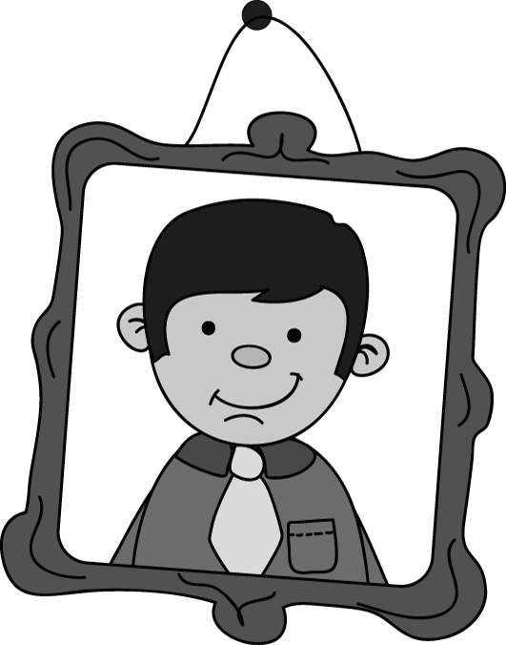
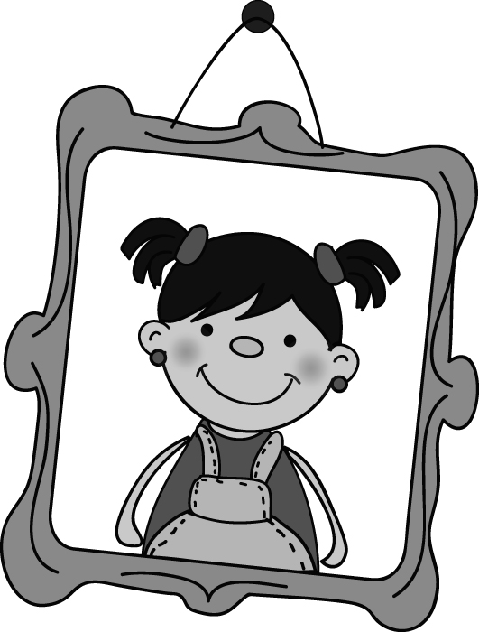
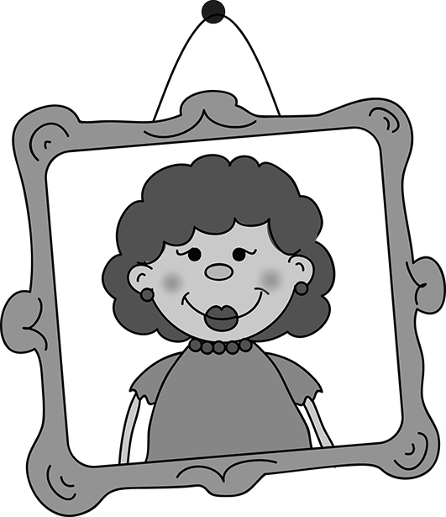
R | G | Y | U | I | O | P | R | G
A | R | O | K | J | S | D | G | R
F | A | T | H | E | R | S | A | A
A | N | E | D | T | R | I | V | N
E | D | W | V | R | T | Y | U | D
B | M | Q | F | F | G | K | L | F
M | O | T | H | E | R | K | J | A
M | T | S | H | F | G | H | G | T
N | H | D | L | O | Z | X | C | H
J | E | S | I | S | T | E | R | E
G | R | Y | U | Z | X | N | V | R

Anna
Julian
Tita

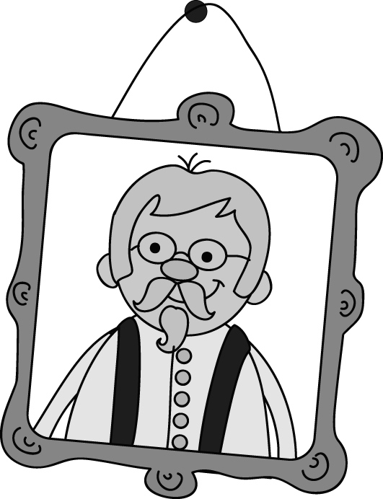
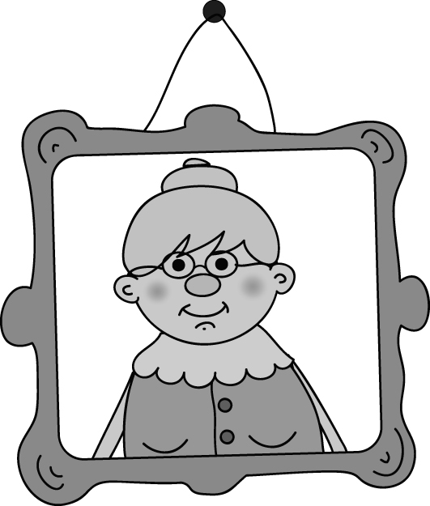


Mariah
Herman

Hello, my name is Tom. This is my family.

- Can you remember all these body parts (face)?


1._____________
3._____________

4._____________
2._____________

5._____________

Read Diego’s email to his friend.
Reading Comprehension

Hi Sebastian,
My name is Diego. I’m 11 years old. I’m from South Africa.
This is my family. I’ve got a little brother. His name is Thomas. He is three.
My father’s name is Robert. He is tall. He has got black, short hair. His eyes are black. My mother is Thais. She is also tall and very beautiful. She has got long, black hair. They are thirty years old.
My brother has got curly hair and black eyes.
I have got a pet, a turtle.

Have you got a pet?
Where are you from?

Your new friend,
Diego


- True or False?
True / False
- Diego is 12 years old…………….……………………..…….
- He is French………………..…………………………………
- His mother is 30 years old………………..………………….
- He has got a pet……………………………………………….
- His brother is Thomas. ……………………………………….

- Answer the questions.

- How old is Robert?__________________________________________________
- Has he got brown hair?_______________________________________________
- Who is Thomas?____________________________________________________
- How old is he?_____________________________________________________
- Is his mother tall and beautiful?____________________________________________

Grammar

- Complete with ’ or ’s.
- She is Mariah_____ sister.
- We are Charles_____ cousins.
- Peter _____ hair is black.
- James _____ eyes are blue.
- Are you the girls_____ uncle?

- Order the following sentences.

- He / big / eyes / has got _________________________________________
- Liliana / a / beautiful / is / girl _______________________________________
- Luís and Miguel / short / are ________________________________________
- They / curly / black / hair / have got __________________________________
- David / small / ears / has got _______________________________________

- Complete with the opposites of the following adjectives.

1. big ________________
2. short hair ___________
3. curly _______________
4. old _________________
5. tall _________________

- Complete this email from Sebastian with the verbs ‘to be’ or ‘to have (got)’.
Hello Diego,
I (1)_______ ten years old and I (2)________ from the USA.
I (3)___________ blue eyes and red hair.
My family (4) ________ small. My sister (5)_______ seven years old. She (6)____________ short hair. My mother’s name is Cathie and she (7)_________ wavy hair. My father (8)___________ Manuel and he 9)___________ brown hair.
We (10)_________ an apartment in Savannah.
Bye,
Sebastian

- Rewrite the sentences with and or but.

- Justin has got straight hair. Marie has got straight hair. __________________________________
- We have got a big nose. Jasmine has got a small nose. _________________________________
Writing

- Imagine you are talking with Diego about his family. Complete the conversation.

YOU: (1) Hi ____________________________?
DIEGO: I’m fine, thanks.
YOU: (2) ________________________________?
DIEGO: Yes, they are. They are my grandparents.
YOU: (3)_________________________________?
DIEGO: My grandfather is 67 years old.
YOU: (4)_________________________________?
DIEGO: They are from Tanzania.
YOU: (5) _________________________________?
DIEGO: He is my cousin, Jokai.

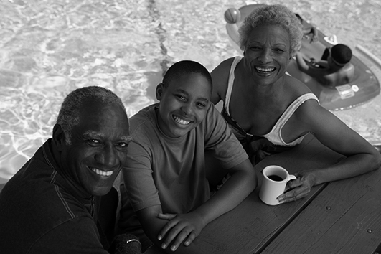

B. Write an email describing your family. Write five sentences.
Name
Age
Physical description
Small or big family
Brothers and sisters

________________________________________________________
________________________________________________________
________________________________________________________
________________________________________________________
________________________________________________________

________________________________________________________
________________________________________________________
________________________________________________________
________________________________________________________

Good luck!
Unit 3 Test B

School:_______________________________________________________________________________
Name:_____________________________________________________ Class:_______ Nr:___________
Date:_____________________________ _________________________ Score:_____________________
Enc. Educação:____________________________________________Teacher:__________________

Vocabulary

- Try to find the family members in the wordsearch.

R | G | Y | U | I | O | P | R | G
A | R | O | K | J | S | D | G | R
F | A | T | H | E | R | S | A | A
A | N | E | D | T | R | I | V | N
E | D | W | V | R | T | Y | U | D
B | M | Q | F | F | G | K | L | F
M | O | T | H | E | R | K | J | A
M | T | S | H | F | G | H | G | T
N | H | D | L | O | Z | X | C | H
J | E | S | I | S | T | E | R | E
G | R | Y | U | Z | X | N | V | R

Tita
Anna
Julian

Mariah
Herman
Hello, my name is Tom. This is my family.

- Can you remember all these body parts ?
mouth eyes ear hair nose

1._____________
3._____________

4._____________
2._____________
5._____________

a)_____________
b)_____________
Reading Comprehension

- Read Diego’s email to his friend.
Hi Sebastian,
My name is Diego. I’m 11 years old. I’m from South Africa.
This is my family. I’ve got a little brother. His name is Thomas. He is three.
My father’s name is Robert. He is tall. He has got black, short hair. His eyes are black. My mother is Thais. She is also tall and very beautiful. She has got long, black hair. They are thirty years old.
My brother has got curly hair and black eyes.
I have got a pet, a turtle.

Have you got a pet?
Where are you from?

Your new friend,
Diego

- True or False?
True / False
- Diego is 12 years old…………….……………………..…….
- He is French………………..…………………………………
- His mother is 30 years old………………..………………….
- He has got a pet……………………………………………….
- His brother is Thomas. ……………………………………….

- Match the questions with the answers.
a) | Yes, she is.
b) | He is three.
c) | Thomas is Diego’s brother,
d) | Robert is 30 years old.
e) | No, he hasn’t.

- How old is Robert?
- Has he got brown hair?
- Who is Thomas?
- How old is he?
- Is his mother tall and beautiful?

Grammar

- Complete with ’ or ’s.
- She is Mariah_____ sister.
- We are Charles_____ cousins.
- Peter _____ hair is black.
- James _____ eyes are blue.
- Are you the girls_____ uncle?

- Order the following sentences.

- He / big / eyes / has got _________________________________________
- Liliana / a / beautiful / is / girl _______________________________________
- Luís and Miguel / short / are ________________________________________
- They / curly / black / hair / have got __________________________________
- David / small / ears / has got _______________________________________

- Complete with the opposites of the following adjectives. Use the words in the box to help. Some are not necessary.
young long hair ugly
short straight
beautiful small
1. big ________________
2. short hair ___________
3. curly _______________
4. old _________________
5. tall _________________

- Complete this email from Sebastian with the verbs ‘to be’ or ‘to have (got)’.
Hello Diego,
I (1) am / have got ten years old and I (2) have got / am from the USA.
I (3) am / have got blue eyes and red hair.
My family (4) is / has got small. My sister (5) am / is seven years old. She (6) have got / has got short hair. My mother’s name is Cathie and she (7) have got / has got wavy hair. My father (8) are / is Manuel and he 9) have got / has got brown hair.
We (10) has got / have got an apartment in Savannah.
Bye,
Sebastian

- Choose and or but to complete the sentences.
- Justin and / but Marie have got straight hair.
- We have got a big nose and / but Jasmine has got a small nose.
Writing

- Imagine you are talking with Diego about his family. Complete the conversation.

How old is your grandparent? Where are your grandparents from?
Who is this boy? How are you? Are they your grandparents?
YOU: (1) Hi ____________________________?
DIEGO: I’m fine, thanks.
YOU: (2) ________________________________?
DIEGO: Yes, they are. They are my grandparents.
YOU: (3)_________________________________?
DIEGO: My grandfather is 67 years old.
YOU: (4)_________________________________?
DIEGO: They are from Tanzania.
YOU: (5) _________________________________?
DIEGO: This is my cousin, Jokai.

B. Write an email describing your family. Write five sentences.
Name
Age
Physical description
Small or big family
Brothers and sisters

My name is ____________ and I’m __________years old.
I’m __________________________________________________
I’ve got _______________________________________________
My family: I’ve got _______________________________________
_____________________________________________________
________________________________________________________

Good luck!

~
Answer Key Unit 3
Test A
VOCABULARY
A.
 | G |  |  |  |  |  |  | G
 | R |  |  |  |  |  |  | R
F | A | T | H | E | R |  |  | A
 | N |  |  |  |  |  |  | N
 | D |  |  |  |  |  |  | D
 | M |  |  |  |  |  |  | F
M | O | T | H | E | R |  |  | A
 | T |  |  |  |  |  |  | T
 | H |  |  |  |  |  |  | H
 | E | S | I | S | T | E | R | E
 | R |  |  |  |  |  |  | R

B. 1. hair 2. ear 3. eyes 4. nose 5. mouth

READING COMPREHENSION

B. 1. False 2. False 3. True 4. True 5. True
C. 1. Robert is thirty years old. 2. No, he hasn’t. 3. Thomas is Diego’s brother. 4. He is three. 5. Yes, she is.

GRAMMAR
A. 1.’s 2.’ 3.’s 4.’ 5.’
B. 1. He has got big eyes. 2. Liliana is a beautiful girl. 3. Luís and Miguel are short. 4. They have got curly black hair. 5. David has got small ears.
C. 1. small 2. long hair 3. straight 4. young 5. short
D. 1. am 2.am 3. have got 4. is 5.is 6. has got 7. has got 8. is 9. has got 10. have got
E. 1. Justin and Marie have got straight hair. 2. We have got a big nose but Jasmine has got a small nose.

WRITING
A. 1. How are you? 2. Are they your grandparents? 3. How old is your grandparent? 4. Where are they from? 5. Who is the boy?
B. Personal answer.
Test B
 | G |  |  |  |  |  |  | G
 | R |  |  |  |  |  |  | R
F | A | T | H | E | R |  |  | A
 | N |  |  |  |  |  |  | N
 | D |  |  |  |  |  |  | D
 | M |  |  |  |  |  |  | F
M | O | T | H | E | R |  |  | A
 | T |  |  |  |  |  |  | T
 | H |  |  |  |  |  |  | H
 | E | S | I | S | T | E | R | E
 | R |  |  |  |  |  |  | R
VOCABULARY
A.

B. 1. hair 2. ear 3. eyes 4. nose 5. mouth

READING COMPREHENSION

B. 1. False 2. False 3. True 4.True 5. True
C. 1. Robert is thirty years old. 2. No, he hasn’t. 3. Thomas is Diego’s brother. 4. He is three. 5. Yes, she is.

GRAMMAR
A. 1.’s 2.’ 3.’s 4.’ 5.’
B. 1. He has got big eyes. 2. Liliana is a beautiful girl. 3. Luís and Miguel are short. 4. They have got curly black hair. 5. David has got small ears.
C. 1. small 2. long hair 3. straight 4. young 5. short
D. 1. am 2. am 3. have got 4. is 5. is 6. has got 7. has got 8. is 9. has got 10. have got .
E. 1. Justin and Marie have got straight hair. 2. We have got a big nose but Jasmine has got a small nose.

WRITING
A. 1. How are you? 2. Are they your grandparents? 3. How old is your grandparent? 4. Where are they from? 5. Who is the boy?
B. Personal answer.

