1. small 2. long hair 3. straight 4. young 5. short
Matriz do teste Unit 4

Teste A
Objetivos/Competências | Conteúdos | Estrutura | Cotações | Critérios de classificação
VOCABULARY  Aplicar o vocabulário da unidade.  25% | Vocabulário relacionado com a unidade 4 | A. Legendar imagens (as partes da casa) | 4 x 3 = 12 | Erros de ortografia: - 0,5 pontos  Resposta errada: 0
VOCABULARY  Aplicar o vocabulário da unidade.  25% | Vocabulário relacionado com a unidade 4 | B. Descobrir na sopa de letras a mobília dada | 5 x 1 = 5 | Erros de ortografia: - 0,5 pontos  Resposta errada: 0
VOCABULARY  Aplicar o vocabulário da unidade.  25% | Vocabulário relacionado com a unidade 4 | C. Legendar a imagem (objetos da casa) | 4 x 2 = 8 | Erros de ortografia: - 0,5 pontos  Resposta errada: 0
READING COMPREHENSION  Compreender o texto na globalidade e em detalhe.  25% | Texto relacionado com a unidade | A. Escolher a opção correta (verdadeiro ou falso) | 5 x 2 = 10 | Erros de ortografia: - 0,5 pontos  Erros de ortografia + estrutura: - 1 ponto  Resposta errada: 0
 | Texto relacionado com a unidade | B. Responder a perguntas sobre o texto | 5 x 3 = 15
GRAMMAR  Aplicar os itens gramaticais tratados.  25% | This/that these/those | A. Reescrever frases no plural | 5 x 2 = 10 | Erros de ortografia: - 0,5 pontos  Erros de ortografia + estrutura: - 1 ponto  Resposta errada: 0
GRAMMAR  Aplicar os itens gramaticais tratados.  25% | Prepositions of place | B. Completar frases com base numa imagem | 5 x 1 = 5
GRAMMAR  Aplicar os itens gramaticais tratados.  25% | Verb ‘There to be’ | C. Escrever frases partindo de outras | 5 x 2 = 10
WRITING  Produzir um enunciado escrito guiado e um livre.  25% | Tema:  Identidade pessoal  Descrição física  Desportos e passatempos | A. Completar um diálogo | 5 x 2 = 10 | Erros de ortografia irrelevantes + estrutura organizada e coerente - 11 – 15 pontos  Erros de ortografia + estrutura pouco organizada  6 - 11 pontos  Erros de ortografia + estrutura bastante desorganizada: - 1 - 6 pontos  Frases incoerentes sem estrutura: 0 pontos
 |  | B. Escrever um texto | 5 x 3 = 15

Teste B
Objetivos/Competências | Conteúdos | Estrutura | Cotações | Critérios de classificação
VOCABULARY  Aplicar o vocabulário da unidade.  25% | Vocabulário relacionado com a unidade 4 | A. Legendar imagens (as partes da casa) | 4 x 3 = 12 | Erros de ortografia: - 0,5 pontos  Resposta errada: 0
VOCABULARY  Aplicar o vocabulário da unidade.  25% | Vocabulário relacionado com a unidade 4 | B. Descobrir na sopa de letras a mobília dada | 5 x 1 = 5 | Erros de ortografia: - 0,5 pontos  Resposta errada: 0
VOCABULARY  Aplicar o vocabulário da unidade.  25% | Vocabulário relacionado com a unidade 4 | C. Legendar a imagem (objetos da casa) | 4 x 2 = 8 | Erros de ortografia: - 0,5 pontos  Resposta errada: 0
READING COMPREHENSION  Compreender o texto na globalidade e em detalhe.  25% | Texto relacionado com a unidade | A. Escolher a opção correta (verdadeiro ou falso) | 5 x 2 = 10 | Erros de ortografia: - 0,5 pontos  Erros de ortografia + estrutura: - 1 ponto  Resposta errada: 0
 | Texto relacionado com a unidade | B. Relacionar as perguntas sobre o texto com as respostas | 5 x 3 = 15
GRAMMAR  Aplicar os itens gramaticais tratados.  25% | This/that these/those | A. Reescrever frases no plural | 5 x 2 = 10 | Erros de ortografia: - 0,5 pontos  Erros de ortografia + estrutura: - 1 ponto  Resposta errada: 0
GRAMMAR  Aplicar os itens gramaticais tratados.  25% | Prepositions of place | B. Completar frases com base numa imagem | 5 x 1 = 5
GRAMMAR  Aplicar os itens gramaticais tratados.  25% | Verb ‘There to be’ | C. Escolher frases partindo de outras | 5 x 2 = 10
WRITING  Produzir um enunciado escrito guiado e um livre.  25% | Tema:  Identidade pessoal  Descrição física  Desportos e passatempos | A. Completar um diálogo | 5 x 2 = 10 | Erros de ortografia irrelevantes + estrutura organizada e coerente - 11 – 15 pontos  Erros de ortografia + estrutura pouco organizada  6 - 11 pontos  Erros de ortografia + estrutura bastante desorganizada: - 1 - 6 pontos  Frases incoerentes sem estrutura: 0 pontos
 |  | B. Escrever um texto | 5 x 3 = 15
Unit 4 Test A

CASA DA AULA – CENTRO DE EXPLICAÇÕES
Name:_____________________________________________________ Class:_______ Nr:___________
Date:______________________________________________________ Score:_____________________
Enc. Educação:____________________________________________Teacher:__________________

Vocabulary

- Write the parts of the house.
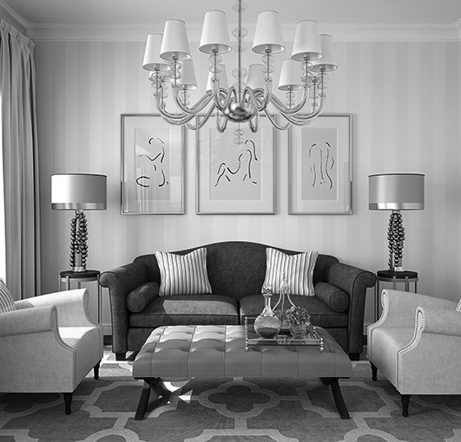
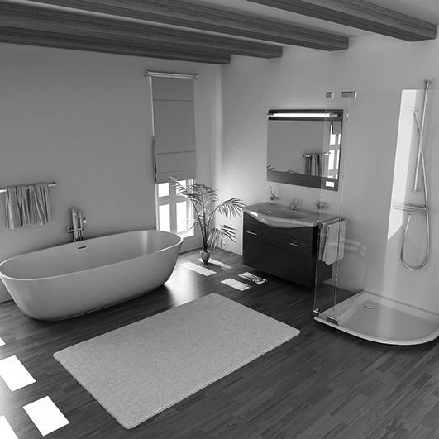
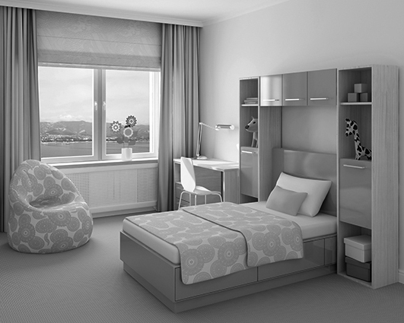
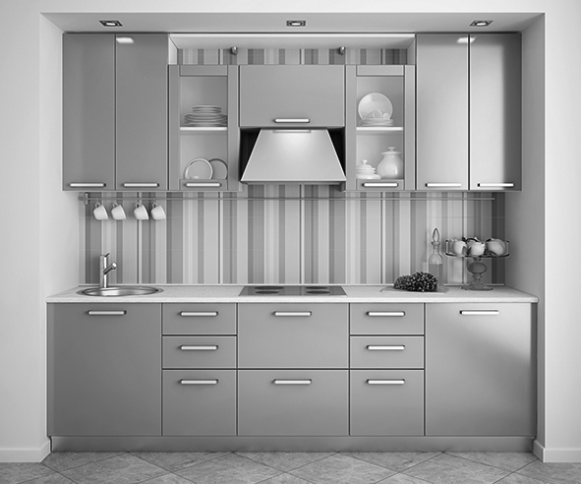
1.___________________
2.__________________
3._________________
4._________________

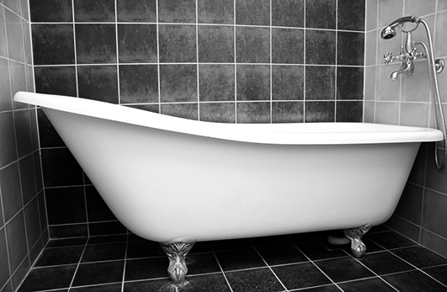
B. Find out the furniture in the word search and write them under the corresponding picture.
2._____________
1._____________
A | R | M | C | H | A | I | R
C | S | T | H | Q | T | G | H
Z | A | B | A | T | H | F | L
X | U | M | I | S | O | F | A
R | E | I | R | H | B | Y | O
W | A | R | D | R | O | B | E
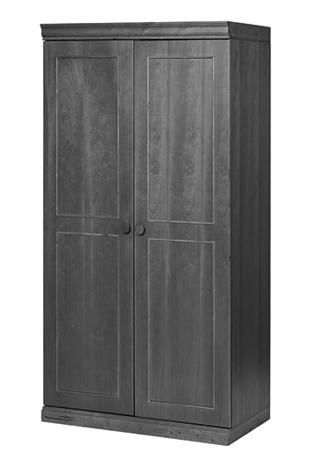
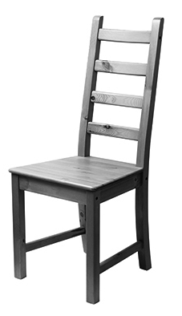
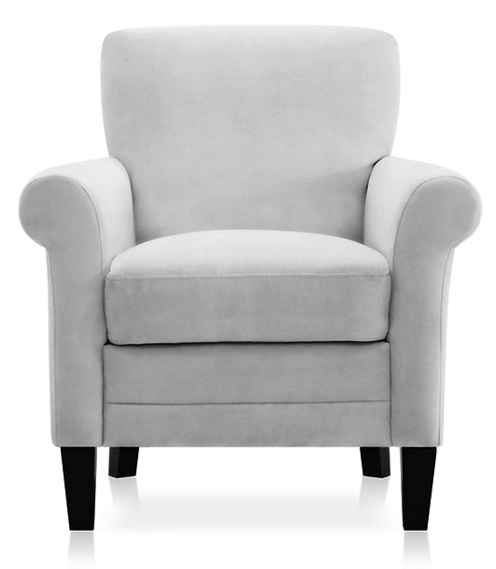

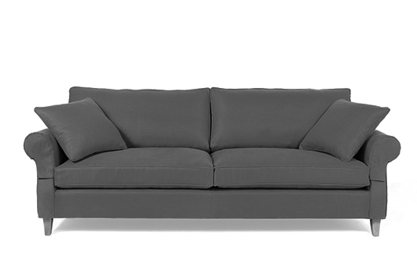
3._____________
2._____________
1._____________
4._____________
5_____________

- Complete with the names of the following objects.
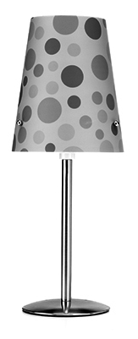
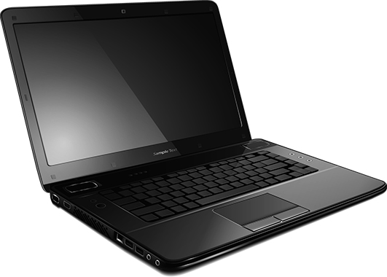



1._____________
4._____________
2._____________
3._____________
1._____________

Read Diego’s email to his friend.
Reading Comprehension

Read the text about Asha.
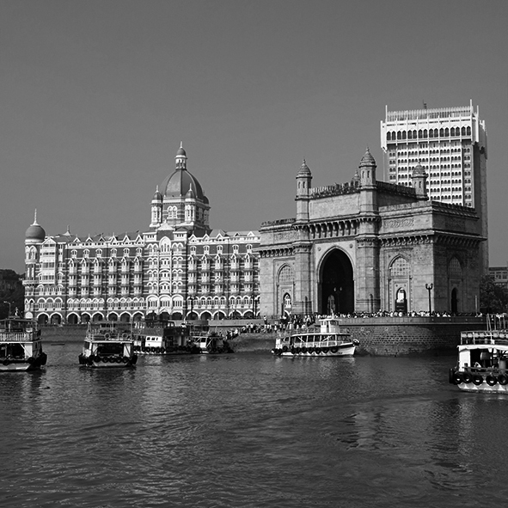
Hello,
I’m Asha and this is my friend Salima. I’m 10 and she is 11. We are from India.
We live in Mumbai, Bombay, in India.
This is the view from our house. We live in an apartment; we can see these beautiful monuments: the Gate of India and the Hotel Taj Mahal Palace. They are amazing.
My apartment is very big because my family is big. We have got four bedrooms, three bathrooms, one living room, one dining room and a kitchen. It is brown and orange. Outside there is a big and beautiful garden!
I’ve got two little twin sisters, Jayita and Tamasi. They are four. They have got straight black hair. Their eyes are blue.
My father’s name is Omar. He is medium size. He has got black, short hair. His eyes are black. My mother is Urbi. She is tall and beautiful. She has got long, straight brown hair. Her eyes are blue.
Where do you live?
Where are you from?

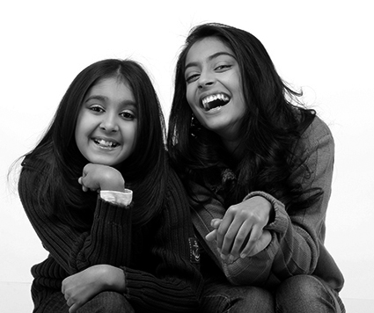

- TRUE or FALSE?
TRUE FALSE
- Asha is Salima’s friend. …..…….……………………..…….
- They are Portuguese……..…………………………………
- They live in India.………….……………..………………….
- Asha has got four sisters. ………………………………….
- Her father’s name is Omar. ……………………………….

- Answer the questions.

- How old is Asha?___________________________________________________
- What can she see from her house?______________________________________
- How is her house?____________________________________________________
- Is the Gate of India a monument?________________________________________
- Are there two living rooms in Asha’s house?__________________________________

Grammar

- Write these sentences in the plural.

e.g. That table is brown. Those tables are brown.

- That is my chair. ________________________________________.
- This armchair is small. _____________________________________.
- That fridge is old. ________________________________________.
- That skirt is mine. _____________________________________ .
- This is my sister. _________________________________________.

- Look at Vasco’s bedroom. Complete the sentences using the prepositions of place:
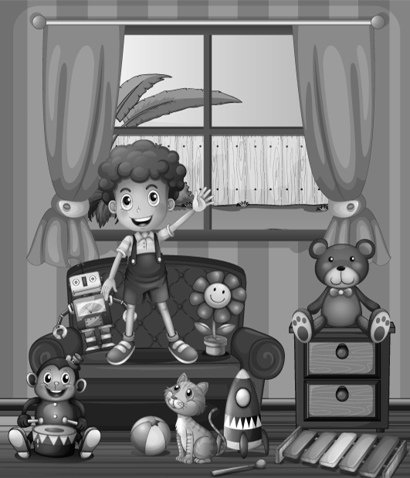
on, in, near.

- There is a robot _____ the sofa.
- There is a ball ________ the cat.
- There is a flower___________ the sofa.
- There is a monkey ______ the floor.
- There are five toys________ the sofa.

- Complete the sentences with the verb There to be.

e.g. I have got a chair in my house. There is a chair in my house.
- She has got three armchairs in the house. ________________________________
- He has got two televisions in the living room.___________________________________
- We have got one bed in the bedroom.___________________________________
- They have got four lamps in the dining room.______________________________
- I have got a computer in my bedroom. ___________________________________

Writing
- Imagine you are talking with Asha about her house. Complete the conversation.

YOU: (1) Hi ____________________________?
ASHA: Yes, it is. This is my bedroom windows.
YOU: (2) ________________________________?
ASHA: There are four bedrooms.
YOU: (3)_________________________________?
ASHA: No, there isn’t an attic.
YOU: (4)_________________________________?
ASHA: My bedroom is pink.
YOU: (5) _________________________________?
ASHA: My favourite place in my house is the living room.

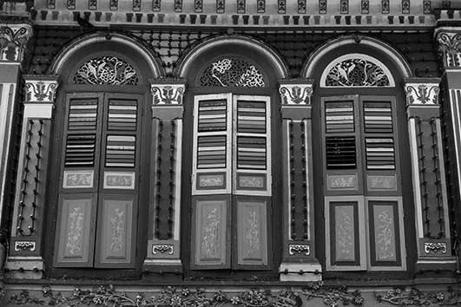

B. Write a description about your family and your house. Write five sentences.
Name
Age
Physical description
Hometown
House

________________________________________________________
________________________________________________________
________________________________________________________
________________________________________________________
________________________________________________________

________________________________________________________
________________________________________________________
________________________________________________________
________________________________________________________

Good luck!

Unit 4 Test B

School:_______________________________________________________________________________
Name:_____________________________________________________ Class:_______ Nr:___________
Date:_____________________________ _________________________ Score:_____________________
Enc. Educação:____________________________________________Teacher:__________________

Vocabulary

- Write the parts of the house.
living room garage bathroom dining room bedroom kitchen

2.___________________
3.___________________
4.___________________
1.___________________
B. Find out the furniture in the word search.
1._____________
2._____________
A | R | M | C | H | A | I | R
C | S | T | H | Q | T | G | H
Z | A | B | A | T | H | F | L
X | U | M | I | S | O | F | A
R | E | I | R | H | B | Y | O
W | A | R | D | R | O | B | E
3.____________

1.____________
2.____________
4.____________
5.____________

- Write the names of the following objects under the correct picture.
books lamp sofa computer chair television

4._____________
3._____________
2._____________
1.____________

Reading Comprehension
- Read Diego’s email to his friend.

Read the text about Asha.

Hello,
I’m Asha and this is my friend Salima. I’m 10 and she is 11. We are from India.
We live in Mumbai, Bombay, in India.
This is the view from our house. We live in an apartment; we can see these beautiful monuments: the Gate of India and the Hotel Taj Mahal Palace. They are amazing.
My apartment is very big because my family is big. We have got four bedrooms, three bathrooms, one living-room, one dining room and a kitchen. It is brown and orange. Outside there is a big and beautiful garden!
I’ve got two little twin sisters, Jayita and Tamasi. They are four. They have got straight black hair. Their eyes are blue.
My father’s name is Omar. He is medium size. He has got black, short hair. His eyes are black. My mother is Urbi. She is tall and beautiful. She has got long, straight brown hair. Her eyes are blue.
Where do you live?
Where are you from?

- True or False?
True / False
- Asha is Salima’s friend. …..…….……………………..…….
- They are Portuguese……..…………………………………
- They live in India.………….……………..………………….
- Asha has got four sisters. ………………………………….
- Her father’s name is Omar. ……………………………….

- Match the questions with the answers.
a) | Her house is big.
b) | Yes, it is.
c) | No, there aren’t.
d) | Asha is 10.
e) | They can see The Gate of India and the Hotel Taj Mahal Palace.

1. How old is Asha?
2. What can they see from their house?
3. How is her house?
4. The Gate of India is a monument?
5. Are there two living rooms in Asha’s house?

Grammar

- Write these sentences in the plural.

e.g. That table is brown. Those tables are brown.

- That is my chair. These / Those are my chairs.
- This armchair is small. These / Those armchairs are small.
- That fridge is old. These / Those fridges are old.
- That skirt is mine. These / Those skirts are mine.
- This is my sister. These / Those are my sisters.

- Look at Vasco’s bedroom. Complete the sentences using the prepositions of place:
on, in, near.

- There is a robot _____ the sofa.
- There is a ball ________ the cat.
- There is a flower___________ the sofa.
- There is a monkey ______ the floor.
- There are five toys________ the sofa.

- Complete the sentences with the verb there to be.

e.g. I have got a chair in my house. There is / There are a chair in my house.
- She has got three armchairs in the house. There are / There is three armchairs in the house
- He has got two televisions in the living room. There are / There is two televisions in the living room.
- We have got one bed in the bedroom. There are / There is one bed in the bedroom.
- They have got four lamps in the dining room. There are / There is four lamps in the dining room.
- I have got a computer in my bedroom. There are / There is a computer in my bedroom.

Writing
- Imagine you are talking with Asha about her house. Complete the conversation.

What colour is your bedroom? * What’s your favourite place in the house?
How many bedrooms are there? * Are these your bedroom windows? * Is there an attic?
YOU: (1) Hi ____________________________?
ASHA: Yes, it is. These are my bedroom windows.
YOU: (2) ________________________________?
ASHA: There are four bedrooms.
YOU: (3)_________________________________?
ASHA: No, there isn’t an attic.
YOU: (4)_________________________________?
ASHA: My bedroom is pink.
YOU: (5) _________________________________?
ASHA: My favourite place in my house is the living room.

B. Write an description about your family and your house. Write five sentences.

My name is ____________ and I’m __________years old.
My family: I’ve got _________________________________
My house is ____________. It is ___________________________.
There are ______ bedrooms, ______ kitchen and _____________
_____________________________________________________
________________________________________________________

Good luck!
~
Answer Key Unit 4
Test A
VOCABULARY
A 1. bedroom 2. kitchen 3. bathroom 4. living room
A | R | M | C | H | A | I | R
 |  |  | H
 |  | B | A | T | H
 |  |  | I | S | O | F | A
 |  |  | R
W | A | R | D | R | O | B | E
B.

1. armchair 2. chair 3. bath 4. sofa 5. wardrobe

C. 1. television 2. lamp 3. computer 4. books

READING COMPREHENSION

B. 1. True 2. False 3. True 4. False 5. True
C. 1 Asha is 10. 2. She can see the Gate of India and the Hotel Taj Mahal Palace. 3. Her house is big. 4. Yes, it is. 5. No, there aren’t.

GRAMMAR
A. 1. Those are my chairs. 2. These armchairs are small. 3. Those fridges are old. 4. Those skirts are mine. 5. These are my sisters.
B. 1.in 2. near 3. in 4. on 5. near
C. 1. There are three armchairs in the house. 2. There are two televisions in the living room. 3. There is one bed in the bedroom. 4. There are four lamps in the dining room. 5. There is a computer in my bedroom.

WRITING
- 1. Are these your bedroom windows? 2. How many bedrooms are there? 3. Is there an attic? 4. What colour is your bedroom? 5. What’s your favourite place in your house?
B. Personal answer.

TEST B
VOCABULARY
A 1. bedroom 2. kitchen 3. bathroom 4. living room
A | R | M | C | H | A | I | R
 |  |  | H
 |  | B | A | T | H
 |  |  | I | S | O | F | A
 |  |  | R
W | A | R | D | R | O | B | E
B.

1. armchair 2. chair 3. bath 4. sofa 5. wardrobe

C. 1. television 2. lamp 3. computer 4. books

READING COMPREHENSION

B. 1.True 2.False 3. True 4.False 5.True
C. 1 Asha is 10. 2. They can see the Gate of India and the Hotel Taj Mahal Palace. 3. Her house is big. 4. Yes, it is. 5. No, there aren’t.

GRAMMAR
A. 1. Those are my chairs. 2. These armchairs are small. 3. Those fridges are old. 4. Those skirts are mine. 5. These are my sisters.
B. 1.in 2. near 3. in 4. on 5. near
C. 1. There are three armchairs in the house. 2. There are two televisions in the living room. 3. There is one bed in the bedroom. 4. There are four lamps in the dining room. 5. There is a computer in my bedroom.

WRITING
- 1. Are these your bedroom windows? 2. How many bedrooms are there? 3. Is there an attic? 4. What colour is your bedroom? 5. What’s your favourite place in your house?
B. Personal answer.

