Teste B
Objetivos/Competências | Conteúdos | Estrutura | Cotações | Critérios de classificação
VOCABULARY  Aplicar o vocabulário da unidade.  25% | Vocabulário relacionado com as unidades 0 e 1 | A. Escrever os números por extenso | 5 x 2 = 10 | Erros de ortografia: - 0,5 pontos  Resposta errada: 0
VOCABULARY  Aplicar o vocabulário da unidade.  25% | Vocabulário relacionado com as unidades 0 e 1 | B. Escrever o nome das cores | 5 x 1 = 5 | Erros de ortografia: - 0,5 pontos  Resposta errada: 0
VOCABULARY  Aplicar o vocabulário da unidade.  25% | Vocabulário relacionado com as unidades 0 e 1 | C. Escrever as nacionalidades | 5 x 2 = 10 | Erros de ortografia: - 0,5 pontos  Resposta errada: 0
READING COMPREHENSION  Compreender o texto na globalidade e em detalhe.  25% | Texto relacionado com a unidade | A. Escolher a opção correta (verdadeiro ou falso) | 5 x 1 = 5 | Erros de ortografia: - 0,5 pontos  Erros de ortografia + estrutura: - 1 ponto  Resposta errada: 0
 | Texto relacionado com a unidade | B. Ligar perguntas e respostas | 5 x 2 = 10
 | Texto relacionado com a unidade | C. Responder corretamente de acordo com o texto | 5 x 2 = 10
GRAMMAR  Aplicar os itens gramaticais tratados.  25% | Personal pronouns | A. Substituir o nome pelo pronome pessoal correspondente | 5 x 1 = 5 | Erros de ortografia:  -0,5 pontos  Erros de ortografia + estrutura: - 1 ponto  Resposta errada: 0
GRAMMAR  Aplicar os itens gramaticais tratados.  25% | Verbo to be | B. Completar espaços com o verbo na afirmativa | 5 x 1 = 5
GRAMMAR  Aplicar os itens gramaticais tratados.  25% | Verbo to be | C. Completar espaços com o verbo na negativa | 5 x 1 = 5
GRAMMAR  Aplicar os itens gramaticais tratados.  25% | Verbo to be | D. Completar espaços com o verbo de acordo com uma tabela | 10 x 1 = 10
WRITING  Produzir um enunciado escrito guiado e um livre.  25% | Tema:  Identidade  Nacionalidade | A. Completar um diálogo | 5 x 2 = 10 | Erros de ortografia irrelevantes + estrutura organizada e coerente - 11 - 15 pontos  Erros de ortografia + estrutura pouco organizada  6 - 11 pontos  Erros de ortografia + estrutura bastante desorganizada: - 1 - 6 pontos  Frases incoerentes sem estrutura: 0 pontos
 | Tema:  Identidade  Nacionalidade | B. Escrever um texto sobre si | 5 x 3 = 15
Matriz do teste Unit 0 and 1
Teste A
Objetivos/Competências | Conteúdos | Estrutura | Cotações | Critérios de classificação
VOCABULARY  Aplicar o vocabulário da unidade.  25% | Vocabulário relacionado com as unidades 0 e 1 | A. Escrever os números por extenso | 5 x 2 = 10 | Erros de ortografia: - 0,5 pontos  Resposta errada: 0
VOCABULARY  Aplicar o vocabulário da unidade.  25% | Vocabulário relacionado com as unidades 0 e 1 | B. Escrever o nome das cores | 5 x 1 = 5 | Erros de ortografia: - 0,5 pontos  Resposta errada: 0
VOCABULARY  Aplicar o vocabulário da unidade.  25% | Vocabulário relacionado com as unidades 0 e 1 | C. Escrever as nacionalidades | 5 x 2 = 10 | Erros de ortografia: - 0,5 pontos  Resposta errada: 0
READING COMPREHENSION  Compreender o texto na globalidade e em detalhe.  25% | Texto relacionado com a unidade | A. Escolher a opção correta (verdadeiro ou falso) | 5 x 1 = 5 | Erros de ortografia: - 0,5 pontos  Erros de ortografia + estrutura: - 1 ponto  Resposta errada: 0
 | Texto relacionado com a unidade | B. Ligar perguntas e respostas | 5 x 2 = 10
 | Texto relacionado com a unidade | C. Responder corretamente de acordo com o texto | 5 x 2 = 10
GRAMMAR  Aplicar os itens gramaticais tratados.  25% | Personal pronouns | A. Substituir o nome pelo pronome pessoal correspondente | 5 x 1 = 5 | Erros de ortografia: - 0,5 pontos  Erros de ortografia + estrutura: - 1 ponto  Resposta errada: 0
GRAMMAR  Aplicar os itens gramaticais tratados.  25% | Verbo to be | B. Completar espaços com o verbo na afirmativa | 5 x 1 = 5
GRAMMAR  Aplicar os itens gramaticais tratados.  25% | Verbo to be | C. Completar espaços com o verbo na negativa | 5 x 1 = 5
GRAMMAR  Aplicar os itens gramaticais tratados.  25% | Verbo to be | D. Completar espaços com o verbo de acordo com uma tabela | 10 x 1 = 10
WRITING  Produzir um enunciado escrito guiado e um livre.  25% | Tema:  Identidade  Nacionalidade | A. Completar um diálogo | 5 x 2 = 10 | Erros de ortografia irrelevantes + estrutura organizada e coerente- 11 - 15 pontos  Erros de ortografia + estrutura pouco organizada  6 - 11 pontos  Erros de ortografia + estrutura bastante desorganizada: - 1 - 6 pontos  Frases incoerentes sem estrutura: 0 pontos
 | Tema:  Identidade  Nacionalidade | B. Escrever um texto sobre si | 5 x 3 = 15

Unit 0 and 1 Test A

School:_________________________________________________________________________________
Name:_____________________________________________________________ Class:____ Nr:_______
Date:_________________________________________________ Score:___________________________
Enc. Educação:_______________________________________Teacher:_______________________

Vocabulary
- Write the numbers.

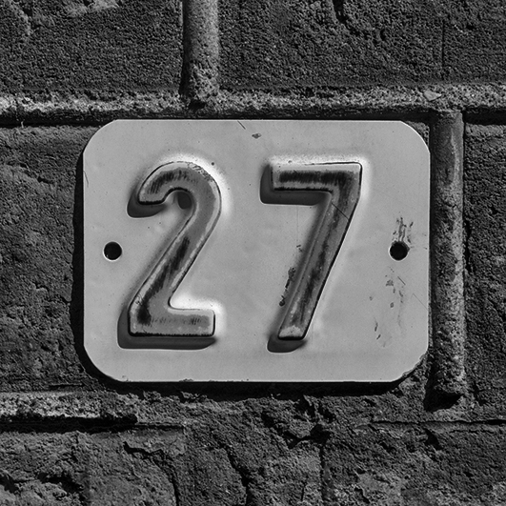

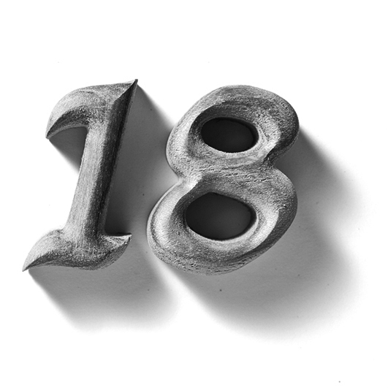
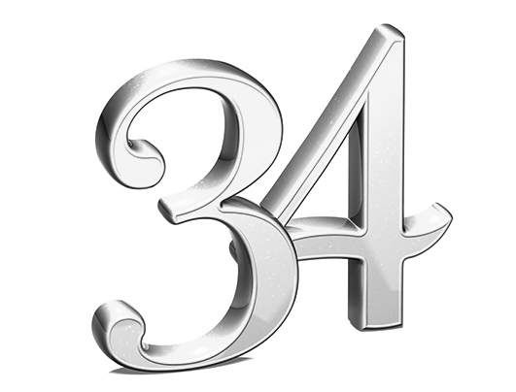
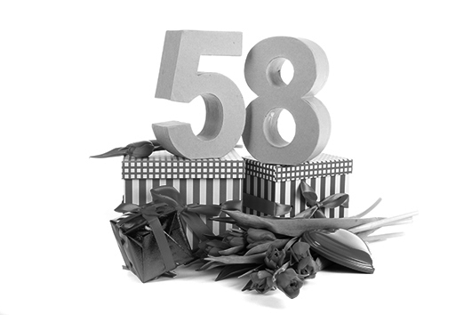

4)
5
3)
2)
1)

- Order the letters and find the colours.

eergn
hitew
knip
wollye
edr

2)
1)
5)
4)
3)
2)
1)

- Complete with the correct nationality.

.
I am from Russia.
I’m (3)__________.
I am from China.
I’m (4)__________.
I am from France.
I’m (5)__________.
I am from Canada.
I’m (2)__________.
I am from Scotland.
I’m (1)__________.
Reading Comprehension
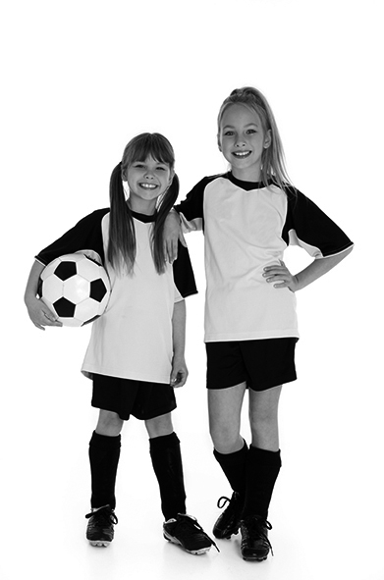
Read about Elena.
Hi, my name is Elena Sanchez and I’m ten years old. My best friend is Thais, she is nine.
My birthday is in June, but her birthday is in May.
I am from Mexico. I’m Mexican. Thais is Brazilian. She is from Brazil.
Our favourite colour is orange and my favourite sport is volleyball. Thais’s favourite sport is football.
See you soon!

A. True (T) or False (F)?

- Elena is British. 4. Thais birthday is in May.

- Elena is 8 years old. 5. Thais is from Italy.

- Elena’s surname is Sanchez.

B. Choose the correct answer.
- No, they aren’t.
- Yes, she is.
- Yes, they are.
- No, it isn’t.
- Yes, she is.

- Are Thais and Elena friends?___________________________
- Is Elena ten years old? _________________________________
- Is Thais Brazilian? ______________________________________
- Are they from Greece? _________________________________
- Is Elena’s favourite sport football? ________________________

C. Answer these questions about the text.
- How old is Elena?_____________________________________________________________
- What’s Elena’s favourite colour?__________________________________________________
- When is Thais’ birthday?_______________________________________________________
- What’s Elena’s favourite sport?___________________________________________________
- Where is Thais from?__________________________________________________________

Grammar

- Replace the underlined expressions by personal pronouns.
e.g. Elena is Mexican. She is Mexican.

- Joana is from France. _______________________________________________________.
- Eva and Trip are eight years old.____________________________________________.
- Theresa is my best friend.___________________________________________________.
- Joaquin is from Venezuela. _______________________________________________.
- Leandro and I are Greek._____________________________________________________.

- Complete the sentences with the verb ‘to be’ – affirmative.

- We _________ Japanese.
- My parents _____ 32 years old.
- My best friend _____ German.
- Adam and Peter _____ best friends.
- He _____ 10 years old.

- Complete the sentences with the verb ‘to be’ – negative.

- They _________ American.
- My grandfather _____ 40 years old.
- She _______ from Canada.
- We _______ nine years.
- My aunt _______ from Spain.

- Look at the table and complete the sentences with the verb ‘to be’ (affirmative or negative).

Name | Age | Nationality | Favourite colour
Renata | 10 | Canadian | pink
Claudia | 9 | Irish | grey
Rubin | 11 | British | yellow
Mariah / Paul | 12 | German | white

- My name ______ Renata. My favourite colour _____pink.
- Claudia _____ German. She _____ Irish.
- Rubin _____ 9 years old. Her favourite colour _____ yellow.
- Mariah and Paul ____German. Their favourite colour ___ purple.
- Renata ____ 10 years. She _____Canadian.

Writing

A. Imagine you are talking with Elena. Complete the conversation.
You: (1)_________________________?
Adam: My name is Elena Sanchez.
You: (2)_________________________?
Adam: I’m ten.
You: (3)_________________________?
Adam: I’m Mexican.
You: (4)_________________________?
Adam: It’s in June.
You: (5)__________________________?
Adam: It’s orange.

B. Write a text about yourself.

My name is ____________________________________
name
age
nationality
birthday
favourite colour

______________________________________________
______________________________________________
______________________________________________
______________________________________________
______________________________________________
______________________________________________

Good luck!

Unit 0 and 1 Test B

School:_________________________________________________________________________________
Name:_____________________________________________________________ Class:____ Nr:_______
Date:_________________________________________________ Score:___________________________
Enc. Educação:_______________________________________Teacher:_______________________

Vocabulary
- Write the numbers.
eighteen twenty-seven fifty-eight ninety-five thirty-four fifty-eight ninety -five

4)
5
3)
2)
1)

- Write the colours.
white red green pink yellow

eergn
hitew
knip
wollye
edr

2)
1)
5)
4)
3)
2)
1)

- Complete with the correct nationality.
Russian
French
Scottish Chinese
Canadian

.
I am from Russia.
I’m (3)__________.
I am from China.
I’m (4)__________.
I am from France.
I’m (5)__________.
I am from Scotland.
I’m (1)__________.
I am from Canada.
I’m (2)__________.
Reading Comprehension

Read about Elena.
Hi, my name is Elena Sanchez and I’m ten years old. My best friend is Thais, she is nine.
My birthday is in June, but her birthday is in May.
I am from Mexico. I’m Mexican. Thais is Brazilian. She is from Brazil.
Our favourite colour is orange and my favourite sport is volleyball. Thais’s favourite sport is football.
See you soon!

A. True (T) or False (F)?

- Elena is British. 4. Thais birthday is in May.

- Elena is 8 years old. 5. Thais is from Italy.

- Elena’s surname is Sanchez.

B. Choose the correct answer.
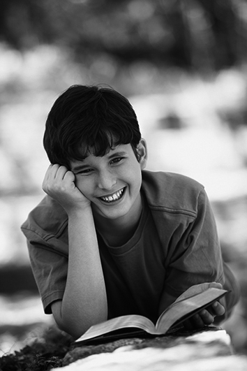
- Are Thais and Elena friends? Yes, they are / No, they aren’t.
- Is Elena ten years old? Yes, she is / No, she isn’t.
- Is Thais Brazilian? Yes, she is / No, she isn’t.
- Are they from Greece? Yes, they are / No, they aren’t.
- Is Elena’s favourite sport football? Yes, it is / No, it isn’t.

C. Answer these questions about the text. Choose the best answer.
- How old is Elena? She is eight / ten.
- What’s Elena’s favourite colour? It’s green / orange.
- When is Thais’s birthday? Thais birthday is in December /May.
- What’s Elena’s favourite sport? It’s volleyball / football.
- Where is Thais from? She is from Portugal / Brazil.

Grammar

- Circle the correct personal pronouns.
e.g. Elena is Mexican. She is Mexican.

- Joana is from France. He / She is from France.
- Eva and Trip are eight years old. They / She are eight years old.
- Theresa is my best friend. He / She is my best friend.
- Joaquin is from Venezuela. He / She is from Venezuela.
- Leandro and I are Greek. We / They are Greek.

- Choose the right form of the verb ‘to be’ – affirmative.

- Tania is / are Japanese.
- My parents is / are 32 years old.
- My best friend is / are German.
- Adam and Peter is / are best friends.
- He is / are 10 years old.

- Circle the correct form of the verb ‘to be’ – negative.

- They aren’t / isn’t American.
- My grandfather aren’t / isn’t 40 years old.
- She aren’t / isn’t from Canada.
- We aren’t / isn’t nine years.
- My aunt aren’t / isn’t from Spain.

- Look at the table and complete the sentences with the verb ‘to be’ (affirmative or negative).

Name | Age | Nationality | Favourite colour
Renata | 10 | Canadian | pink
Claudia | 9 | Irish | grey
Rubin | 11 | British | yellow
Mariah / Paul | 12 | German | white

- My name are / is Renata. My favourite colour are / is pink
- Claudia is / are German. She is / isn’t Irish.
- Rubin are / is 9 years old. Her favourite colour isn’t / is yellow.
- Mariah and Paul aren’t / are German. Their favourite colour isn’t / aren’t purple.
- Renata is / are 10 years old. She are / is Canadian.

Writing

A. Imagine you are talking with Elena. Complete the conversation.
How old are you? * What’s your favourite colour? * What’s your name? * When’s your birthday? *What’s your nationality?

You: (1)_________________________?
Adam: My name is Elena Sanchez.
You: (2)_________________________?
Adam: I’m ten.
You: (3)_________________________?
Adam: I’m Mexican.
You: (4)_________________________?
Adam: It’s in June.
You: (5)__________________________?
Adam: It’s orange.

B. Write a text about yourself.

name
age
nationality
birthday
favourite colour

My name is _____________________________
I am _______ years old.
I am __________________________________.
My birthday is in_________________________.
My favourite colour is_____________________.

Good luck!
Test A
Answer Key Unit 0 and 1

TEST A
VOCABULARY
A. 1. thirty-four 2. fifty-eight 3. eighteen 4. twenty-seven 5. ninety-five
B. 1. red 2. yelllow 3. pink 4. white 5. green
C. 1. Scottish 2. Canadian 3.Russian 4. Chinese 5. French

READING COMPREHENSION
A. 1. False 2. False 3. True 4. True 5. False
B. 1. Yes, they are. 2. Yes, she is. 3. Yes, she is. 4. No, they aren’t. 5. No, it isn’t.
C. 1. She is ten years old. 2. Elena’s favourite colour is orange. 3. Thais’ birthday is in May. 4. Elena’s favourite sport is volleyball. 5. Thais is from Brazil.

GRAMMAR
A. 1. She 2.They 3. She 4. He 5. We
B. 1. is 2. are 3. is 4. are 5. is
C. 1. aren’t 2. isn’t 3. isn’t 4. aren’t 5.isn’t
D. 1. is / is 2. isn’t / is 3. isn´t / is 4. are / isn´t 5. is/ is

WRITING
A.1. What’s your name? 2. How old are you? 3. What’s your nationality? 4. When is your birthday 5. What’s your favourite colour?
B. Personal answer

Test B
VOCABULARY
A. 1. thirty-four 2. fifty-eight 3. eighteen 4. twenty-seven 5. ninety-five
B. 1. red 2. yelllow 3. pink 4. white 5. green
C. 1. Scottish 2. Canadian 3. Russian 4. Chinese 5. French

READING COMPREHENSION
A. 1.False 2. False 3. True 4. True 5. False
B. 1.Yes, they are. 2. Yes, he is. 3. Yes, he is. 4. No, they aren’t. 5. No, it isn’t.
C. 1. She is ten years old. 2. Elena’s favourite colour is orange. 3. Thais’ birthday is in May. 4. It’s volleyball. 5. She is from Brazil.

GRAMMAR
A. 1. She 2. They 3. She 4. He 5. We
B. 1. are 2. are 3. is 4. are 5. is
C. 1. aren’t 2. isn’t 3. isn’t 4. aren’t 5.isn’t
D. 1. is / is 2. isn’t / is 3. isn´t / is 4. are / isn´t 5. is / is

WRITING
A.1. What’s your name? 2. How old are you? 3. What’s your nationality? 4. When is your birthday 5. What’s your favourite colour?
B. Personal answer

