Matriz do teste Unit 5 and 6

Teste A
Objetivos/Competências | Conteúdos | Estrutura | Cotações | Critérios de classificação
VOCABULARY  Aplicar o vocabulário da unidade.  25% | Vocabulário relacionado com as unidades 5 e 6 | A. Completar com os desportos | 5 x 1 = 5 | Erros de ortografia: - 0,5 pontos  Resposta errada: 0
VOCABULARY  Aplicar o vocabulário da unidade.  25% | Vocabulário relacionado com as unidades 5 e 6 | B. Completar (dias da semana e meses) | 12 x 0.5 = 6 | Erros de ortografia: - 0,5 pontos  Resposta errada: 0
VOCABULARY  Aplicar o vocabulário da unidade.  25% | Vocabulário relacionado com as unidades 5 e 6 | C. Completar com rotina diária | 4 x 2 = 8 | Erros de ortografia: - 0,5 pontos  Resposta errada: 0
VOCABULARY  Aplicar o vocabulário da unidade.  25% | Vocabulário relacionado com as unidades 5 e 6 | D. Completar com as horas | 4 x 2 = 8 | Erros de ortografia: - 0,5 pontos  Resposta errada: 0
READING COMPREHENSION  Compreender o texto na globalidade e em detalhe.  25% | Texto relacionado com as unidades 5 e 6 | A. Completar uma tabela | 5 x 2 = 10 | Erros de ortografia: - 0,5 pontos  Erros de ortografia + estrutura: - 1 ponto  Resposta errada: 0
 | Texto relacionado com as unidades 5 e 6 | B. Responder às perguntas sobre o texto | 5 x 3 = 15
GRAMMAR  Aplicar os itens gramaticais tratados.  25% | Prepositions of time:  in, on, at, after, before | A. Escolher a hipótese correta. | 5 x 1 = 5 | Erros de ortografia: - 0,5 pontos  Erros de ortografia + estrutura: - 1 ponto  Resposta errada: 0
GRAMMAR  Aplicar os itens gramaticais tratados.  25% | Modal verb can | B. Escrever frases | 5 x 1 = 5
GRAMMAR  Aplicar os itens gramaticais tratados.  25% | Connectors:  and, or, but | C. Completar frases | 5 x 1 = 5
GRAMMAR  Aplicar os itens gramaticais tratados.  25% | Present Simple | D. Completar as frases | 8 x 2 = 8
WRITING  Produzir um enunciado escrito guiado e um livre.  25% | Tema:  Identidade  Desportos e passatempo | A. Completar um diálogo | 5 x 2 = 10 | Erros de ortografia irrelevantes + estrutura organizada e coerente - 8 - 12 pontos  Erros de ortografia + estrutura pouco organizada  5 - 8 pontos  Erros de ortografia + estrutura bastante desorganizada: - 1 - 4 pontos  Frases incoerentes sem estrutura: 0 pontos
 | Tema:  Identidade  Desportos e passatempo | B. Escrever um texto | 15

Teste B
Objetivos/Competências | Conteúdos | Estrutura | Cotações | Critérios de classificação
VOCABULARY  Aplicar o vocabulário da unidade.  25% | Vocabulário relacionado com as unidades 5 e 6 | A. Completar com os desportos | 5 x 1 = 5 | Erros de ortografia: - 0,5 pontos  Resposta errada: 0
VOCABULARY  Aplicar o vocabulário da unidade.  25% | Vocabulário relacionado com as unidades 5 e 6 | B. Completar (dias da semana e meses) | 12 x 0.5 = 6 | Erros de ortografia: - 0,5 pontos  Resposta errada: 0
VOCABULARY  Aplicar o vocabulário da unidade.  25% | Vocabulário relacionado com as unidades 5 e 6 | C. Completar com rotina diária | 4 x 2 = 8 | Erros de ortografia: - 0,5 pontos  Resposta errada: 0
VOCABULARY  Aplicar o vocabulário da unidade.  25% | Vocabulário relacionado com as unidades 5 e 6 | D. Completar com as horas | 4 x 2 = 8 | Erros de ortografia: - 0,5 pontos  Resposta errada: 0
READING COMPREHENSION  Compreender o texto na globalidade e em detalhe.  25% | Texto relacionado com as unidades 5 e 6 | A. Completar uma tabela | 5 x 2 = 10 | Erros de ortografia: - 0,5 pontos  Erros de ortografia + estrutura: - 1 ponto  Resposta errada: 0
 | Texto relacionado com as unidades 5 e 6 | B. Responder às perguntas sobre o texto | 5 x 3 = 15
GRAMMAR  Aplicar os itens gramaticais tratados.  25% | Prepositions of time:  in, on, at, after, before | A. Escolher a hipótese correta | 5 x 1 = 5 | Erros de ortografia: - 0,5 pontos  Erros de ortografia + estrutura: - 1 ponto  Resposta errada: 0
GRAMMAR  Aplicar os itens gramaticais tratados.  25% | Modal verb can | B. Escrever frases | 5 x 1 = 5
GRAMMAR  Aplicar os itens gramaticais tratados.  25% | Connectors:  and, or, but | C. Completar frases | 5 x 1 = 5
GRAMMAR  Aplicar os itens gramaticais tratados.  25% | Present Simple | D. Completar as frases | 8 x 2 = 8
WRITING  Produzir um enunciado escrito guiado e um livre.  25% | Tema:  Identidade  Desportos e passatempo | A. Completar um diálogo | 5 x 2 = 10 | Erros de ortografia irrelevantes + estrutura organizada e coerente - 8 - 12 pontos  Erros de ortografia + estrutura pouco organizada  5 - 8 pontos  Erros de ortografia + estrutura bastante desorganizada: - 1 - 4 pontos  Frases incoerentes sem estrutura: 0 pontos
 | Tema:  Identidade  Desportos e passatempo | B. Escrever um texto | 15

Units 5 and 6 Test A

School:_______________________________________________________________________________
Name:_____________________________________________________ Class:_______ Nr:___________
Date:______________________________________________________ Score:_____________________
Enc. Educação:____________________________________________Teacher:__________________

Vocabulary

- Look at the pictures and write the names of the sports.

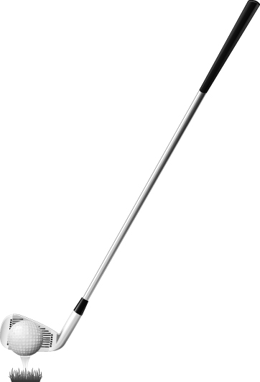

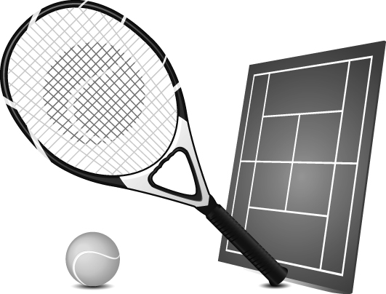


4.
3.
2.
5.
1.

- Write the days of the week and the months.

Monday - _________ - __________ - Thursday - __________ - ____________ - _____________

January - _________ - March - ________ - ________ - ________ - July - ________ - September - __________- __________- December

- This is Mark’s daily routine in the morning. Label the pictures.

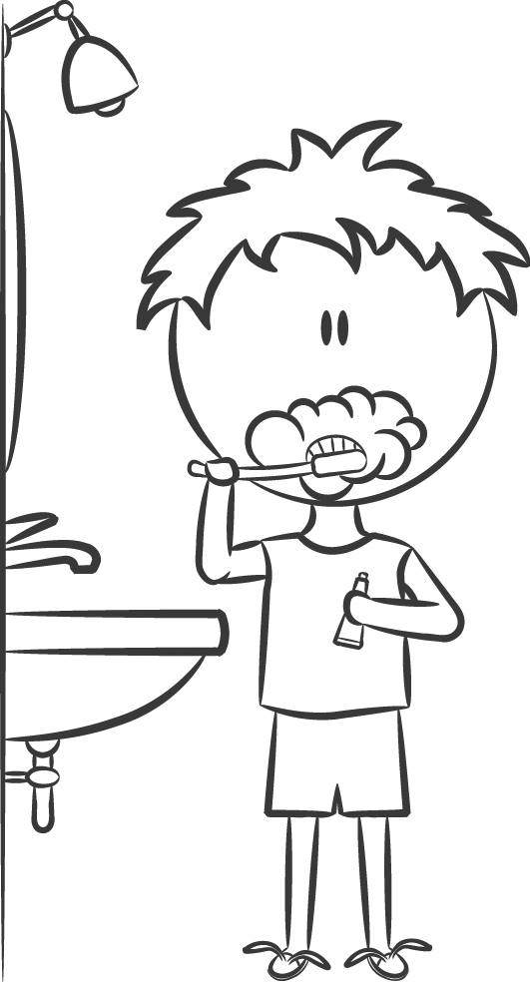

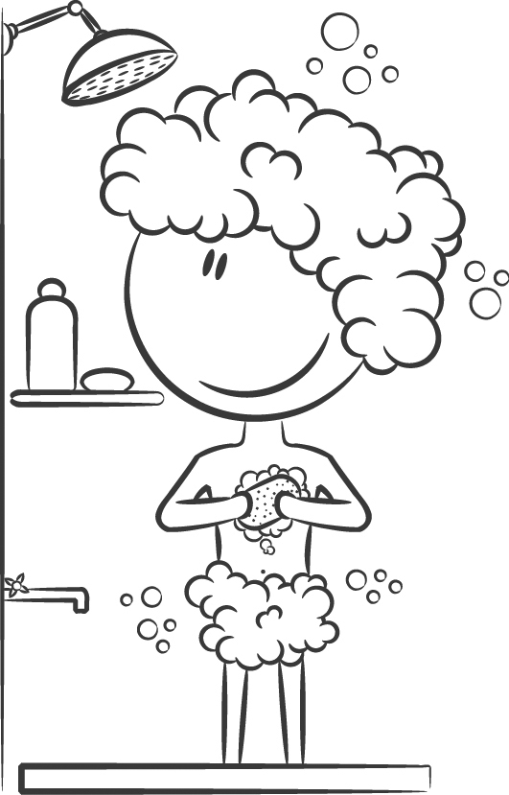

1.
3.
4.
2.



- What time is it?
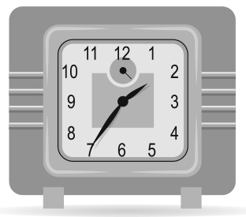
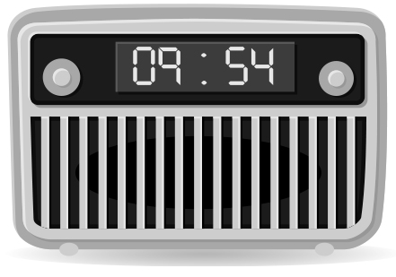
3. _____________
_______________
4. _____________
_______________
2. _____________
_______________
1. _____________
_______________
Reading Comprehension


Hello, how are you?
My name is Justin Stevenson and this is my sister Joyce. I’m eleven years old and my sister is ten. We are from Wales.
My favourite sport is running. My sister’s favourite sport is volleyball.
At the weekends I get up early, have a shower, have breakfast and then I go jogging. I run for one hour with my father and my dog, Max. He also loves running.
Joyce plays volleyball on Mondays and on Thursdays after school. She does her homework and she goes to the gym. I can’t play volleyball.
And you?
What’s your favourite sport?



- Complete the table with information about Justin.
Name | Justin
Surname
Nationality
Sister’s name
His favourite sport
When Joyce practices volleyball

- Answer these questions according to the text.

- How old is Justin?________________________________________________________________
- What’s Joyce favourite sport?_______________________________________________________
- Has Justin got pets?_______________________________________________________________
- Can he play volleyball?_____________________________________________________________
- Is his dog’s name Max?___________________________________________________________

Grammar
- Complete using the prepositions of time in, on, at, before, after.

      - I have classes ____ the morning.
      - Michael plays badminton ______Wednesday.
      - Justin has got Maths_____ half past four.
      - I go home ______ school.
      - Your birthday is ______ Christmas.

- Look at the table and write sentences about Justin and Joyce with can or can’t.

 | play tennis | ride a horse | dance Hip-Hop
Justin |  | X
Joyce |  |  | X

e.g. Justin can play tennis. 3. _________________________________
1. __________________________________ 4.__________________________________
2.__________________________________ 5.__________________________________


- Complete the sentences with but, and, or.

1. You can dance Hip-Hop _____ ballet. You have to choose one.
2. I can’t play tennis ____ I can play football.
3. Jasmine has got Maths _____ English on Friday.
4. Choose your favourite sport: volleyball ____ basketball.
5. They can ride a bike _____ a horse.

- Complete with the Present Simple of the verbs in brackets.

Andrea (1)_________ (play) football on Wednesday. She (2)___________ (like) to play tennis. Her mother (3) _______ (can) ride a bike. Her father (4) _________ (prefer) to ride a horse. Her brother name’s (5) ___________ (be) Vasco. He (6)__________ (go) to school in the morning. He (7)___________ (not have) classes in the afternoon. They (8) ____________ (be) a big family.

Writing

- Imagine you are talking with Justin about Kevin, his best friend. Complete the conversation.
JUSTIN: Look, this is my best friend.
YOU: (1) _______________________________________?
JUSTIN: His name is Kevin.
YOU: (2) _______________________________________?
JUSTIN: He is eleven years old.
YOU: (3) _______________________________________?
JUSTIN: We are from Canada.
YOU: (4)__________________________________________?
JUSTIN: My birthday? It’s in April.
YOU: Right. Let’s play chess! (5)___________________?
JUSTIN: No, I can’t. But I can run fast!



Name |  |  | ABOUT ME  _______________________________________  _______________________________________  _______________________________________  _______________________________________  _______________________________________  _______________________________________  _______________________________________
Age
Nationality
Favourite hobby
Can
Can’t


B. Fill in the table and write a text about yourself.

Good luck!
Units 5 and 6 Test B

School:_______________________________________________________________________________
Name:_____________________________________________________ Class:_______ Nr:___________
Date:______________________________________________________ Score:_____________________
Enc. Educação:____________________________________________Teacher:__________________

Vocabulary

- Look at the pictures and write the names of the sports.

4.
3.
2.
5.
1.

- Write the days of the week and the months.

Monday - _________ - __________ - Thursday - __________ - ____________ - _____________

January - _________ - March - ________ - ________ - ________ - July - ________ - September - _________- __________- December

- This is Mark’s daily routine in the morning. Label the images.

go to bed have a shower get up go to school wash his teeth have breakfast

3.
1.
4.
2.

- What time is it? Complete.
4.
3.
2.
1.
a) It’s ten past ten.
b) It’s six to ten.
c) It’s twenty past twelve.
d) It’s twenty-five to two.
Reading Comprehension

Hello, how are you?
My name is Justin Stevenson and this is my sister Joyce. I’m eleven years old and my sister is ten. We are from Wales.
My favourite sport is running. My sister’s favourite sport is volleyball.
At the weekends I get up early, have a shower, have breakfast and I go jogging. I run for one hour with my father and my dog, Max. He also loves running.
Joyce plays volleyball on Mondays and on Thursdays after school. She does her homework and she goes to the gym. I can’t play volleyball.
And you?
What’s your favourite sport?

- Complete the table with information about Justin.
Name | Justin
Surname
Nationality
Sister’s name
His favourite sport
When Joyce practices volleyball

- Match these questions according to the text.
a) No, he can’t.
b) Max.
c) He is eleven.
d) Yes, he has.
e) It’s volleyball.
- How old is Justin?
- What’s Joyce favourite sport?
- Has Justin got any pet?
- Can he play volleyball?
- What’s his dog’s name?

Grammar
- Complete using the prepositions of time in, on, at, before, after.

- I have classes in / on the morning.
- Michael plays badminton in / on Wednesday.
- Justin has got Maths at / before / after half past four.
- I go home before / after school.
- Your birthday is before / after Christmas.

- Look at the table and write sentences about Justin and Joyce with can or can’t.

 | play tennis | ride a horse | dance Hip-Hop
Justin |  | X
Joyce |  |  | X

e.g. Justin can play tennis. 3. _________________________________
1. __________________________________ 4.__________________________________
2.__________________________________ 5.__________________________________

- Complete the sentences with but, and, or.
1. You can dance Hip-Hop _____ ballet. You have to choose one.
2. I can’t play tennis ____ I can play football.
3. Jasmine has got Maths _____ English on Friday.
4. Choose your favourite sport: volleyball ____ basketball.
5. They can ride a bike _____ a horse.

- Choose the best option for the Present Simple.

Andrea (1) plays / play football on Wednesday. She (2) don’t like / doesn’t like to play tennis. Her mother (3) can / can’t ride a bike. Her father (4) prefer / prefers to ride a horse. Her brother’s name (5)
is / are Vasco. He (6) go / goes to school in the morning. He (7) has / doesn’t have classes in the afternoon. They (8) isn’t / aren’t a big family.

- magine you are talking with Justin about Kevin, his best friend. Complete
Writing

- Imagine you are talking with Justin about Kevin, his best friend. Complete the conversation.
How old is he? Can you play chess? Where are you from? What’s his name? When is your birthday?

JUSTIN: Look, this is my best friend.
YOU: (1) _______________________________________?
JUSTIN: His name is Kevin.
YOU: (2) _______________________________________?
JUSTIN: He is eleven years old.
YOU: (3) _______________________________________?
JUSTIN: We are from Wales.
YOU: (4)__________________________________________?
JUSTIN: My birthday? It’s in April.
YOU: Right. Let’s play chess! (5)___________________?
JUSTIN: No, I can’t. But I can run fast!

B. Fill in the table and write a text about yourself.
Name |  |  | ABOUT ME  _______________________________________  _______________________________________  _______________________________________  _______________________________________  _______________________________________  _______________________________________  _______________________________________
Age
Nationality
Favourite hobby
Can
Can’t

Good luck!
Answer Key Units 5 and 6

Test A
VOCABULARY
A. 1. baseball 2. tennis 3. basketball 4. volleyball 5. golf
B. Monday / Tuesday / Wednesday / Thursday / Friday / Saturday / Sunday
January / February/ March / April/ May / June / July / August / September / October / November / December
C. 1. get up 2. wash his teeth 3. have a shower 4. have breakfast
D. 1. It’s six to ten. 2. It’s twenty past twelve. 3. It’s twenty-five to two. 4. It’s ten past ten.

READING COMPREHENSION
A. Stevenson / Welsh / Joyce / running / Mondays and Thursdays
B. 1. Justin is eleven. 2. Her favourite sport is volleyball. 3. Yes, he has. 4. No, he can’t. 5. Yes, it is.

GRAMMAR
A. 1. in 2. on 3. at 4. after 5. before
B. 1. Justin can’t ride a horse. 2. Justin can dance Hip-Hop. 3. Joyce can play tennis. 4. Joyce can ride a horse. 5. Joyce can’t dance Hip-Hop.
C. 1. or 2. but 3. and 4. or 5. and
D. 1. plays 2. doesn’t like 3. can 4. prefers 5. is 6. goes 7. doesn’t have 8. aren’t

WRITING
- 1. What’s his name? 2. How old is he? 3. Where are you from? 4. When is your birthday? 5. Can you play chess?
- Personal answer.
Test B
VOCABULARY
A. 1. baseball 2. tennis 3. basketball 4. volleyball 5. golf
B. Monday / Tuesday / Wednesday / Thursday / Friday / Saturday / Sunday
January / February / March / April / May / June / July / August / September / October / November / December
C. 1. get up 2. wash his teeth 3. have a shower 4. have breakfast
D. 1. B 2. C 3. D 4. A

READING COMPREHENSION
A. Stevenson / Welsh / Joyce / running / Mondays and Thursdays
B. 1. He is eleven. 2. It’s volleyball. 3. Yes, he has. 4. No, he can’t. 5. Max.

GRAMMAR
A. 1. in 2. on 3. at 4. after 5. before
B. 1. Justin can’t ride a horse. 2. Justin can dance Hip-Hop. 3. Joyce can play tennis. 4. Joyce can ride a horse.
5. Joyce can’t dance Hip-Hop.
C. 1. or 2. but 3. and 4. or 5. and
D. 1. plays 2. doesn’t like 3. can 4. prefers 5. is 6.goes 7. doesn’t have 8. aren’t

WRITING
- 1. What’s his name? 2. How old is he? 3. Where are you from? 4. When is your birthday? 5. Can you play chess?
- Personal answer.

