Matriz do teste Units 7 and 8

Teste A
Objetivos/Competências | Conteúdos | Estrutura | Cotações | Critérios de classificação
VOCABULARY  Aplicar o vocabulário da unidade.  25% | Vocabulário relacionado com as unidades 7 e 8 | A. Completar com as partes do corpo | 6 x 0.5 = 3 | Erros de ortografia: - 0,5 pontos  Resposta errada: 0
VOCABULARY  Aplicar o vocabulário da unidade.  25% | Vocabulário relacionado com as unidades 7 e 8 | B. Completar com roupa e calçado | 6 x 2 = 12 | Erros de ortografia: - 0,5 pontos  Resposta errada: 0
VOCABULARY  Aplicar o vocabulário da unidade.  25% | Vocabulário relacionado com as unidades 7 e 8 | C. O tempo que faz | 5 x 2 = 10 | Erros de ortografia: - 0,5 pontos  Resposta errada: 0
READING COMPREHENSION  Compreender o texto na globalidade e em detalhe.  25% | Texto relacionado com as unidades | A. Escolher a opção correta (verdadeiro ou falso) | 5 x 2 = 10 | Erros de ortografia: - 0,5 pontos  Erros de ortografia + estrutura: - 1 ponto  Resposta errada: 0
 | Texto relacionado com as unidades | B. Responder às perguntas sobre o texto | 5 x 3 = 15
GRAMMAR  Aplicar os itens gramaticais tratados.  26% | Adjectives: opposites | A. Ligar | 5 x 1 = 5 | Erros de ortografia: - 0,5 pontos  Erros de ortografia + estrutura: - 1 ponto  Resposta errada: 0
GRAMMAR  Aplicar os itens gramaticais tratados.  26% | Questions | B. Escrever perguntas | 4 x 2 = 8
GRAMMAR  Aplicar os itens gramaticais tratados.  26% | Some / any | C. Completar | 5 x 1 = 5
GRAMMAR  Aplicar os itens gramaticais tratados.  26% | Present Simple – Short answers | D. Responder a questões | 4 x 2 = 8
WRITING  Produzir um enunciado escrito guiado e um livre.  24% | Tema:  Identity  Favourite things | A. Completar um diálogo | 10 | Erros de ortografia irrelevantes + estrutura organizada e coerente - 11 - 14 pontos  Erros de ortografia + estrutura pouco organizada  6 - 11 pontos  Erros de ortografia + estrutura bastante desorganizada: - 1 - 6 pontos  Frases incoerentes sem estrutura: 0 pontos
 | Tema:  Identity  Favourite things | B. Escrever um texto | 14

Teste B
Objetivos/Competências | Conteúdos | Estrutura | Cotações | Critérios de classificação
VOCABULARY  Aplicar o vocabulário da unidade.  25% | Vocabulário relacionado com as unidades 7 e 8 | A. Completar com as partes do corpo | 6 x 0.5 = 3 | Erros de ortografia: - 0,5 pontos  Resposta errada: 0
VOCABULARY  Aplicar o vocabulário da unidade.  25% | Vocabulário relacionado com as unidades 7 e 8 | B. Completar com roupa e calçado | 6 x 2 = 12 | Erros de ortografia: - 0,5 pontos  Resposta errada: 0
VOCABULARY  Aplicar o vocabulário da unidade.  25% | Vocabulário relacionado com as unidades 7 e 8 | C. O tempo que faz | 5 x 2 = 10 | Erros de ortografia: - 0,5 pontos  Resposta errada: 0
READING COMPREHENSION  Compreender o texto na globalidade e em detalhe.  25% | Texto relacionado com as unidades | A. Escolher a opção correta (verdadeiro ou falso) | 5 x 2 = 10 | Erros de ortografia: - 0,5 pontos  Erros de ortografia + estrutura: - 1 ponto  Resposta errada: 0
 | Texto relacionado com as unidades | B. Responder às perguntas sobre o texto | 5 x 3 = 15
GRAMMAR  Aplicar os itens gramaticais tratados.  26% | Adjectives: opposites | A. Ligar | 5 x 1 = 5 | Erros de ortografia: - 0,5 pontos  Erros de ortografia + estrutura: - 1 ponto  Resposta errada: 0
GRAMMAR  Aplicar os itens gramaticais tratados.  26% | Questions | B. Escolher a correta | 4 x 2 = 8
GRAMMAR  Aplicar os itens gramaticais tratados.  26% | Some / any | C. Completar | 5 x 1 = 5
GRAMMAR  Aplicar os itens gramaticais tratados.  26% | Present Simple – Short answers | D. Responder a questões | 4 x 2 = 8
WRITING  Produzir um enunciado escrito guiado e um livre.  24% | Tema:  Identity  Favourite things | A. Completar um diálogo | 24 | Erros de ortografia irrelevantes + estrutura organizada e coerente - 18 - 24 pontos  Erros de ortografia + estrutura pouco organizada  10- 18 pontos  Erros de ortografia + estrutura bastante desorganizada: - 1 - 10 pontos  Frases incoerentes sem estrutura: 0 pontos

Units 7 and 8 Test A

School:__________________________________________________________________
Name:________________________________________________ Class:____ Nr:_______
Date:_________________________________________________ Score:_______________
Enc. Educação:________________________________Teacher:__________________

Vocabulary
- Complete the picture with the right parts of the body.

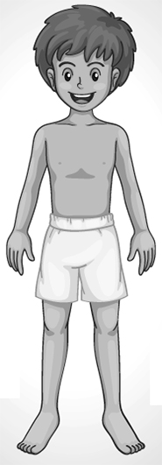
4.
1.
5.

2.
6.
3.

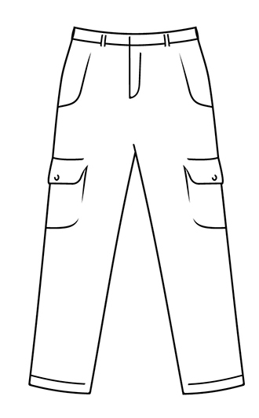
- Complete with the name of the clothes.
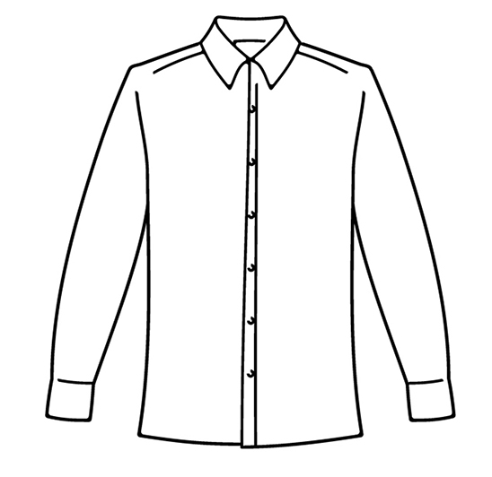
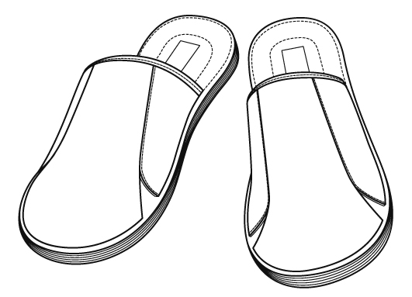
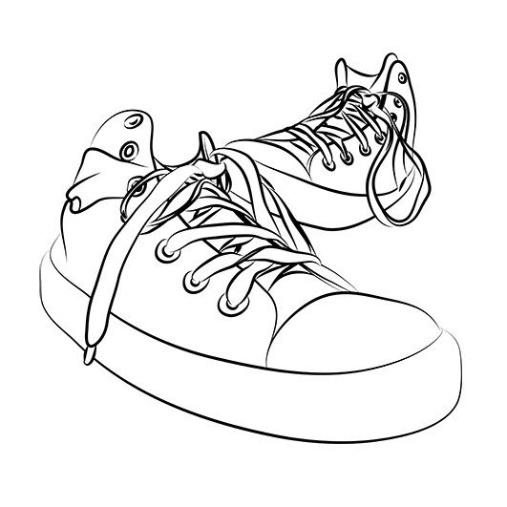

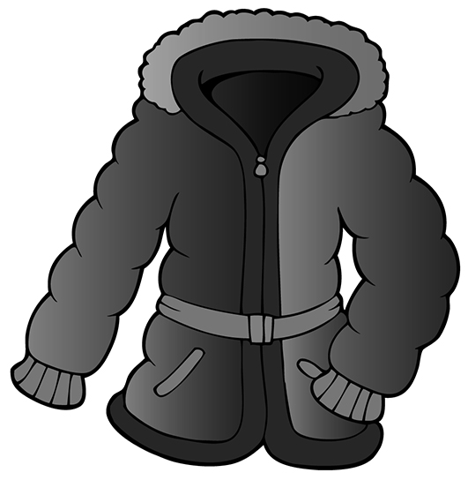

6.
5.
4.
3.
2.
1.



- What’s the weather like?



1. It’s _________
2._________________
3.________________
4. _____________
5._______________
Reading Comprehension
Charles is in Toronto. Read the postcard he wrote to his friend.



25th August
Hello Jason,
How are you? I’m fine. Today it’s my brother’s birthday. The weather is not very good! It’s cloudy and windy. We have to wear raincoats all the time. What’s the weather like in Edinburgh?
Now I am with Sonya and Tripp’s parents. I’m also with my brother Fernando. We are in the CN Tower. Toronto is very beautiful. I like it very much.
See you soon,
Charles

.

A. True (T) or false (F)?
F

e.g. Charles is in London 3. Fernando is Charles’ friend.

- Charles is in Toronto. 4. Charles is with his parents.

- The weather in Toronto is very good. 5. They are in the hotel.

B. Answer the questions according to the text.
- What’s the weather like in Toronto?___________________________________________________
- When is Fernando’s birthday?___________________________________________________________
- Where is Charles? ________________________________________________________________
- Who is Sonya? ______________________________________________________________________
- Does he like Toronto?__________________________________________________________________

Grammar

- Match the adjectives with their opposites.
1. beautiful a) weak
2. tall b) thin
3. young c) ugly
4. fat d) short
5. strong e) old

- Write questions. Follow the example.
e. g. She likes this weather. Does she like this weather?
1. He loves Paris. _________________________________________________
2. Gil and Francisco prefer blue jeans. _________________________________
3. The girls have got a family. ________________________________________
4. It is sunny today. ________________________________________________

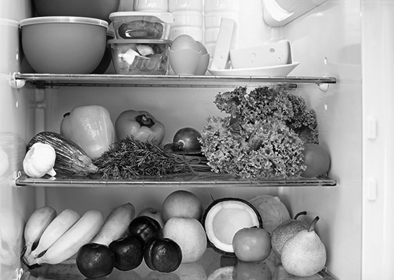
- Complete with some and any.

- There are______ apples in the fridge.
- There isn’t ________ water.
- Look, there are ________ bananas.
- There is ________ cheese.
- Is there _____ meat?

- Choose the correct question word.

1. Which / Whose skirt do you prefer?
2. Whose / Which coat is this?
3. Why / Which are you sad?

- Answer with short answers.
e.g. Does she listen to music? (v) Yes, she does.
1. Do you like rain? (x) __________________________
2. Does he wear a shirt? (v) _________________________
3. Do you like winter? (x) ___________________________
4. Do they get up at seven? (v) ________________________

Writing


A. Charles meets Lana in Toronto. Complete their conversation.
LANA: (1) Hi Charles.__________________________?
CHARLES: Hi, Lana! I’m fine, thanks! And you?
LANA: Great… Oh… this is my cousin Stephan.
Stephan, this is my friend Charles.
STEPHAN: (2) Hi, nice ____________________________
CHARLES: (3)______________________________?
STEPHAN: I’m from London.
CHARLES: (4)_____________________________?
STEPHAN: I’m eleven years old.
CHARLES: (5)__________________________________?
STEPHAN: Yes, I do. I love Toronto. It’s a beautiful city.





B. Imagine you meet Charles in Toronto. Write him an e-mail talking about yourself.
Write five sentences mentioning your name, age, nationality, school, likes and dislikes.

To:
Subject:

______________________________________________________________________________________________________________________________________________________
______________________________________________________________________________________________________________________________________________________
______________________________________________________________________________________________________________________________________________________

Good luck!

Units 7 and 8 Test B

School:__________________________________________________________________
Name:________________________________________________ Class:____ Nr:_______
Date:_________________________________________________ Score:_______________
Enc. Educação:________________________________Teacher:__________________

Vocabulary
- Complete the picture with the right parts of the body. Use the words in the box. Some are not necessary.
hair
eyes
elbow
hand
mouth
foot
nose
neck
leg
4.
1.
5.

2.
6.
3.

- Complete with the name of the clothes. Use the words in the box. Some are not necessary.
skirt gloves slippers shirt boots trainers jeans coat dress

4.
6.
5.
3.
2.
1.

- What’s the weather like? Use the words in the box.
It’s stormy. It’s windy. It’s cloudy. It’s rainy. It’s sunny.
1. It’s ______
2._________________
3.________________
4. _____________
5._______________
Reading Comprehension
Charles is in Toronto. Read the postcard he wrote to his friend.

25th August
Hello Jason,
How are you? I’m fine. Today it’s my brother’s birthday. The weather is not very good! It’s cloudy and windy. We have to wear raincoats all the time. What’s the weather like in Edinburgh?
Now I am with Sonya and Tripp’s parents. I’m also with my brother Fernando. We are in the CN Tower. Toronto is very beautiful. I like it very much.
See you soon,
Charles

.

A. True (T) or false (F)?
F

e.g. Charles is in London 3. Fernando is Charles’s friend.

1. Charles is in Toronto. 4. Charles is with his parents.

2. The weather in Toronto is very good. 5. They are in the hotel.

B. Answer these questions according to the text.
a. Yes, he does.
b. She is his mother.
c. It’s cloudy and windy.
d. It’s in August.
e. He is in Toronto.

1. What’s the weather like in Toronto?
2. When is Fernando’s birthday?
3. Where is Charles?
4. Who is Sonya?
5. Does he like Toronto?

Grammar

- Match the adjectives with their opposites.
  - beautiful a) weak
  - tall b) thin
  - young c) ugly
  - fat d) short
  - strong e) old

- Choose Do or Does to make questions.
e. g. I like the weather. Do I like the weather?
1. He loves Paris. Does / Do he love Paris?
2. Gil and Francisco prefer blue jeans. Does / Do Gil and Francisco prefer blue jeans?
3. The girls have got a family. Does / Do the girls have got a family?
4. It is sunny today. Is / Are it sunny today?

- Complete with some and any.

1. There are some / any apples in the fridge.
2. There isn’t some / any water.
3. Look, there are some / any bananas.
4. There is some / any cheese.
5. Is there some / any meat?

- Choose the correct question word.

1. Which / Whose skirt do you prefer?
2. Whose / Which coat is this?
3. Why / Which are you sad?

- Answer with short answers.
e.g. Does she listen to music? (v) Yes, she does.
1. Do you like rain? (x) ___________________________
2. Does he wear a shirt? (v) ___________________________
3. Do you like winter? (x) ___________________________
4. Do they get up at seven? (v) ___________________________

Writing

A. Charles meets Lana in Toronto. Complete their conversation. Some questions are not necessary.
What’s the weather like? Where do you live? Do you live in Toronto?
Do you like Toronto? Where are you from? What’s your name?
to meet you How old are you? How are you?

LANA: (1) Hi Charles.__________________________?
CHARLES: Hi, Lana! I’m fine, thanks! And you?
LANA: Great… Oh… this is my cousin Stephan.
Stephan, this is my friend Charles.
STEPHAN: (2) Hi, nice ________________________.
CHARLES: 3)______________________________?
STEPHAN: I’m from London.
CHARLES: (4)_____________________________?
STEPHAN: I’m eleven years old.
CHARLES: (5)__________________________________?
STEPHAN: Yes, I do. I love Toronto. It’s a beautiful city.

Good luck!

Answer Key Units 7 and 8

Test A
VOCABULARY
A. 1. neck 2. hand 3. foot 4. head / hair 5. shoulder 6. leg / knee
B. 1. coat 2. shirt 3. gloves 4. jeans 5. tennis 6. slippers
C. 1. It’s sunny. 2. It’s rainy. 3. It’s windy. 4. It’s stormy. 5. It’s cloudy.

READING COMPREHENSION
A. 1. True 2. False 3. False 4. False 5. False
B. 1. It’s cloudy and windy. 2. It’s in August. 3. He is in Toronto. 4. She is his mother. 5. Yes, he does.

GRAMMAR
A. 1. c) 2.d) 3. e) 4. B) 5. a)
B. 1. Does he love Paris? 2. Do they prefer blue jeans? 3. Do they have got a family? 4. Is it sunny today?
C. 1. some 2. any 3. some 4. some 5. any
D. 1. Which 2. Whose 3. Why
E. 1. No, I don’t. 2. Yes, he does. 3. No, I don’t. 4. Yes, they do.

WRITING
- 1. How are you? 2. to meet you 3. Where are you from? 4. How old are you? 5. Do you like Toronto?
- Personal answer.

Test B
VOCABULARY
A. 1. neck 2. hand 3. foot 4. hair 5. shoulder 6. leg
B. 1. coat 2. Shirt 3. gloves 4. Jeans 5. tennis 6. slippers
C. 1. It’s sunny. 2. It’s rainy. 3. It’s windy. 4. It’s stormy. 5. It’s cloudy.

READING COMPREHENSION
A. 1. True 2. False 3. False 4. False 5. False
B. 1. It’s cloudy and windy. 2. It’s in August. 3. He is in Toronto. 4. It’s his mother. 5. Yes, he does.

GRAMMAR
A. 1. c) 2. d) 3. e) 4. b) 5. a)
B. 1. Does he love Paris? 2. Do they prefer blue jeans? 3. Do they have got a family? 4. Is it sunny today?
C. 1. some 2. any 3. some 4. some 5. any
D. 1. Which 2. Whose 3. Why
E. 1. No, I don’t. 2. Yes, he does. 3. No, I don’t. 4. Yes, they do.

WRITING
- 1. How are you? 2. to meet you 3. Where are you from? 4. How old are you? 5. Do you like Toronto?

