I – Reading

Read the text.

– Gru’s family

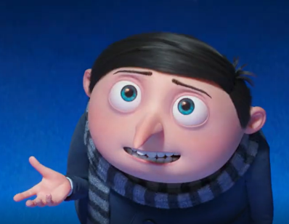
My name is Felonius Gru. I’m 12 years old and I’m a student. Oh well, I’m a supervillain¹, too. It’s my real job! I’m from San Francisco, a beautiful city in California, the United States of America.
My parents are divorced and I live with my mother. Her name is Marlena. I have got a twin brother. His name is Dru. Our father’s name is Robert.
My best friends are the Minions! I’m their Mini Boss and they help me when I’m in trouble. There are hundreds of Minions, but Kevin, Stuart and Bob are my favourites!
In the film Minions: The Rise of Gru, I fight the Vicious 6 supervillain group. Thanks to the Minions and our teamwork, we win² this fight!
Word check: ¹ supervillain = supervilão; ² win = vencemos, ganhamos

- What is this text about? Tick () the correct option.
The text is about…
1. the Vicious 6, a supervillain group. 2. Gru’s identification and his family and friends. 3. the Minions’ names.

- Correct the underlined information according to the text. There is one example.
- Gru is a nurse. ____student __
- Gru is from San Antonio, California. ____________________
- His parents are married. ____________________
- Dru is Gru’s cousin. ___________________
- Stuart is his father’s name. _________________
- Gru and the Minions are brothers. ___________________

- Answer the questions. Give complete answers.

- What’s Gru’s full name? _____________________________________________________________
- How old is he? ____________________________________________________________________
- What’s his real job? _________________________________________________________________
- Who is Marlena? ___________________________________________________________________
- Is Dave Gru’s favourite Minion? ________________________________________________________

II – Language

- Look at Gru’s family tree as an adult and complete the text with family words.

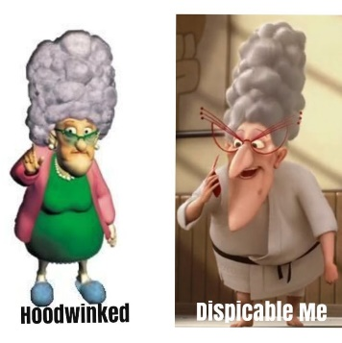

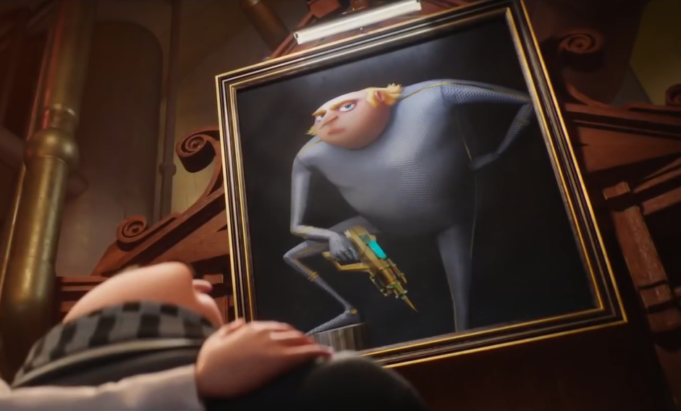


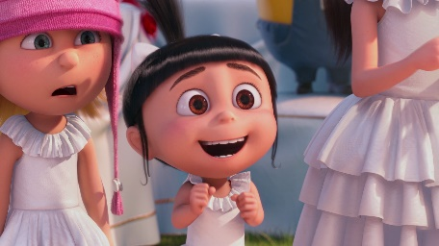
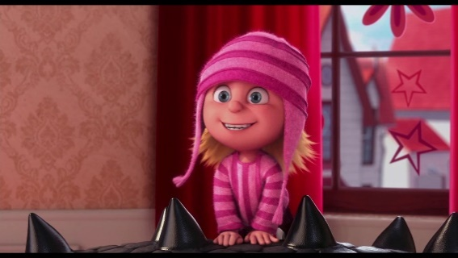


Marlena Gru
Robert Gru
Felonius Gru
Dru Gru
Lucy Wilde
Agnes Gru
Edith Gru
Margo Gru

Hi there! This is my family tree. Can you guess the missing family words?
Robert and Marlena Gru are my ¹__________________. I’m their ²_______________ and Dru Gru is my twin ³________________. I’m married to Lucy Wilde, so she is my ⁴_______________ and I’m her ⁵_______________. We have got three ⁶________________: Agnes, Edith and Margo. They are lovely and they like their ⁷__________________, Marlena and Robert, very much. Their ⁸__________________, Dru, isn’t very kind, so they don’t like him.

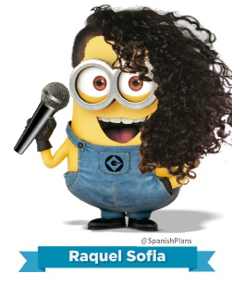



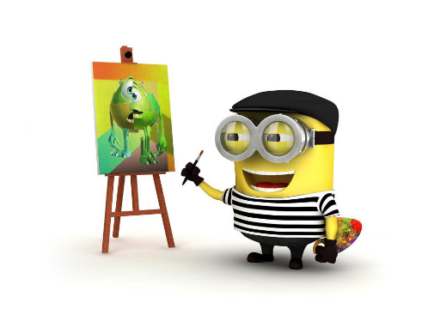
- Label the jobs.
- _____________
_____________
- _____________
_____________
- _____________
_____________
- _____________
_____________
- _____________
_____________

- Complete the sentences with the correct forms of the verb to be.
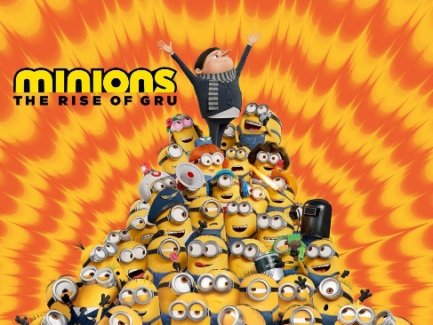
- I ___________ a movie fan.
- Minions: The Rise of Gru ____________ my favourite film.
- The Minions’ voices ______________ funny.
- Stuart ______________ (not) a bad singer.
- Dave _______________ a painter.
- Kevin and Bob _______________ (not) teachers.
- I ________________ (not) a big fan of Kevin.
- Gru and the Minions ________________ good friends.

- Look at the pictures and write questions and short answers (affirmative/negative). There is one example.
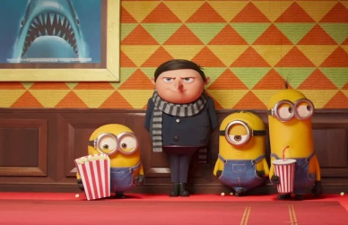
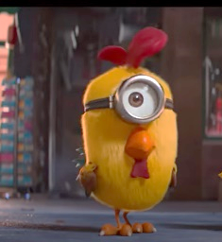
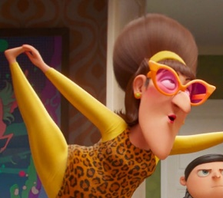
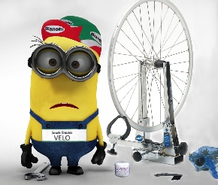

35
3
2
1

- Marlena / twenty years old __Is Marlena twenty years old ? No, she isn´t __.
- Stuart / a rabbit _____________________________________? _________________________.
- he / a mechanic _____________________________________? _________________________.
- Gru and the Minions / at the cinema ____________________________________? _________________________.

- Fill in the gaps with a, an or the.
- I’m from ______ United Kingdom.
- Marcus is ______ singer.
- My mother is ______ architect.
- Washington, D.C. is _______ capital of the United States of America.

- Complete the sentences with the possessive determiners from the box.
- I have got a sister. ______ name is Ruth.
my your
his her
our their
- This is my cousin. ______ name is Gonçalo.
- We are best friends. _______ names are John and Nick.
- Louise and Ricky are my grandparents. ______ new house is very modern.
- ______ baby brother is so sweet. You are lucky.
- _____ name is Steve and I’m a police officer.

- Circle the correct question words to complete the questions.
- “When / Where / What is her birthday?” “Her birthday is on 12th January.”
- “How / How old / Who is Lizzo?” “She is 34 years old.”
- “Where / When / How old is Raul from?” “He is from Mexico.”

III – Writing

Write a short text about yourself (20-30 words).
Don’t forget to mention:
- your name;
- your surname;
- your age;
- your birthday;
- your hometown;
- your family;
- …


Good work!
Your teacher

Year 5 – Progress test 1A
Answer key
I – Reading
A. (1 x 5 = 5%)
2
B. (5 x 2 = 10%)
1. San Francisco | 2. divorced | 3. brother | 4. Robert | 5. friends
C. (5 x 3 = 15%)
1. Gru’s full name is Felonius Gru. | 2. He’s 12 years old. | 3. He’s a supervillain. | 4. Marlena is Gru’s mother. | 5. No, he isn’t.

II – Language
A. (8 x 1 = 8%)
1. parents | 2. son | 3. brother | 4. wife | 5. husband | 6. daughters/children | 7. grandparents | 8. uncle
B. (5 x 2 = 10%)
1. painter | 2. singer | 3. doctor/nurse | 4. firefighter | 5. cook/chef
C. (8 x 2 = 16%)
1. am | 2. is | 3. are | 4. isn’t | 5. is | 6. aren’t | 7. am not | 8. are
D. (3 x 2 = 6%)
1. Is Stuart a rabbit? No, he isn’t. | 2. Is he a mechanic? Yes, he is. | 3. Are Gru and the Minions at the cinema? Yes, they are.
E. (4 x 0,5 = 2%)
1. the | 2. a | 3. an | 4. the
F. (6 x 1 = 6%)
1. Her | 2. His | 3. Our | 4. Their | 5. Your | 6. My
G. (4 x 0,5 = 2%)
1. When | 2. Who | 3. How old | 4. Where

III – Writing
(20%)
(Suggested answer)
My name is Rita and my surname is Martins. I’m ten years old. My birthday is on 10th April. I’m from Portimão. I live with my parents and my brother.

Alternative marking scheme

Per skill

I – Reading (100%)
A – 1 x 5 = 5%
B – 5 x 7 = 35%
C – 5 x 12 = 60%

II – Language (100%)
A – 8 x 2 = 16%
B – 5 x 2 = 10%
C – 8 x 2 = 16%
D – 3 x 4 = 12%
E – 4 x 3 = 12%
F – 6 x 3 = 18%
G – 4 x 4 = 16%

III – Writing
100%

