I – Reading

Read the text. (Lê o texto.)

– Gru’s family

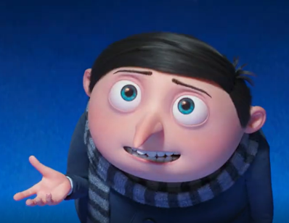
My name is Felonius Gru. I’m 12 years old and I’m a student. Oh well, I’m a supervillain¹, too. It’s my real job! I’m from San Francisco, a beautiful city in California, the United States of America.
My parents are divorced and I live with my mother. Her name is Marlena. I have got a twin brother. His name is Dru. Our father’s name is Robert.
My best friends are the Minions! I’m their Mini Boss and they help me when I’m in trouble. There are hundreds of Minions but Kevin, Stuart and Bob are my favourites!
In the film Minions: The Rise of Gru, I fight the Vicious 6 supervillain group. Thanks to the Minions and our teamwork, we win² this fight!
Word check: ¹ supervillain = supervilão; ² win = vencemos, ganhamos

- What is this text about? Tick () the correct option. (De que fala o texto? Assinala a opção correta.)
The text is about…
1. the Minions’ names. 2. Gru’s identification and his family and friends.

- Correct the underlined information according to the text. Use the options from the box. There is one example. (Corrige a informação sublinhada, de acordo com o texto. Usa as opções da caixa. Segue o exemplo.)

- Gru is a nurse. ____student __
- Gru is from San Antonio, California. ____________________
friends student
divorced San Francisco
brother Robert
- His parents are married. ____________________
- Dru is Gru’s cousin. ___________________
- Stuart is his father’s name. _________________
- Gru and the Minions are brothers. ___________________

- Read the questions and complete the answers. (Lê as perguntas e completa as respostas.)
- What’s Gru’s full name? Gru’s full name is ____________________________________________.
- How old is he? He is ___________________ years old.
- What’s his real job? He is a _________________________.
- Who is Marlena? Marlena is Gru’s _____________________.
- Is Dave Gru’s favourite Minion? (Tick () the correct option. Assinala a opção correta.)
a) Yes, he is. b) No, he isn’t.

II – Language

- Look at Gru’s family tree as an adult and circle the correct words to complete the text.
(Observa a árvore genealógica do Gru como adulto e rodeia as palavras corretas para completar o texto.)

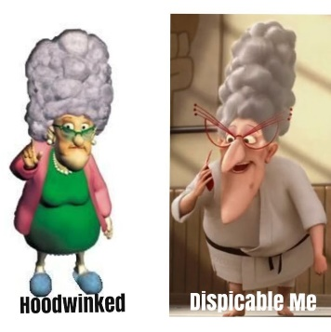
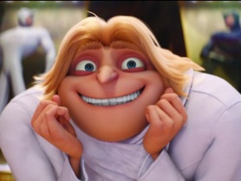
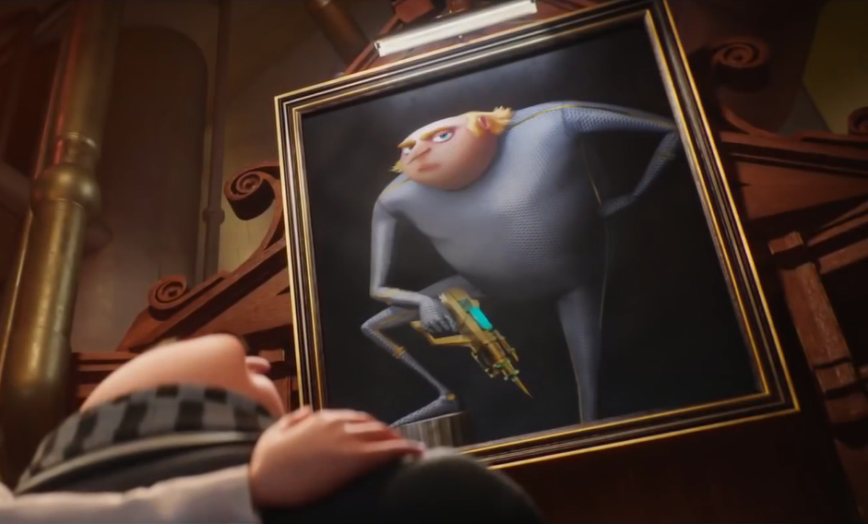

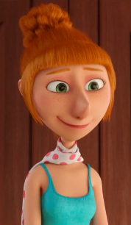
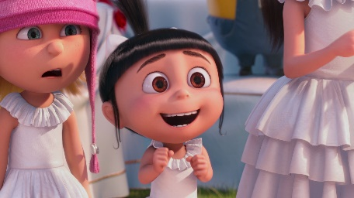
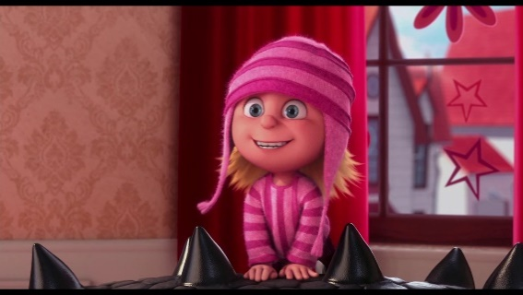
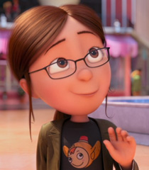

Marlena Gru
Robert Gru
Feionius Gru
Dru Gru
Lucy Wilde
Agnes Gru
Edith Gru
Margo Gru

Hi there! This is my family tree. Can you guess the missing family words?
Robert and Marlena Gru are my ¹ cousins / parents. I’m their ² son / sister and Dru Gru is my twin ³ daughter / brother. I’m married to Lucy Wilde, so she is my ⁴ wife / mother and I’m her ⁵ father / husband. We have got three ⁶ daughters / sons: Agnes, Edith and Margo. They are lovely and they like their
⁷ aunts / grandparents, Marlena and Robert, very much. Their ⁸ nephew / uncle, Dru, isn’t very kind, so they don’t like him.

- Label the jobs with the words from the box. (Legenda as profissões com as palavras da caixa.)
cook firefighter doctor painter singer
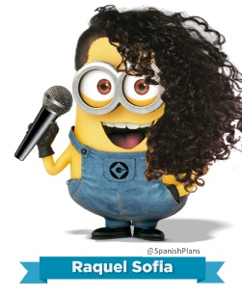
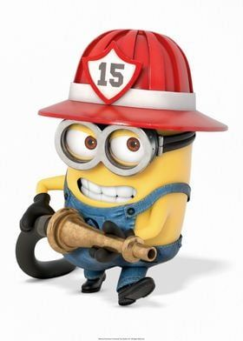


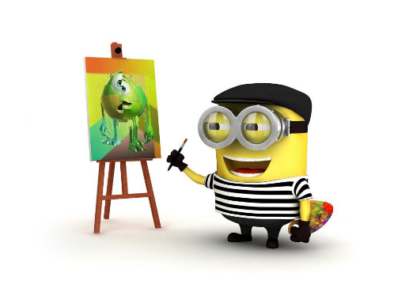
- _____________
_____________
- _____________
_____________
- _____________
_____________
- _____________
_____________
- _____________
_____________

- Circle the correct form of the verb to be. (Rodeia a forma correta do verbo to be.)

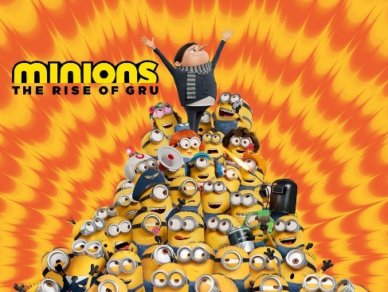
- I is / am a movie fan.
- Minions: The Rise of Gru is / am my favourite film.
- The Minions’ voices is / are funny.
- Stuart aren’t / isn’t a bad singer.
- Dave are / is a painter.
- Kevin and Bob isn’t / aren’t teachers.
- I isn’t / am not a big fan of Kevin.
- Gru and the Minions is / are good friends.

- Read the questions and write short answers with the verb to be. There is one example.
(Lê as perguntas e escreve respostas curtas com o verbo to be. Segue o exemplo.)

- Is Marlena twenty years old? No, _she isn´t. __.
- Is Stuart a rabbit? No, _______________________.
- Is he a mechanic? Yes, ______________________.
- Are Gru and the Minions at the cinema? Yes, _________________________.

- Fill in the gaps with a or an. (Completa os espaços com a ou an.)

- I am _____ engineer.
- Marcus is _____ singer.
- My mother is _____ architect.
- New York is ______ beautiful city.

- Circle the correct possessive determiners. (Rodeia os determinantes possessivos corretos.)

- I have got a sister. Her / Their name is Ruth.
- This is my cousin. Your / His name is Gonçalo.
- We are best friends. Our / My names are John and Nick.
- Louise and Ricky are my grandparents. Your / Their new house is very modern.
- Your / Her baby brother is so sweet. You are lucky.
- My / Our name is Steve and I’m a police officer.

- Circle the correct question words to complete the questions.
(Sublinha as question words corretas para completar as perguntas.)

- “When / Where is her birthday?” “Her birthday is on 12th January.”
- “When / Who is your favourite singer?” “My favourite singer is Lizzo.”
- “How / How old is Lizzo?” “She is 34 years old.”
- “Where / When is Raul from?” “He is from Mexico.”

III – Writing

Read the example.
(Lê o exemplo.)

My name is Janine and my surname is Thomson. I’m twelve years old. I’m from Manchester, in England.
My birthday is on 20th January.
My mother is a teacher and her name is Theresa. My father is Jacob and he is a photographer.

Replace the words underlined in the example and write a text about YOU.
(Substitui as palavras sublinhadas no exemplo e escreve um texto sobre ti.)


Good work!
Your teacher

Year 5 – Progress test 1B
Answer key
I – Reading
A. (1 x 5 = 5%)
2
B. (5 x 2 = 10%)
1. San Francisco | 2. divorced | 3. brother | 4. Robert | 5. friends
C. (5 x 3 = 15%)
1. Felonius Gru | 2.12 (twelve) | 3. supervillain | 4. mother | 5. b)

II – Language
A. (8 x 1 = 8%)
1. parents | 2. son | 3. brother | 4. wife | 5. husband | 6. daughters/children | 7. grandparents | 8. uncle
B. (5 x 2 = 10%)
1. painter | 2. singer | 3. doctor | 4. firefighter | 5. cook
C. (8 x 2 = 16%)
1. am | 2. is | 3. are | 4. isn’t | 5. is | 6. aren’t | 7. am not | 8. are
D. (3 x 2 = 6%)
1. he isn’t | 2. he is | 3. they are
E. (4 x 0,5 = 2%)
1. an | 2. a | 3. an | 4. a
F. (6 x 1 = 6%)
1. Her | 2. His | 3. Our | 4. Their | 5. Your | 6. My
G. (4 x 0,5 = 2%)
1. When | 2. Who | 3. How old | 4. Where

III – Writing
(20%)
(Suggested answer)
My name is Rita and my surname is Martins. I’m eleven years old. I’m from Manchester, in England.
My birthday is on 20th January.
My mother is a doctor and her name is Joana. My father is Rui and he is a vet.

Alternative marking scheme

Per skill

I – Reading (100%)
A – 1 x 5 = 5%
B – 5 x 7 = 35%
C – 5 x 12 = 60%

II – Language (100%)
A – 8 x 2 = 16%
B – 5 x 2 = 10%
C – 8 x 2 = 16%
D – 3 x 4 = 12%
E – 4 x 3 = 12%
F – 6 x 3 = 18%
G – 4 x 4 = 16%

III – Writing
100%

