I – Reading

Read the text.

Benicio Bryant
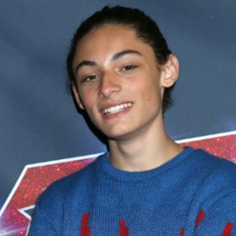
Benicio Bryant is a singer and a songwriter. He is famous for¹ his performance in the
TV show America’s Got Talent and his 2022 song “I Can’t Dance to This!” is a hit² in America.
Benicio is eighteen years old. He is from Maple Valley, a city in the United States of America. He has got one sister, but he hasn’t got any brothers. He lives with his parents.
Benicio is 1.54 metres tall, so he’s medium height. He’s thin and he has got black eyes. His hair is curly and black, too.
Benicio Bryant
He loves wearing casual clothes because they’re comfortable. Jeans, T-shirts and sports jackets are his favourite. He sometimes wears a cap and glasses, too. About footwear? He loves his red trainers.
This young singer is shy, friendly and polite. He has got a very beautiful and happy smile.

Word check: ¹ famous for = famoso por; ² hit = sucesso, êxito.

A. Complete the table with the missing information about the text in note form.

Benicio’s age | 1.
His home town | 2.
Number of sisters | 3.
Benicio’s height | 4.
Footwear (and colour) | 5.
Benicio’s smile | 6. and

B. Tick () the correct options to complete the sentences.
1. Benicio is famous for his
a) American hit song.
b) participation in America’s Got Talent.
c) beautiful smile.
2. His favourite clothes are
a) trainers and glasses.
b) sports jackets and a cap.
c) jeans, T-shirts and sports jackets.
3. He is
a) shy, friendly and polite.
b) shy, beautiful and happy.
c) shy, polite and happy.

C. Answer the questions. Give complete answers.
1. What’s Benicio’s job?
___________________________________________________________________________________________
2. What’s the title of his hit song?
___________________________________________________________________________________________
3. Has he got any brothers?
___________________________________________________________________________________________
4. What does Benicio look like?
___________________________________________________________________________________________
5. Why does he like wearing casual clothes?
___________________________________________________________________________________________

II – Language

A. Label the picture with the parts of the human body.
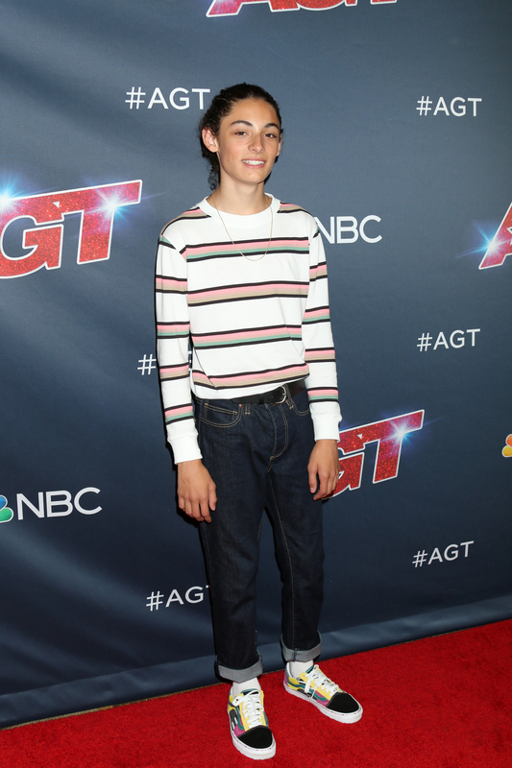
1. _________________________
2. _________________________
3. _________________________
4. _________________________
5. _________________________
6. _________________________
7. _________________________
8. _________________________
8
7
6
5
3
4
2
1
B. Look at the pictures. Read the sentences and circle the correct answers.
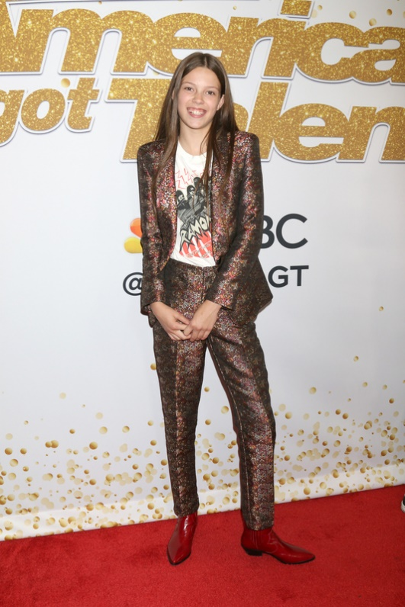
Hi! I’m Courtney and today I’m wearing a
¹ sweater / raincoat / T-shirt and a dark ² jacket / skirt / dress.
I’ve got comfortable ³ shoes / sandals / trainers and dark
⁴ pyjamas / tracksuit / trousers.

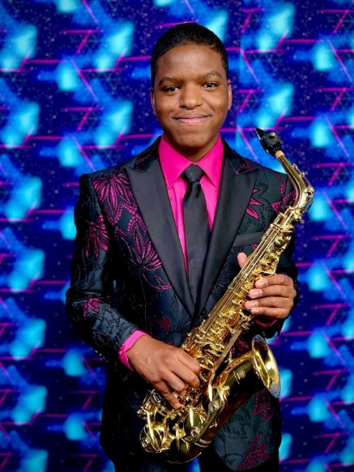
Hello! My name’s Avery and I’m
a saxophone player. I’m wearing a
⁵ suit / skirt / belt.
I’ve got a ⁶ scarf / hat / tie and a colourful ⁷ shirt / flip flops / sweater.

C. Fill in the gaps with the verb have got (affirmative or negative). There is one example.
• Courtney and Avery have got a beautiful smile.
1. Courtney ______________________ brown eyes.
2. Avery and his brother ______________________ (not) long hair.
3. My best friend ______________________ a big mouth.
4. Benicio ______________________ (not) straight hair.
5. My sister and I ______________________ dark hair.

D. Look at the picture. Write questions and short answers with the verb have got. There is one example.

Sue
Rita
Jason
Ava
Bryan

• (Jason and Bryan) Have Jason and Bryan got wavy hair? No, they haven’t .
1. (Rita) ________________________ short hair? _____, _________________
2. (Ava) ________________________ curly hair? ______ ,________________
3. (Bryan and Sue) __________________________ glasses? _____ ,_________________
4. (Jason) ________________________ a moustache? _____ ,_________________
5. (the girls) __________________________ jeans? ______ ,________________

E. Circle the correct option to complete the sentences. There is one example.
• That is Jasons’ / Jason / Jason’s sweater.
1. Avery’s / Avery’ / Avery hair is short.
2. These are my friend / friends / friend’s trainers.
3. Those are Sues / Sue’s / Sue’ jeans.
4. Bryan’s / Bryan / Bryans’ cap is really cool.
5. Those are the children / children’ / children’s video games.

F. Complete the sentences with possessive pronouns from the box. There are two extra pronouns.
1. We have got a new car. It’s ___________.
his its
yours ours theirs mine hers
2. Jason has got cool trainers. They are ____________.
3. You have got a great jacket. It’s _____________.
4. I have got a new scarf. It’s _______________.
5. My mother has got a green dress. It’s _____________.

G. Put the words in the correct order to make sentences.
1. are / you / generous
_______________________________________________________________________________________
2. teenager / is / Benicio / a kind
_______________________________________________________________________________________
3. and I / sociable / are / my / friends
_______________________________________________________________________________________
4. your / isn’t / brother / short
_______________________________________________________________________________________
5. aren’t / Avery / rude / and Courtney
_______________________________________________________________________________________

III – Writing
Describe yourself (20-35 words). Don’t forget to mention:
- height and weight;
- hair;
- face (nose, eyes…);
- personality;
- clothes.
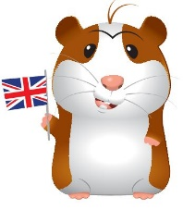
Good work!
Your teacher

Year 5 – Progress test 2A
Answer key
I – Reading
A. (7 x 2% = 14%)
1. 18 | 2. Maple Valley | 3. one | 4. 1.54 metres (tall) / medium height | 5. red trainers | 6. beautiful… happy
B. (3 x 2% = 6%)
1. b) | 2. c) | 3. a)
C. (5 x 3% = 15%)
1. Benicio is a singer and a songwriter. | 2. The title of his hit song is “I Can’t Dance to This!” | 3. No, he hasn’t. | 4. Benicio is medium height and thin. He has got black eyes and curly black hair. | 5. He likes wearing casual clothes because they’re comfortable.

II – Language
A. (8 x 1% = 8%)
1. hair | 2. eye | 3. mouth | 4. nose | 5. arm | 6. hand | 7. leg | 8. foot
B. (7 x 1% = 7%)
1. T-shirt | 2. jacket | 3. shoes | 4. trousers | 5. suit | 6. tie | 7. shirt
C. (5 x 1% = 5%)
1. has got | 2. haven’t got | 3. has got | 4. hasn't got | 5. have got
D. (5 x 2% = 10%)
1. Has Rita got… No, she hasn’t. | 2. Has Ava got… Yes, she has. | 3. Have Bryan and Sue got… No, they haven’t. | 4. Has Jason got… No, he hasn’t. | 5. Have the girls got… Yes, they have.
E. (5 x 1% = 5%
1. Avery’s | 2. friend's | 3. Sue’s | 4. Bryan’s | 5. children’s
F. (5 x 1% = 5%)
1. ours | 2. his | 3. yours | 4. mine | 5. hers
G. (5 x 1% = 5%)
1. You are generous. | 2. Benicio is a kind teenager. | 3. My friends and I are sociable. | 4. Your brother isn’t short. | 5. Avery and Courtney aren’t rude.

III – Writing (20%)
(Suggested answer)
I am short and thin. I have got short blonde hair. My face is oval. I have got blue eyes and my nose is small. I am polite. I am wearing jeans, a sweater and boots.

Alternative marking scheme
Per skill

I – Reading (100%)
A – 7 x 5% = 35%
B – 3 x 5% = 15%
C – 5 x 10% = 50%
II – Language (100%)
A – 8 x 2% = 16%
B – 7 x 2% = 14%
C – 5 x 3% = 15%
D – 5 x 4% = 20%
E – 5 x 2% = 10%
F – 5 x 2% = 10%
G – 5 x 3% = 15%
III – Writing
100%

