I – Reading

Read the text. (Lê o texto.)

Benicio Bryant
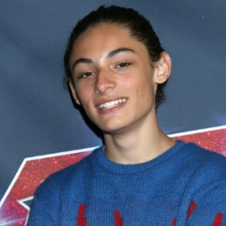
Benicio Bryant is a singer and a songwriter. He is famous for¹ his performance in the
TV show America’s Got Talent and his 2022 song “I Can’t Dance to This!” is a hit² in America.
Benicio is eighteen years old. He is from Maple Valley, a city in the United States of America. He has got one sister, but he hasn’t got any brothers. He lives with his parents.
Benicio Bryant
Benicio is 1.54 metres tall, so he’s medium height. He’s thin and he has got black eyes. His hair is curly and black, too.
He loves wearing casual clothes because they’re comfortable. Jeans, T-shirts and sports jackets are his favourite. He sometimes wears a cap and glasses, too. About footwear?
He loves his red trainers.
This young singer is shy, friendly and polite. He has got a very beautiful and happy smile.

Word check: ¹ famous for = famoso por; ² hit = sucesso, êxito.

A. Complete the table with the missing information. Use the words underlined in the text.
(Completa a tabela com a informação em falta. Usa as palavras sublinhadas no texto.)
Benicio’s age | 1.
His home town | 2.
Number of sisters | 3.
Benicio’s height | 4.
Footwear (and colour) | 5.
Benicio’s smile | 6. and

B. Tick () the correct options to complete the sentences.
(Assinala as opções corretas para completar as frases.)
1. Benicio is famous for his…
a) American hit song.
b) participation in America’s Got Talent.
2. His favourite clothes are…
a) sports jackets and a cap.
b) jeans, T-shirts and sports jackets.
3. He is…
a) shy, friendly and polite.
b) shy, beautiful and happy.

C. Read the questions and complete the answers.
(Lê as perguntas e completa as respostas.)
1. What’s Benicio’s job?
He is a ________________________ and a _____________________________________
2. What’s the title of his hit song?
The title of his hit song is _____________________________________________
3. Has he got any brothers? (Choose the correct option. – Escolhe a opção correta.)
a) Yes, he has. b) No, he hasn’t.
4. What does Benicio look like?
Benicio is ___________________ and _______________________. He has got _____________________ eyes and __________________________________ hair.
5. Why does he like wearing casual clothes?
He likes wearing casual clothes because _________________________________________________________

II – Language
A. Label the picture with the parts of the human body. Use the words from the box.
(Legenda a imagem com as partes do corpo humano. Usa as palavras da caixa.)
mouth leg hair arm
foot nose eye hand
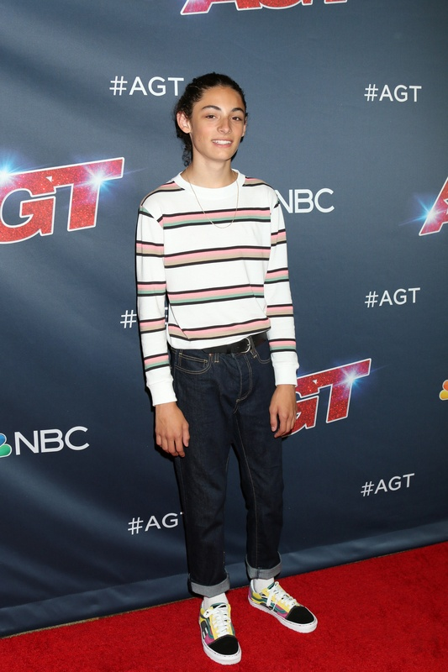
1. _________________________
2. _________________________
3. _________________________
4. _________________________
5. _________________________
6. _________________________
7. _________________________
8. _________________________
3
2
8
7
6
4
5
1

B. Look at the pictures. Read the sentences and circle the correct answers.
(Lê as frases e rodeia as respostas corretas.)
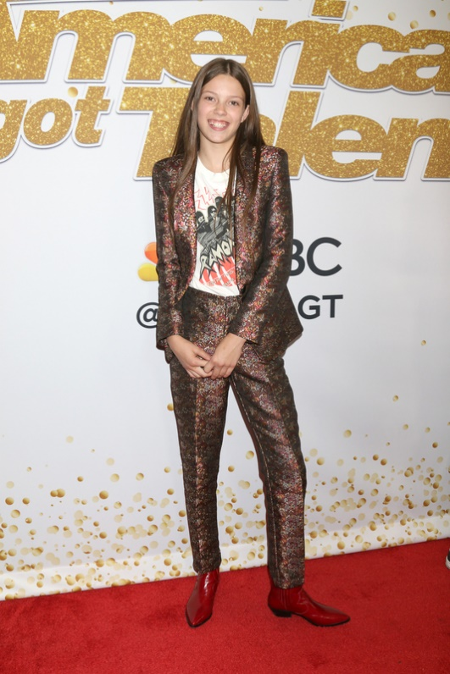
Hi! I’m Courtney and today I’m wearing
a ¹ raincoat / T-shirt and a dark ² dress / jacket.
I’ve got comfortable ³ shoes / sandals and dark ⁴ pyjamas / trousers.

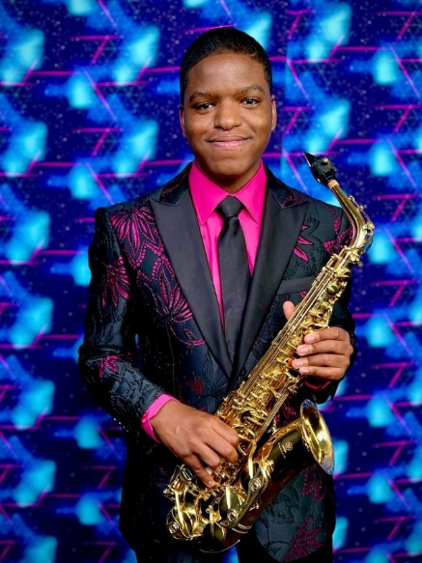

Hello! My name’s Avery and I’m a saxophone player. I’m wearing a ⁵ suit / skirt. I’ve got a ⁶ hat / tie and a colourful ⁷ shirt / sweater.

C. Complete the sentences with have got or has got. There is one example.
(Preenche os espaços com have got ou has got. Segue o exemplo.)
• Courtney and Avery have got a beautiful smile.
1. Courtney _________________ brown eyes.
2. Avery and his brother _________________ long hair.
3. My best friend _________________ a big mouth.
4. Benicio _________________ straight hair.
5. My sister and I _________________ dark hair.

D. Look at the picture and write short answers. Use the expressions from the box. There is one example.
(Observa a imagem e escreve respostas curtas. Utiliza as expressões da caixa. Segue o exemplo.)

Yes, she has. | No, they haven’t. | No, she hasn’t. | Yes, they have. | No, he hasn’t. | No, they haven’t.


• Have Jason and Bryan got wavy hair? No, they haven’t .
Rita
Jason
Sue
Bryan
Ava
1. Has Rita got short hair? _____, _________________
2. Has Ava got curly hair? _____, _________________
3. Have Bryan and Sue got glasses? _____, ________________
4. Has Jason got a moustache? _____, _________________
5. Have the girls got jeans? _____, _________________

E. Circle the correct option to complete the sentences. There is one example.
(Rodeia a opção correta para completares as frases. Segue o exemplo.)
• That is Jason / Jason’s sweater.
1. Avery’s / Avery’ hair is short.
2. These are my friends / friend’s trainers.
3. Those are / Sue’s / Sue’ jeans.
4. Bryan’s / Bryans’ cap is really cool.
5. Those are the children’ / children’s video games.

F. Complete the sentences with possessive pronouns from the box. Pay attention to the underlined words.
(Completa as frases com os pronomes possessivos da caixa. Presta atenção às palavras sublinhadas.)
1. We have got a new car. It’s ___________.
his
yours ours
mine hers
2. Jason has got cool trainers. They are ____________.
3. You have got a great jacket. It’s _____________.
4. I have got a new scarf. It’s _______________.
5. She has got a green dress. It’s _____________.

G. Put the words in the correct order to make sentences.
(Ordena as palavras corretamente para construíres frases.)
- are / you / generous
_____________________________________________________________________________________________
- is / Benicio / kind
_____________________________________________________________________________________________
- sociable / are / we
_____________________________________________________________________________________________
- isn’t / he / short
_____________________________________________________________________________________________
- aren’t / they / rude
_____________________________________________________________________________________________

III – Writing
Describe yourself. Complete the text.
(Descreve-te. Completa o texto.)

I am _________________________________________________ (height and weight).
I have got __________________________________ hair. My face is __________________.
I have got ____________ eyes and my nose is ______________________.
I am ___________________________________________________ (personality). I am wearing ____________________________________________________________________________ (clothes) and ______________________________________________________________ (footwear).

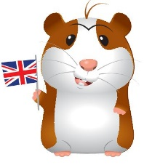
Good work!
Your teacher

Year 5 – Progress test 2B
Answer key
I – Reading
A. (7 x 2% = 14%)
1. eighteen | 2. Maple Valley | 3. one | 4. 1.54 metres tall | 5. red trainers | 6. beautiful… happy
B. (3 x 2% = 6%)
1. b) | 2. b) | 3. a)
C. (5 x 3% = 15%)
1. singer… songwriter. | 2. “I can’t dance to this!” | 3. b) | 4. medium height … thin… black… curly black | 5. they are comfortable.

II – Language
A. (8 x 1% = 8%)
1. hair | 2. eye | 3. mouth | 4. nose | 5. arm | 6. hand | 7. leg | 8. foot
B. (7 x 1% = 7%)
1. T-shirt | 2. jacket | 3. shoes | 4. trousers | 5. suit | 6. tie | 7. shirt
C. (5 x 1% = 5%)
1. has got | 2. have got | 3. has got | 4. has got | 5. have got
D. (5 x 2% = 10%)
1. No, she hasn’t. | 2. Yes, she has. | 3. No, they haven’t. | 4. No, he hasn’t. | 5. Yes, they have.
E. (5 x 1% = 5%)
1. Avery’s | 2. friend's | 3. Sue’s | 4. Bryan’s | 5. children’s
F. (5 x 1% = 5%)
1. ours | 2. his | 3. yours | 4. mine | 5. hers
G. (5 x 1% = 5%)
1. You are generous. | 2. Benicio is kind. | 3. We are sociable. | 4. He isn’t short. | 5. They aren’t rude.

III – Writing (8 x 2.5% = 20%)
(Suggested answer)
I am short and thin. I have got short blonde hair. My face is oval. I have got blue eyes and my nose is small. I am polite. I am wearing jeans, a sweater and boots.

Alternative marking scheme

Per skill
I – Reading (100%)
A – 7 x 5% = 35%
B – 3 x 5% = 15%
C – 5 x 10% = 50%
II – Language (100%)
A – 8 x 2% = 16%
B – 7 x 2% = 14%
C – 5 x 3% = 15%
D – 5 x 4% = 20%
E – 5 x 2% = 10%
F – 5 x 2% = 10%
G – 5 x 3% = 15%

III – Writing
8 x 12.5% = 100%

