I – Reading
Read the dialogue.
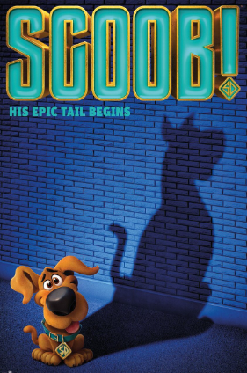
SCOOB!
Mary: What’s your favourite film, Peter?
Peter: My favourite film is Scoob! I love it! Scooby-Doo is a dog and he has got four friends. Together they solve mysteries!
Mary: Cool! Who is Scooby-Doo’s best friend?
Peter: Shaggy is Scooby-Doo’s best friend. Shaggy is tall and thin. He has got light brown hair, brown eyes and a small beard.
Mary: What about his other friends? What do they look like?
Peter: Fred is tall and slim. He has got short blonde hair and blue eyes. He always wears a white jacket. Daphne is medium height and slim. She has got long wavy red hair and green eyes. She is very beautiful. Velma is short (1 metre 50 tall) and slim. She has got straight hair, brown eyes and she has got glasses. She is very intelligent!
Mary: That’s funny, Daphne looks like me! I am also medium height, I have got green eyes and I have got long wavy hair! But her hair is red and mine is brown…
Peter: That’s right! She looks a lot like you! What a coincidence!

A. Read the text again and write the names of the characters.
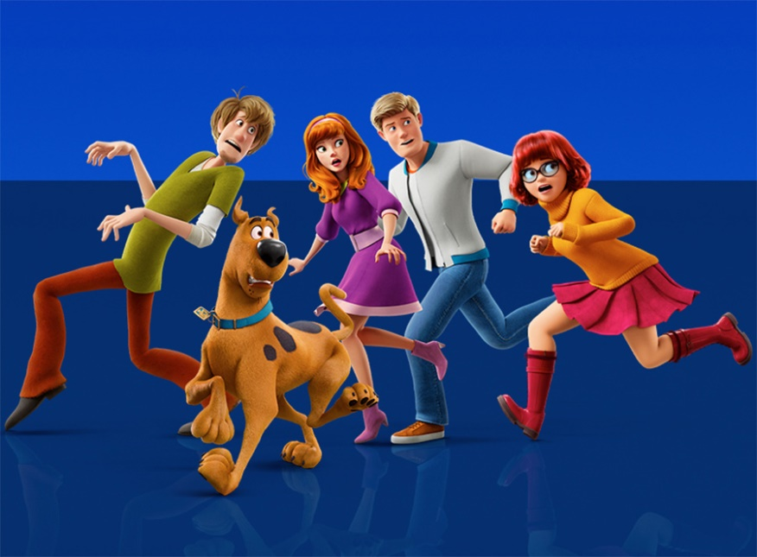
1
2
3
4
5

- _______________________
- _______________________
- _______________________
- _______________________
- _______________________

B. Complete the table with the physical features. There is one example.
 | Shaggy | Fred | Daphne | Velma
height | - tall | 4. | 8. | 12.
weight | 1. | 5. | 9. | 13.
hair | 2. | 6. | 10. | 14.
eyes | 3. | 7. | 11. | 15.

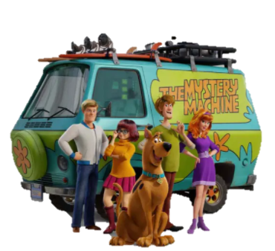
C. Match the two columns to make correct sentences.
1. Scooby-Doo is a… | a) small beard.
2. Shaggy has got a… | b) glasses.
3. Fred always wears a white… | c) beautiful.
4. Velma has got… | d) jacket.
5. Daphne is very… | e) dog.

D. Answer the questions. Give complete answers.
- What is Peter’s favourite film?
________________________________________________________________________________
- Has Scooby-Doo got four friends?
________________________________________________________________________________
- Who is Scooby-Doo’s best friend?
________________________________________________________________________________
- How tall is Velma?
________________________________________________________________________________
- What does Mary look like?
________________________________________________________________________________

II – Language

A. Zac Effron is the voice of Shaggy Rogers in the film Scoob!. Label the parts of the face in his photo.

4.
5.
6.
3.
1.
2.

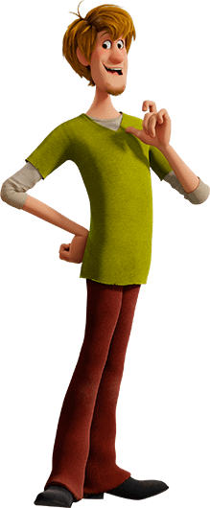
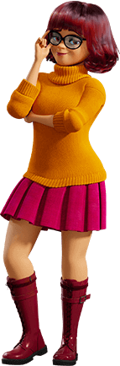
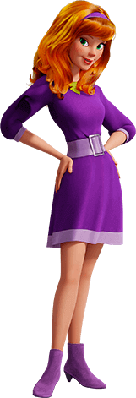
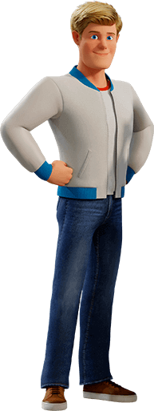
B. Match the sentences with the characters. Write numbers.
a)
b)
c)
d)

- He / She is wearing a sweater, a skirt and boots. _____
- He / She is wearing jeans, trainers and a jacket. _____
- He / She is wearing trousers, a T-shirt and shoes. ______
- He / She is wearing a dress with a belt and boots. ______

C. Complete the sentences with the verb have got (affirmative or negative).
- I __________ a new coat. It __________ a big belt.
- My sister ____________ a red dress.
- Lucas _______________ (not) any brothers, but he __________ one sister.
- My parents ________________ a new car.
- My family and I ___________________ (not) any pets.


D. Ask and answer. There is one example.
- (She) Has she got a pet? No , she ha sn’t .

- (They) __________________ a new car? ____, ____________.
- (He) __________________ blue trainers? ____, ____________.
- (Julie) __________________ many friends? ____, ____________.
- (Your sisters) __________________ a brown dog? ____, ____________.
- (you) __________________ a white shirt? ____, ____________.

E. Circle the correct option to complete the sentences.
- This is Victoria’s / Victorias’ dress.
- It’s Johns’ / John’s father.
- Mary’s / Marys’ shoes are blue.
- My cousins’ / cousins’s house is white.
- These are the children’s / childrens’ clothes.

F. Complete the sentences with possessive pronouns. There is one example.
- She has got a big belt. It’s hers .
- I have got a jacket. It’s ___________.
- He has got a mobile phone. It’s ___________.
- They have got a big car. It’s ___________.
- We have got a dog. It’s ___________.
- You have got a blue scarf. It’s ___________.

G. Put the words in the correct order. There is one example.
- long / they / have got / hair / . They have got long hair. .
- brown / is / hair / her / . ______________________________________________________________
- eyes / she / dark / has got / . ______________________________________________________
- is / John / a polite / boy / . ____________________________________________________________

III – Writing

Describe Gina Rodriguez, the voice of Velma in the film Scoob!. Write a short text (20-30 words).
You can mention:
- height;
- weight;
- hair;
- face;
- general appearance;
- clothes.
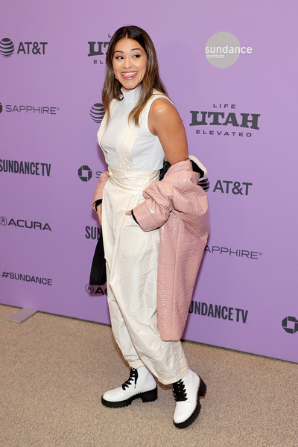

Good work!

Answer key
I – Reading

A. 5 x 1% = 5%
1. Shaggy | 2. Scooby-Doo | 3. Daphne | 4. Fred | 5. Velma

B. 15 x 1% = 15%
1. thin | 2. brown | 3. brown | 4. tall | 5. slim | 6. blonde | 7. blue | 8. medium height | 9. slim | 10. red | 11. green |
12. short | 13. slim | 14. straight | 15. brown

C. 5 x 1% = 5%
1. e) | 2. a) | 3. d) | 4. b) | 5. c)

D. 5 x 3% = 15%
1. Peter’s favourite film is Scoob!. | 2. Yes, he (it) has. | 3. Scooby-Doo’s best friend is Shaggy. | 4. Velma is 1 metre 50 tall. | 5. Mary is medium height and slim. She has got long wavy brown hair and green eyes.

II – Language

A. 6 x 1% = 6%
1. hair | 2. eye | 3. mouth | 4. ear | 5. nose | 6. tooth (teeth)

B. 4 x 1% = 4%
1. c) | 2. a) | 3. d) | 4. b)

C. 7 x 1% = 7%
1. have got… has got | 2. has got | 3. hasn’t got… has got | 4. have got | 5. haven’t got

D. 5 x 2% = 10%
1. Have they got… Yes, they have. | 2. Has he got… No, he hasn’t. | 3. Has Julie got… Yes, she has. | 4. Have your sisters got… No, they haven’t. | 5. Have you got… Yes, I have.

E. 5 x 1% = 5%
1. Victoria’s | 2. John’s | 3. Mary’s | 4. cousins’ | 5. children’s

F. 5 x 1% = 5%
1. mine | 2. his | 3. theirs | 4. ours | 5. yours

G. 3 x 1% = 3%
1. Her hair is brown. | 2. She has got dark eyes. | 3. John is a polite boy.

III – Writing (20%)

Suggested answer:
Gina is medium height and slim. She has got long straight hair and a big mouth. She is very beautiful. She is wearing white trousers, a white top, a pink coat and boots.

