I – Reading
Read the dialogue.
(Lê o diálogo.)
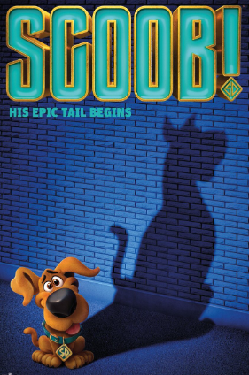
SCOOB!
Mary: What’s your favourite film, Peter?
Peter: My favourite film is Scoob! I love it! Scooby-Doo is a dog and he has got four friends. Together they solve mysteries!
Mary: Cool! Who is Scooby-Doo’s best friend?
Peter: Shaggy is Scooby-Doo’s best friend. Shaggy is tall and thin. He has got light brown hair, brown eyes and a small beard.
Mary: What about his other friends? What do they look like?
Peter: Fred is tall and slim. He has got short blonde hair and blue eyes. He always wears a white jacket. Daphne is medium height and slim. She has got long wavy red hair and green eyes. She is very beautiful. Velma is short (1 metre 50 tall) and slim. She has got straight hair, brown eyes and she has got glasses. She is very intelligent!
Mary: That’s funny, Daphne looks like me! I am also medium height, I have got green eyes and I have got long wavy hair! But her hair is red and mine is brown…
Peter: That’s right! She looks a lot like you! What a coincidence!

- Write the names of the characters. Choose from the box.
(Escreve os nomes das personagens. Escolhe os nomes da caixa.)
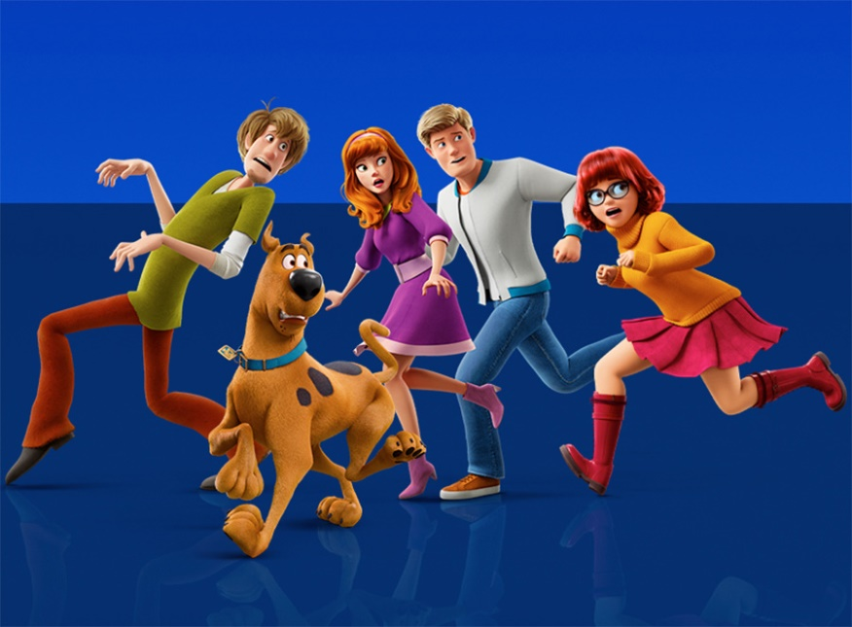
1
2
3
4
5
Scooby-Doo Velma Daphne
Shaggy Fred

- _______________________
- _______________________
- _______________________
- _______________________
- _______________________

- Complete the table with the physical features. The first letter is completed. There is one example.
(Completa a tabela com as características físicas. A primeira letra já está lá. Segue o exemplo.)
 | Shaggy | Fred | Daphne | Velma
height | - ta l l | 4. t | 8. m  h | 12. s
weight | 1. t | 5. s | 9. s | 13. s
hair | 2. b | 6. b | 10. r | 14. s
eyes | 3. b | 7. b | 11. g | 15. b

- Tick () the correct option to complete the sentences.
(Escolhe a opção correta para completares as frases.)

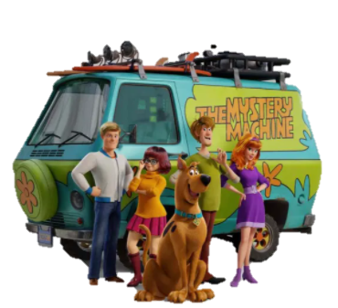
1. Scooby-Doo is a…
a) dog. b) boy.
2. Shaggy has got a…
a) moustache. b) small beard.
3. Fred always wears a white…
c) dress. b) jacket.
4. Velma has got…
a) glasses. b) long hair.
5. Daphne is very…
a) short. b) beautiful.
- Complete the answers to the questions about the text with ONE word.
(Completa as respostas às perguntas sobre o texto com uma palavra.)

- What is Peter’s favourite film?
Peter’s favourite film is __________________________.
- Has Scooby-Doo got four friends?
________, he has .
- Who is Scooby-Doo’s best friend?
Scooby-Doo’s best friend is_________________________.
- How tall is Velma?
Velma is 1 metre 50 ________________________________.
- What colour are Mary’s eyes?
Mary’s eyes are____________________________________.
II – Language

- Zac Effron is the voice of Shaggy in the film Scoob!. Label the parts of the face in his photo. Choose words from the box.
(Zac Effron é a voz de Shaggy no filme Scoob!. Legenda a foto com as partes do rosto. Seleciona as palavras da caixa.)
eye ear mouth hair nose teeth

4.
5.
6.
3.
1.
2.

- Tick () the correct option to describe the pictures.
(Assinala a opção correta para descreveres as imagens.)
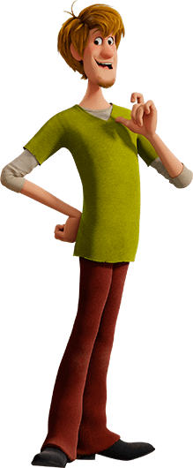
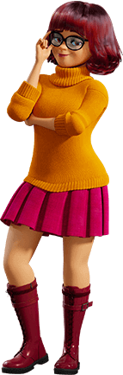
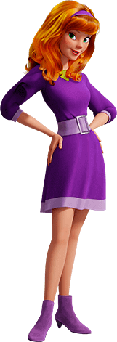
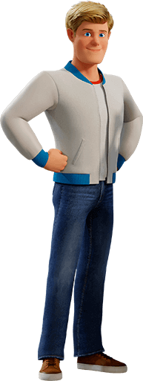
1.
2.
3.
4.

- a) He is wearing jeans, trainers and a jacket. b) He is wearing trousers, shoes and a T-shirt.
- a) She is wearing shorts, a jacket and shoes. b) She is wearing a dress with a belt and boots.
- a) She is wearing a shirt, a dress and trainers. b) She is wearing a sweater, a skirt and boots.
- a) He is wearing trousers, a T-shirt and shoes. b) He is wearing jeans, a sweater and sandals.

- Complete the sentences with the verb have got. Circle the correct option.
(Completa as frases com o verbo have got. Rodeia a opção correta.)
- I have got / has got a new coat. It have got / has got a big belt.
- My sister have got / has got a red dress.
- Lucas haven’t got / hasn’t got any brothers, but he have got / has got one sister.
- My parents have got / has got a new car.
- My family and I haven’t got / hasn’t got any pets.

- Read the questions and write shorts answers. There is one example.

(Lê as perguntas e escreve as respostas curtas. Segue o exemplo.)

- Has she got a pet? No , she hasn’t .
- Have they got a new car? ____, _____________.
- Has he got blue trainers? ____, _____________.
- Has Julie got many friends? ____, _____________.
- Have your sisters got a brown dog? ____, _____________.
- Have you got a white shirt? ____, _____________.

- Circle the correct option to complete the sentences.
(Rodeia a opção correta para completares as frases.)
- This is Victoria’s / Victorias’ dress.
- It’s Johns’ / John’s father.
- Mary’s / Marys’ shoes are blue.
- My cousins’ / cousins’s house is white.
- These are the children’s / childrens’ clothes.

- Complete the sentences with the correct possessive pronouns from the box. There is one example.
(Completa as frases com os possessive pronouns corretos da caixa. Segue o exemplo.)
hers ours yours theirs mine his

- She has got a big belt. It’s hers .
- I have got a jacket. It’s ___________.
- He has got a mobile phone. It’s ___________.
- They have got a big car. It’s ___________.
- We have got a dog. It’s ___________.
- You have got a blue scarf. It’s ___________.
- Put the words in the correct order. There is one example.
(Coloca as palavras pela ordem correta. Segue o exemplo.)
- long / they / have got / hair – They have got long hair. r
- brown / is / hair / her – Her ________________________________________________________
- she / dark eyes / has got – She ____________________________________________________
- is / John / a polite / boy – John _____________________________________________________

III – Writing
Complete the text to describe Gina Rodriguez, the voice of Velma in the film Scoob!. Use some words from the list.
(Completa o texto para descreveres a Gina Rodriguez, a voz de Velma no filme Scoob!. Usa algumas palavras da lista.)

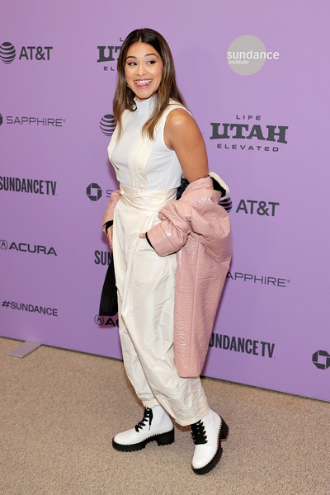
tall short medium height slim fat long curly straight big small ugly beautiful skirt trousers top coat sandals shirt dress boots

Gina is ___________________ and __________________. She has got ____________ ________________ hair and a _____________ mouth. She is very ________________ (general appearance). She is wearing ________________, a_______________, a ______________ and a pair of _____________.

Good work!

Answer key

I – Reading

A. 5 x 1% = 5%
1. Shaggy | 2. Scooby-Doo | 3. Daphne | 4. Fred | 5. Velma

B. 15 x 1% = 15%
1. thin | 2. brown | 3. brown | 4. tall | 5. slim | 6. blonde | 7. blue | 8. medium height | 9. slim | 10. red | 11. green |
12. short | 13. slim | 14. straight | 15. brown

C. 5 x 1% = 5%
1. a) | 2. b) | 3. b) | 4. a) | 5. b)

D. 5 x 3% = 15%
1. Scoob! | 2. Yes | 3. Shaggy | 4. tall | 5. green

II – Language

A. 6 x 1% = 6%
1. hair | 2. eyes | 3. mouth | 4. ear | 5. nose | 6. teeth

B. 4 x 1% = 4%
1. a) | 2. b) | 3. b) | 4. a)

C. 7 x 1% = 7%
1. have got… has got | 2. has got | 3. hasn’t got… has got | 4. have got | 5. haven’t got

D. 5 x 2% = 10%
1. Yes, they have. | 2. No, he hasn’t. | 3. Yes, she has. | 4. No, they haven’t. | 5. Yes, I have.

E. 5 x 1% = 5%
1. Victoria’s | 2. John’s | 3. Mary’s | 4. cousins’ | 5. children’s

F. 5 x 1% = 5%
1. mine | 2. his | 3. theirs | 4. ours | 5. yours

G. 3 x 1% = 3%
1. Her hair is brown. | 2. She has got dark eyes. | 3. John is a polite boy.

III – Writing (20%)

Suggested answer:
Gina is medium height and slim. She has got long straight hair and a big mouth. She is very beautiful. She is wearing trousers, a top, a coat and a pair of boots.

