

A. Read the information on the card and the text.
Hi! My name is Toby. I’m 11 years old and I’m from the USA.
I like eating fish, chips, vegetables and fruit.
I don’t like eating spaghetti or rice.
I like drinking juice and water.
I don’t like drinking coffee.
Name: Toby
Age: 11 years old
Country: USA

Food I like: fish, chips, vegetables, fruit
Food I don’t like: spaghetti, rice,
Drinks I like: juice, water
Drinks I don’t like: coffee

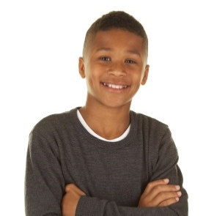



B. Fill in the card with information about you.
Name: _______________________
Age: ________________________
Hometown: ___________________
Food I like: ___________________________
Food I don’t like: ______________________
Drinks I like: ___________________________
Drinks I don’t like: _____________________

ME

C. Tell the class about your preferences. Use the information from B and the model text from A.

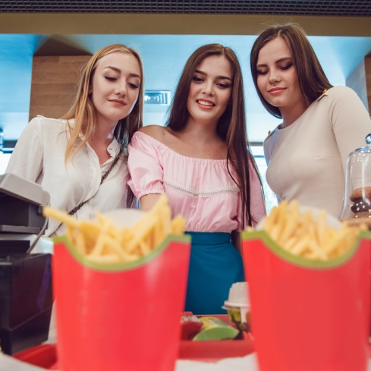
A. Read the dialogue.
Waiter: Good afternoon! Here is the menu!
Janet: Thanks! Can I have a cheeseburger and chips, please?
Waiter: Yes, of course. And to drink?
Janet: A glass of orange juice, please.
Waiter: We have strawberry ice cream for dessert. Do you want some?
Janet: Good idea!
Waiter: Here you are!
Janet: Thanks! How much is it?
Waiter: Here’s the bill! It’s £10.35.
Janet: Here you are! Thanks!

B. Look at the menu. Replace the expressions in bold in A with other expressions from this menu. Then role-play a similar dialogue with your partner.
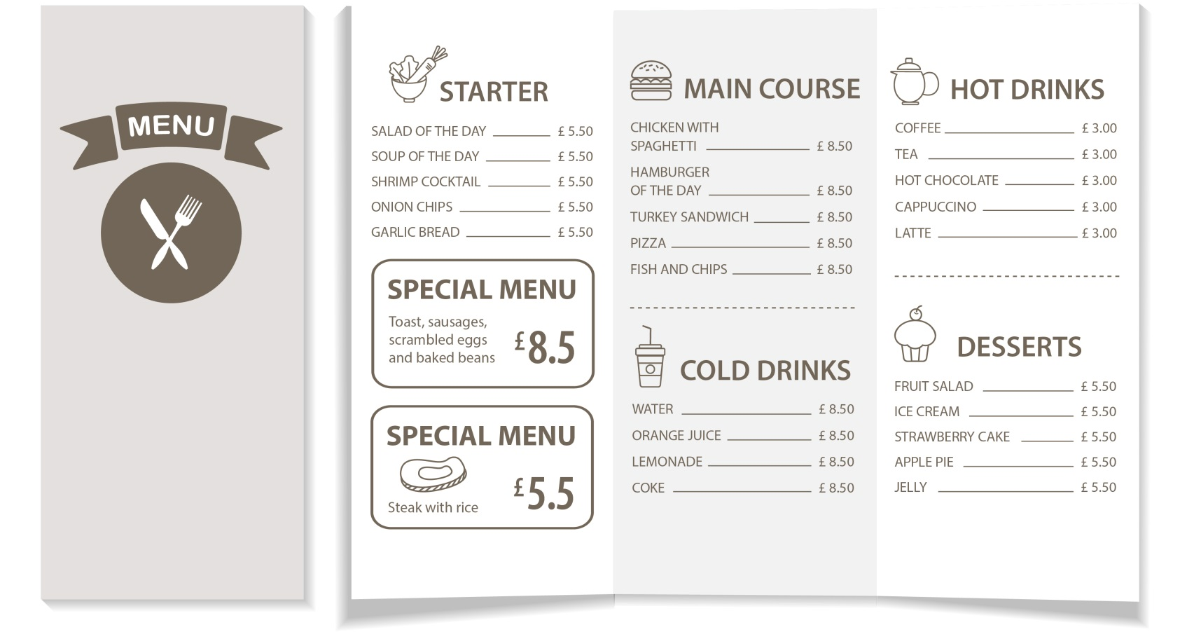
You can write the dialogue in your notebook first.

