Name: ___________________________ Class: ______ No.: ___ Date: _____________________________________
Teacher: _______________ Mark: ___________________ Enc. Educação:_________________________

Progress Test 4A – Year 5

Read the text.
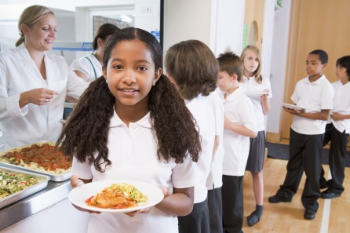
Today is Monday… All the students love Mondays! It’s a special day because it’s lasagne day! The menu for today is carrot soup to start and meat lasagne as the main dish¹. It’s delicious! For dessert we have strawberry jelly or some fruit. I like eating jelly and fruit but I prefer ice cream for dessert! We have bread and salad, too. Students can drink lemonade but some don’t like drinking lemonade very much, so they drink water!

What’s for lunch today?
Melissa Watson is eleven years old and she is from Scotland. She has got a blog called “What’s for lunch today?” A lot of people visit her website to know about what she eats in the school canteen every day.
Let’s see what’s on the menu for today!

Word check
¹ main dish = prato principal

A. This is the menu from Melissa’s school on Monday. Read the text again and correct the wrong words in bold from the menu.
Menu - Monday
Starters
Main dish
Desserts
Drinks
1. pea soup
2. fish lasagne
3. cheesecake
fruit

4. orange juice
water

1. ______________ 2. ______________ 3. _____________ 4. _____________ 5. __________

B. Answer the questions. Give complete answers.
1. How old is Melissa? ________________________________________________________
2. Where is she from? _________________________________________________________
3. Why is Monday a special weekday? ___________________________________________
________________________________________________________________________
4. What does Melissa prefer eating for dessert? ____________________________________
5. Do all the students like drinking lemonade? ______________________________________
C. Write the words from the box in the correct column.
onions pear pie tea dinner rice spaghetti
breakfast coffee cake watermelon potatoes

1. Vegetables | 2. Fruit | 3. Desserts
______________________  ______________________ | ______________________  ______________________ | ______________________  ______________________
4. Drinks | 5. Meals | 6. Other food
______________________  ______________________ | ______________________  _____________________ | _____________________  _____________________

D. Fill in the gaps with some or any.
1. There are _______ apples and oranges for dessert, but there aren’t _________ strawberries.
2. Is there ______ lasagne in the school menu? Yes, there is _______ lasagne on the school menu.
3. There is always ________ soup but sometimes there isn’t _________ salad.
4. Is there _________ orange juice? No, there isn’t ________ orange juice.
5. There is _______ bread. Sometimes there are also _________ cakes.

E. Look at the table. Use the correct form of the verb like (affirmative or negative) to complete the sentences.
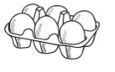  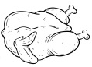  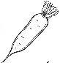     | 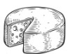    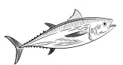  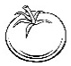  

1. Melissa ___________________ eggs. She ___________________ cheese.
2. Her parents ___________________ tomatoes but they ___________________ carrots.
3. Melissa and her friends ___________________ fish. They ___________________ chicken.
4. Her friend Josh ___________________ coffee. He ___________________ bread a lot.

F. Ask and answer with the verb like and the subjects in brackets. There is one example.
- Do they like (they) soup? Yes, they do .
1. _____________________________ (she) carrots? Yes, _____________________.
2. _______________________ (Melissa and Anna) tea? No, _____________________.
3. __________________________ (you and Tom) fruit? Yes, _____________________.
4. _______________________(Michael) chocolate? No, _____________________.
5. ________________________ (your dog) cookies? Yes, _____________________.
G. Complete the dialogue with the verbs from the box and the -ing form of the verbs in brackets. There is one example.




like prefer don’t like hate

.
Mike – Hi, Julie! Do you like eating _ (eat) fruit?
Julie – Yes, I do. And you? Do you ₍₁₎ ___________________ (eat) fruit or sweets?
Mike – Well, I ₍₂₎ ___________________ (drink) fruit juice, but I prefer sweets!
Julie – How about cooking?
Mike – I ₍₃₎ ___________________ (cook) very much, so when I have time
I ₍₄₎ ___________________ (prepare) dinner or breakfast for my family.
My parents love my food! I ₍₅₎ ___________________ (bake) cakes!
And I also ₍₆₎ ___________________ (go) shopping. I ask my mother to do the shopping.
H. Complete the sentences with so or because.
1. My mother’s food is always perfect ____________ she is an excellent cook.

2. I love lasagne __________ it’s delicious.
4. I hate eating soup, _________ my mother never cooks it.
5. I love fast food, ________ I eat hamburgers and pizzas a lot.
6. My father enjoys cooking __________ it’s great fun.

I. Write a text (20-30 words) about what you like/don’t like eating/drinking. Follow the guidelines.
Paragraph 1 – what you like eating/drinking
Paragraph 2 – what you don’t like eating/drinking
Paragraph 3 – what your favourite meal is/why
_____________________________________________________________________________________________________________________________________________________________________________________________________________________________________________________________________________________________________________________________________________________________________________________________________________________________________________________________________________
Good work!
Your teacher

Answer key
A. 4 x 1% = 4%
1. carrot | 2. meat | 3. strawberry jelly | 4. lemonade
B. 5 x 4% = 20%
1. Melissa (She) is eleven years old. | 2. She is from Scotland. | 3. Monday is special because it’s lasagne day. |
4. Melissa prefers eating ice cream for dessert. | 5. No, they don’t.
C. 12 x 1% = 12%
1. onions, potatoes | 2. pear, watermelon | 3. pie, cake | 4. tea, coffee | 5. dinner, breakfast | 6. rice, spaghetti
D. 10 x 1% = 10%

1. some… any | 2. any… some | 3. some… any | 4. any… any | 5. some… some

E. 8 x 1% = 8%

1. likes… doesn’t like | 2. don’t like… like | 3. don’t like… like | 4. doesn’t like… likes
F. 10 x 1% = 10%
1. Does she like… she does | 2. Do Melissa and Anna like… they don’t | 3. Do you and Tom like… we do | 4. Does Michael like… he doesn’t | 5. Does your dog like… it does
G. 6 x 2% = 12%

1. prefer eating | 2. like drinking | 3. like cooking | 4. prefer preparing | 5. hate baking | 6. don’t like going

H. 6 x 1% = 6%
1. because | 2. because | 3. so | 4. so | 5. because
I. 18%
Personal answer

