Name: ___________________________ Class: ______ No. ___ Date: ___________________________________
Teacher: _______________ Mark: ___________________ Enc. Educação:______________________

Progress Test 4C – Year 5

A. Label the pictures. Use the words from the box.
(Legenda as imagens. Usa as palavras da caixa.)
onions pear pie tea dinner rice spaghetti
breakfast coffee cake watermelon potatoes

Vegetables | Fruit | Desserts
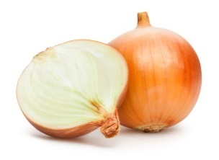  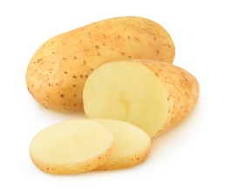  1. ______________________  2. ______________________ | 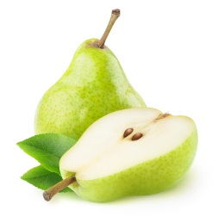  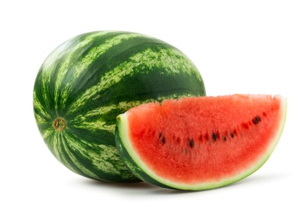  3. ______________________  4. ______________________ | 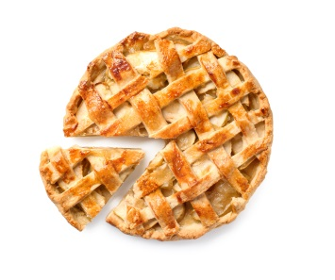  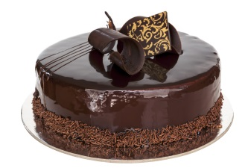  5. _____________________  6. ______________________
Drinks | Meals | Other food
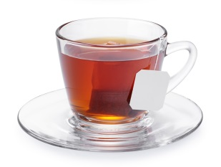  7. ______________________    8. ______________________ |   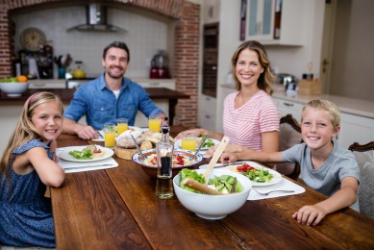    9. ______________________    10. _____________________ | 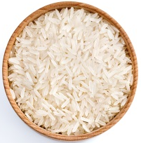  11. _____________________  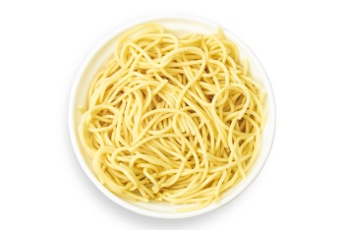  12. _____________________
B. Complete the sentences with some (affirmative sentences) or any (negative sentences and questions).
(Preenche os espaços com some – frases afirmativas – ou any – frases negativas e perguntas.)
1. There are _______ apples and oranges for dessert.
2. There aren’t _________ strawberries.
3. Is there ______ rice in the school menu?
4. There is ________ juice.
5. There aren’t _________ tomatoes. There are _________ carrots.

C. Complete the sentences with like or likes (); don’t like or doesn’t like (). There are two examples. (Completa as frases com like/likes; don’t like / doesn’t like. Segue os dois exemplos.)
- I like water (). I don’t like tea ().
- Jessica doesn’t like pears (). She likes apples ().
1. Melissa _________ eggs (). She _____________ cheese ().
2. Her parents _____________ tomatoes (). They ____________ carrots ().
3. Melissa and her friends ____________ fish (). They _____________ chicken ().
4. Her friend Josh __________ coffee (). He __________ bread ().

D. Choose the correct forms to complete the questions and the answers.
(Escolhe as formas corretas para completar as perguntas e as respostas.)
1. Does / Do she like carrots? Yes, she does / do.
2. Does / Do Melissa and Anna like tea? No, they do / don’t.

3. Does / Do you and Tom like fruit? Yes, they / we do.
4. Does Michael like / likes chocolate? No, he does / doesn’t.
5. Do / Does Garfield like lasagne? Yes, he does / doesn’t.

E. Choose the correct -ing form of the verbs in the box.
(Escolhe a -ing form correta dos verbos da caixa.)
I like .... / I prefer... / I don’t like... / I hate....

1. eating / eating
2. bakeing / baking
3. preparing / prepareing
4. cooking / cookking
5. putting / puting
6. drinkeing / drinking
7. going / goeing
8. making / makeing

Good work!
Your teacher

Answer key

A. 12 x 3% = 36%
1. onions | 2. potatoes | 3. pear | 4. watermelon | 5. pie | 6. cake | 7. tea | 8. coffee | 9. dinner | 10. breakfast |
11. rice | 12. spaghetti
B. 6 x 2% = 12%

1. some | 2. any | 3. any | 4. some | 5. any… some

C. 8 x 2% = 16%

1. likes… doesn’t like | 2. don’t like… like | 3. don’t like… like | 4. doesn’t like… likes

D. 10 x 2% = 20%
1. Does… does | 2. Do… don’t | 3. Do… we | 4. like… doesn’t | 5. Does… does
E. 8 x 2% = 16%

1. eating | 2. baking | 3. preparing | 4. cooking | 5. putting | 6. drinking | 7. going | 8. making

