A. Write the words from the box under the correct headings.
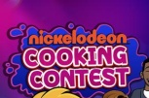
apple fish water meat banana tomato
chocolate cake jelly potato juice

Shopping list
- Vegetables | - Fruit |  | - Desserts
- Drinks |  | - Other food
4
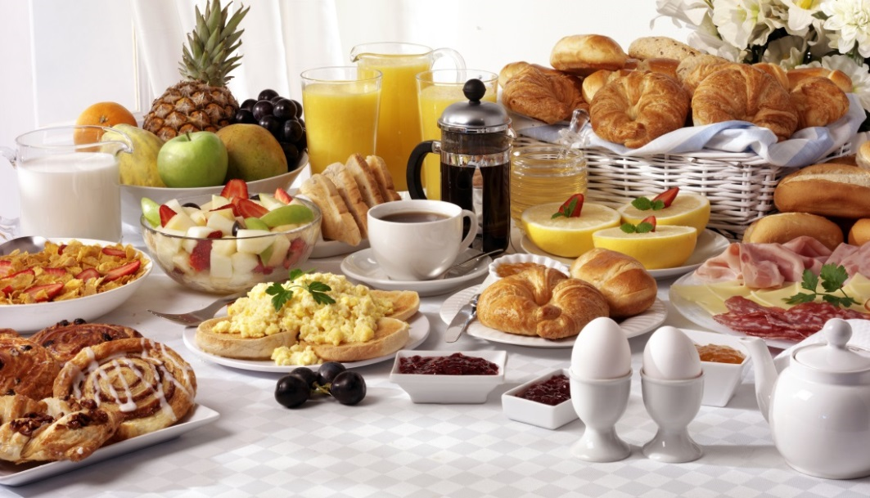
B. Look at this breakfast buffet. Label the food and drinks.
6
5
4
3
2
1
1. ______________
2. ______________
3. ______________
4. ______________
5. ______________
6. ______________
7. ______________
8. ______________

7
8

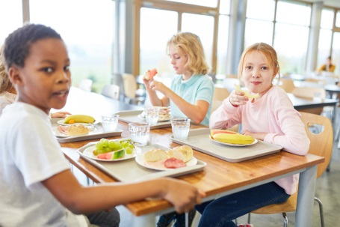
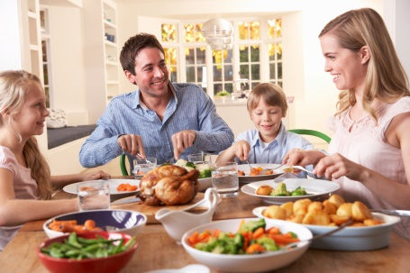
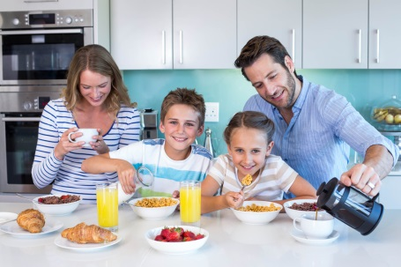
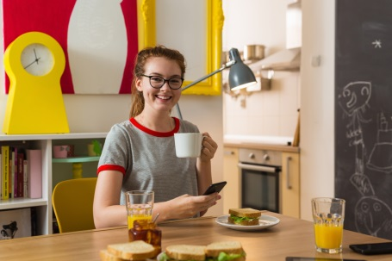


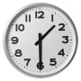
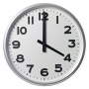
C. Look at the pictures and label the meals.


1. ________________
2. _________________
3. _________________
4._________________

D. Complete the sentences with some or any.
1. There are ___________ potatoes but there isn’t __________ lettuce.
2. Is there _________ juice? Yes, there is. But there isn’t __________ coffee.
3. There aren’t __________ cakes but there is __________ bread.
4. There are ____________ hamburgers and there are __________ pizzas.
5. Are there ____________ oranges? No, there aren’t. But there are _________ apples.
6. There is __________ meat but there isn’t __________ fish.

E. Complete the sentences with the correct form of the verb like.
1. Jason __________ carrots but his friends _______________ (not) vegetables.
2. My sister ______________ (not) fast food but I _____________ hamburgers a lot.
3. ________ Anna___________ hot dogs? Yes, she ____________.
4. We ____________ chips but we _________________ (not) rice or spaghetti.
5. ___________ they _________ salad? No, they _____________.

F. Order the words and write sentences. There is one example.
- I / cakes / bake / like I like baking cakes .
- eat soup / like / Jack
______________________________________________________________________.
- Jack and Jill / drink coffee / not like
______________________________________________________________________.
- prepare snacks / Cathy and I / prefer
______________________________________________________________________.
4. hate / they / cook
______________________________________________________________________.

G. Join the sentences using so or because. Draw lines.
I love fast food, 1. | so  because | - they are very healthy.
My sister doesn’t like cooking 2. | so  because | - it’s my favourite dessert.
We prefer vegetables 3. | so  because | - I eat a lot of pizzas and hot dogs.
I eat cheesecake twice a week 4. | so  because | - she doesn’t eat meat.
Chelsea is a vegetarian, 5. | so  because | - it’s boring.

Answer key

A.
1. tomato, potato | 2. apple, banana | 3. chocolate cake, jelly | 4. water, juice | 5. fish, meat

B.

1. pineapple | 2. (orange) juice | 3. toast / bread | 4. coffee | 5. cheese | 6. bread | 7. cereal | 8. egg(s)

C.

1. lunch | 2. dinner | 3. breakfast | 4. (afternoon) snack

D.

1. some… any | 2. any… any | 3. any… some | 4. some… some | 5. any… some | 6. some… any

E.

1. likes… don’t like | 2. doesn’t like… like | 3. Does… like… does | 4. like… don’t like | 5. Do… like… don’t

F.
1. Jack likes eating soup. | 2. Jack and Jill don’t like drinking coffee. | 3. Cathy and I prefer preparing snacks. | 4. They hate cooking.
G.
1. I love fast food, so I eat a lot of pizzas and hot dogs.| 2. My sister doesn’t like cooking because it’s boring. | 3. We prefer vegetables because they are very healthy.| 4. I eat cheesecake twice a week because it’s my favourite dessert.| 5. Chelsea is a vegetarian, so she doesn’t eat meat.

