A. What’s in the shopping list for the Nickelodeon cooking contest?
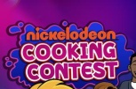
Circle the correct words.

(O que está na lista de compras para o concurso de culinária do Nickelodeon?
Rodeia as palavras corretas.)

Shopping list
Vegetables | Fruit |  | Desserts
1. fish / tomato  2. potato / lasagne | 3. coffee / apple  4. pizza / banana |  | 5. chocolate cake / carrot  6. jelly / cereal
Drinks |  | Other food
7. water / orange  8. strawberry / juice |  | 9. lemonade / fish  10. meat / milk

B. Look at this breakfast buffet. Circle the correct word to label the pictures.
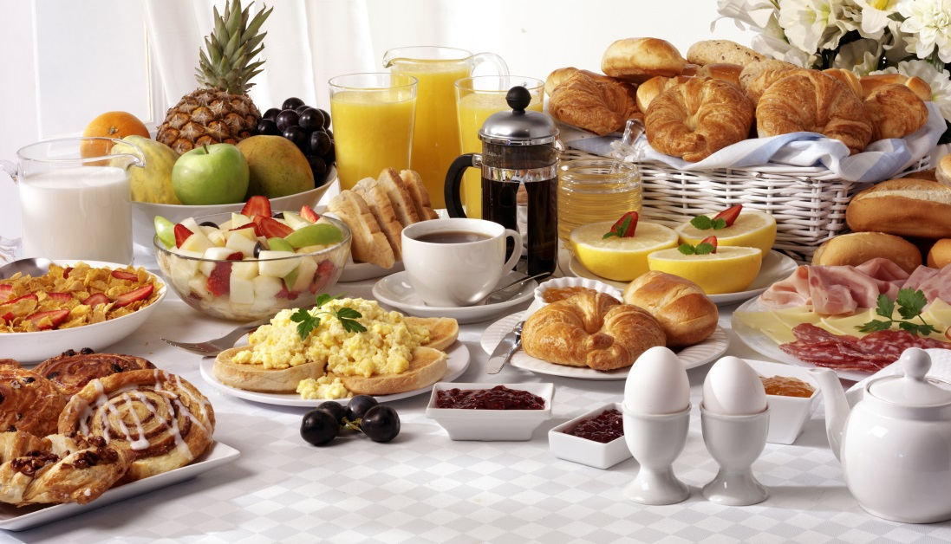
(Olha para este buffet de pequeno-almoço. Rodeia a palavra correta para legendar as imagens.)
1. mango / pineapple
2. water / juice
3. croissant / toast
4. coffee / tea
5. cheese / butter
6. bacon / bread
7. cereal / bread
8. pear / egg

6
4
3
2
5
1

7

8

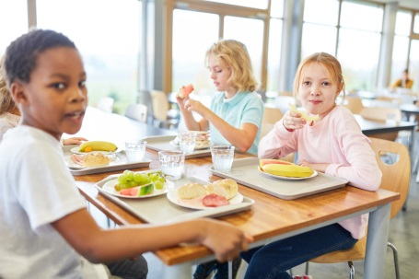
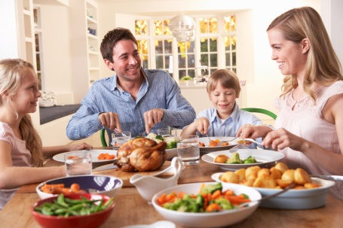






C. Unscramble the letters and write the meals. (Ordena as letras para encontrares refeições.)

4. CKNSA
________________
3. KFASTBREA
____________________________

________________
2. NERDIN
__________________________

________________
1. UNLCH
___________________

_________________

D. Complete the sentences with some or any. (Preenche os espaços com some ou any.)
1. There are ___________ potatoes but there isn’t __________ lettuce.
2. Is there _________ juice? Yes, there is. But there isn’t __________ coffee.
3. There aren’t __________ cakes but there is __________ bread.
4. There are ____________ hamburgers and there are __________ pizzas.
5. Are there ____________ oranges? No, there aren’t. But there are _________ apples.
6. There is __________ meat but there isn’t __________ fish.

E. Choose the correct form of the verb like to complete the sentences.
(Escolhe a forma correta do verbo like para completar as frases.)
1. Jason likes / like carrots but his friends doesn’t like / don’t like vegetables.
2. My sister doesn’t like / don’t like fast food but I likes / like hamburgers a lot.
3. Do / Does Anna like / likes hot dog? Yes, she does / do.
4. We like / likes chips but we don’t like / doesn’t like rice or spaghetti.
5. Does / Do they likes / like salad? No, they doesn’t / don’t.

F. Complete the sentences with the -ing form of the verbs in brackets. There is one example. (Preenche os espaços com a -ing form dos verbos entre parênteses. Segue o exemplo.)
- I like baking (bake) cakes.

1. Jack likes _______________ (eat) soup.
2. You don’t like __________ (drink) coffee.
3. We prefer _____________ (prepare) snacks.
4. They hate _____________ (cook).

G. Complete the sentences with so or because. (Preenche os espaços com so ou because.)
1. I love fast food, __________ I eat a lot of pizzas and hot dogs.
2. My sister doesn’t like cooking ____________ it’s boring.
3. We prefer vegetables ______________ they are very healthy.
4. I eat cheesecake twice a week _________ it’s my favourite dessert.
5. Chelsea is a vegetarian, _________ she doesn’t eat meat.
Answer key

A.

1. tomato | 2. potato | 3. apple | 4. banana | 5. chocolate cake | 6. jelly | 7. water | 8. juice | 9. fish |
10. meat

B.

1. pineapple | 2. juice | 3. toast | 4. coffee | 5. bread | 6. cheese | 7. cereal | 8. egg

C.

1. lunch | 2. dinner | 3. breakfast | 4. snack

D.

1. some… any | 2. any… any | 3. any… some | 4. some… some | 5. any… some | 6. some… any
E.

1. likes… don’t like | 2. doesn’t like… like | 3. Does… like… does | 4. like… don’t like | 5. Do…like… don’t

F.
1. Jack likes eating soup. | 2. You don’t like drinking coffee. | 3. We prefer preparing snacks. | 4. They hate cooking.
G.
1. I love fast food, so I eat a lot of pizzas and hot dogs. | 2. My sister doesn’t like cooking because it’s boring. | 3. We prefer vegetables because they are very healthy. | 4. I eat cheesecake twice a week because it’s my favourite dessert. | 5. Chelsea is a vegetarian, so she doesn’t eat meat.

