- Label the pictures with the names of the jobs. Choose the words from the box.
(Legenda as imagens com os nomes das profissões. Escolhe as palavras da caixa.)
student | singer | cook | football player | mechanic | vet


1. ______________________ 2. ______________________ 3. _____________________





4. _____________________ 5. ____________________ 6. _____________________
- Label John’s family picture with the family words. Use the words from the box.
There is one example. (Legenda a foto de família do John com as palavras sobre a família. Usa as palavras da caixa. Segue o exemplo.)

mother | brother | father | sister | grandmother

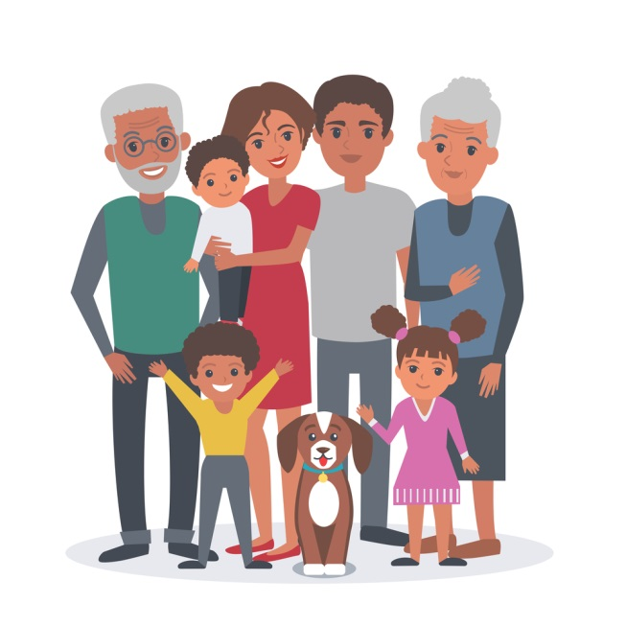
3.
grandfather

4.
1.
5.
2.

- Complete the sentences with the correct form of the verb to be (affirmative or negative). Choose the words form the box. (Completa as frases com a forma correta do verbo to be: afirmativa ou negativa. Escolhe as palavras da caixa.)
- John __________ a nice boy.
- I __________ his sister.
are | is | is | aren’t | isn’t | am

- We __________ a big family.
- Peter ___________ (not) my father.
- My mother _________ a model.
- My sister and I _________ (not) football players.
- Put the words in order to make interrogative sentences. Then complete the short answers. (Ordena as palavras para fazer frases interrogativas. Depois completa as respostas curtas.)
- your mother / Is / a teacher / ?
_________________________________________? Yes, ____________________.
- football players / Are / they / ?
_________________________________________? No, ____________________.
- Peter / is / a good student / ?
_________________________________________? No, ____________________.
- Circle the correct option to complete the sentences.
(Rodeia a opção correta para completar as frases.)

- The / -- Peter is my brother.
- New York is in the / an USA
- My sister is a / an singer.
- Is John --- / an actor?
- They are a / -- doctors.
- This is -- / a great book.

- Complete the sentences with the correct possessive determiner from the box.
(Completa as frases com o possessive determiner correto da caixa.)
- He is a doctor. ________name is Peter.
my | your | his | her | its | our | their

- They are my friends. _______ house is very nice.
- The cat is white. ____ name is Fifi.
- We are twin sisters. ______ family is big.
- I’m Karen. This is ___________ new computer.
- She is a teacher. ________ name is Rachel.
- And you? What’s _________ job?
- Answer the questions about you. (Responde às questões sobre ti.)
- What’s your name? My name is ____________________________________________
- What’s your surname? My surname is _______________________________________
- How old are you? I’m _____________________________________________________
- Where are you from? I’m from_____________________________________________
- What’s your job? I’m _____________________________________________________
Answer key
- 1. cook | 2. singer | 3. football player | 4. vet | 5. student | 6. mechanic
B. 1. brother | 2. mother | 3. grandmother | 4. father | 5. sister
C. 1. is | 2. am | 3. are | 4. isn’t | 5. is | 6. aren’t
D. 1. Is your mother a teacher? Yes, she is. | 2. Are they football players? No, they aren’t. |
3. Is Peter a good student? No, he isn’t.
E. 1. – | 2. the | 3. a | 4. an| 5. – | 6. a
F. 1. His | 2. Their | 3. Its | 4. Our | 5. my | 6. Her | 7. your
G. Personal answer

